Multi-Use PDF TEMP&RH Data Logger
User Manual

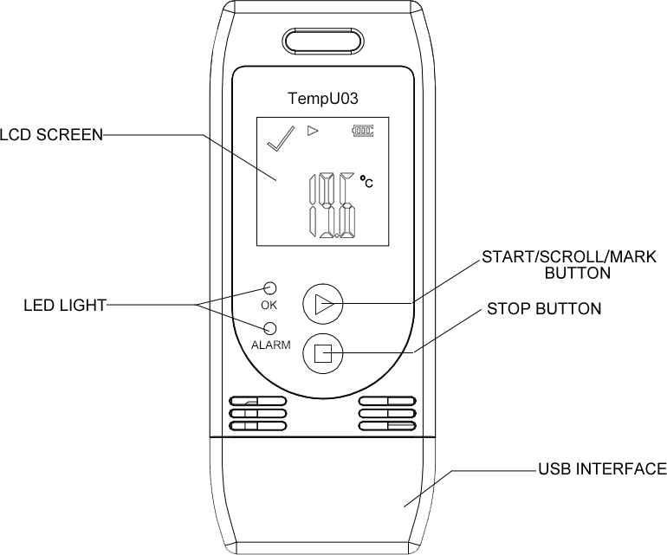

1

Product Introduction
The device is mainly used to monitor the temperature and humidity of food, medicine, chemical products and other products during storage and transportation. It is widely used in all links of warehousing and cold chain logistics, such as reefer containers, refrigerated trucks, refrigerated distribution boxes, cold storage laboratory, etc. Compact, light and economical to use. After the recording is completed, inserting it into the USB port of PC or computer, it will automatically generate reports without any driver.

Product Features
- Designed to be multi-use
- Temperature & Humidity measurement and recording
- Wide measuring range, high accuracy and large data memory
- Statistics available on LCD screen
- No software needed to export data
- Automatically generates PDF report and CSV file
- Programmable software for logging parameters, alarms, and start delay

2

Technical Parameter
Item | Parameter
Temperature Scale | ℃ or ℉
Accuracy | ±3%RH; ±0.5℃(-20℃ ~ +40℃), ±1.0℃(other)
Measuring Range | Humidity 0% ~ 100%RH, Temp -30℃ ~ 60℃
Resolution | 0.1
Memory Capacity | 32,000
Recording Options | Push-To-Start or Start Delay
Interval | Programmable (10s~18h) [Default: 10 mins]
Start Delay | Programmable (0~254 mins) [Default: 30 mins]
Alarm Delay | Programmable (0~960 mins) [Default: 10 mins]
Alarm Range | Programmable high or low alarm limit for each channel [Default: <2℃ or >8℃, <40%RH or >80%RH]
Shelf Life / Battery | Typically 1 Year; CR2032 3.0V Lithium Battery (Depending on sampling rate and environment)
Report Generation | Simultaneously generate PDF report and CSV file
Communication Interface | USB 2.0
Time Zone | UTC +0:00 (Default)
Dimensions | 89mm*36mm*16mm
Product Weight | 25g
3

Operating Instruction
- Start Recording
Press and hold the “▶” button for more than 3s until the “ OK” light is on, and the “▶” or “WAIT” displays on the screen, indicating starting recording successfully.

- Mark
When the device is recording, press and hold the “▶” button for more than 3s, and the screen will switch to the “MARK” interface. The number of “MARK” will increase by one, indicating data was marked successfully.
(Note: One record interval only can mark one time, the logger can mark 6 times in one recording trip. Under status of start delay, the mark operation is disabled.)

- Stop Recording
Press and hold the “■” button for more than 3s until the “ALARM” light is on, and the “■” displays on the screen, indicating stopping recording successfully.
(Note: If the logger is stopped during the status of start delay, a PDF report generated when inserted into PC but without data.)

4

LCD Display Instruction

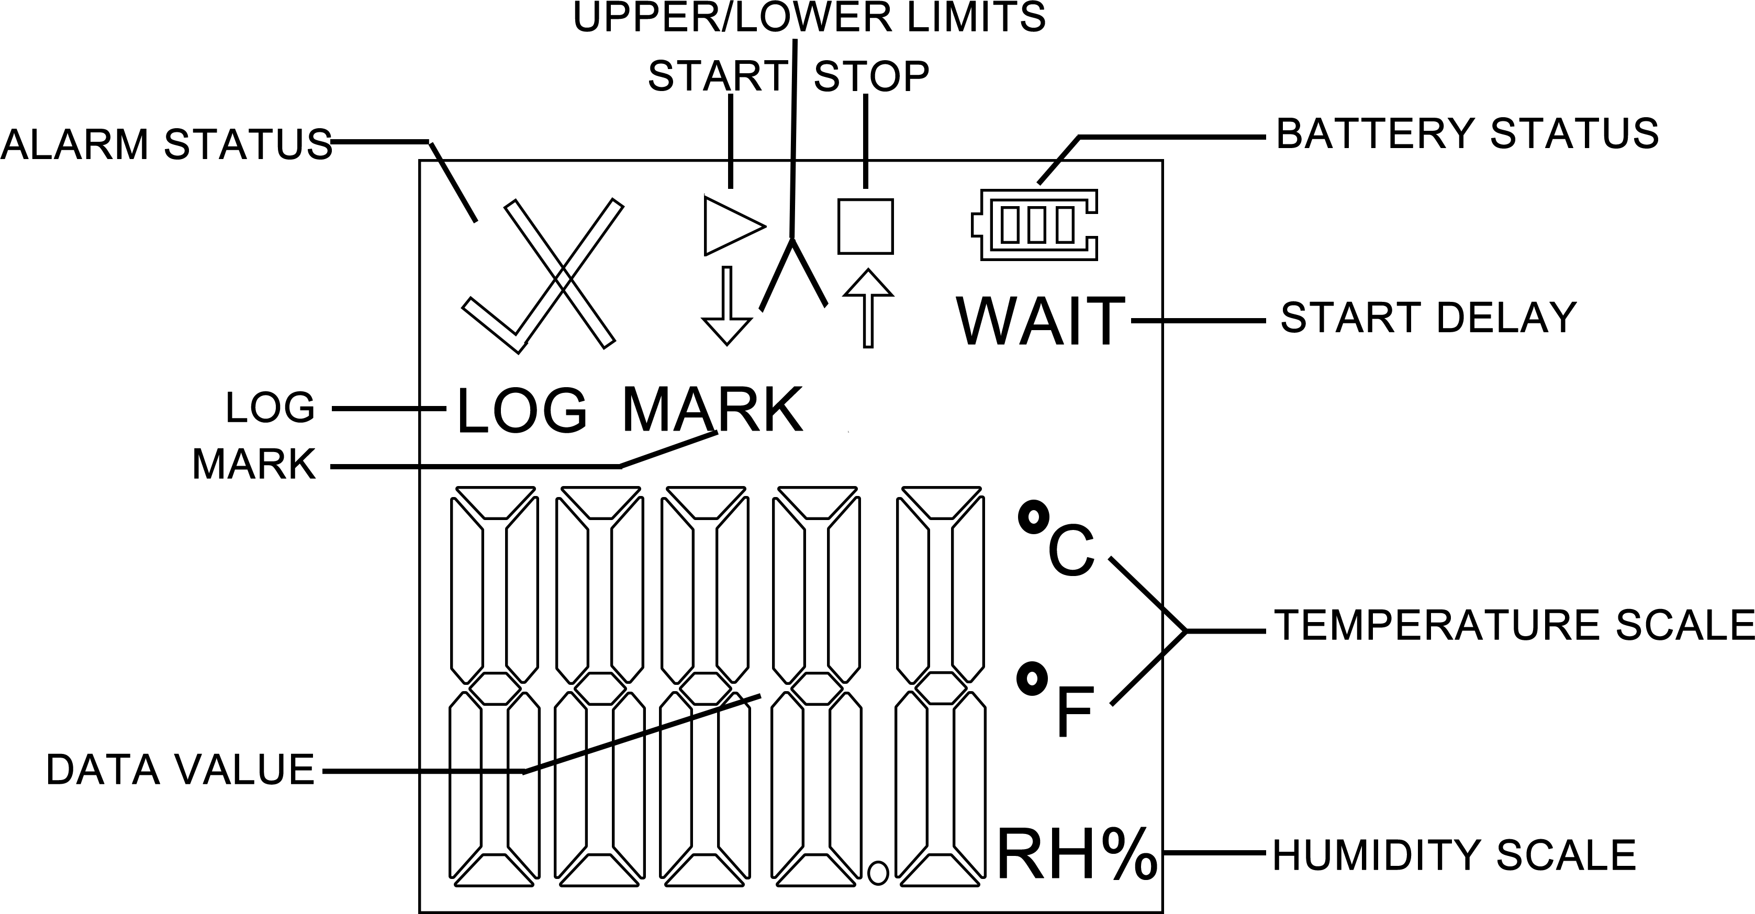
During normal recording process, shortly press “▶” to switch to different display interface. The interfaces shown in sequence are respectively:
Real-time Temperature Interface → Real-time Humidity Interface → LOG Interface → MARK Interface → Temperature Upper Limit Interface → Temperature Lower Limit Interface → Humidity Upper Limit Interface → Humidity Lower Limit Interface.

5

Note:
- If the device is used for the first time or after re-configuration, the real-time temperature interface will be the initialization interface.
- Real-time temperature and humidity interface is updated every 10s.

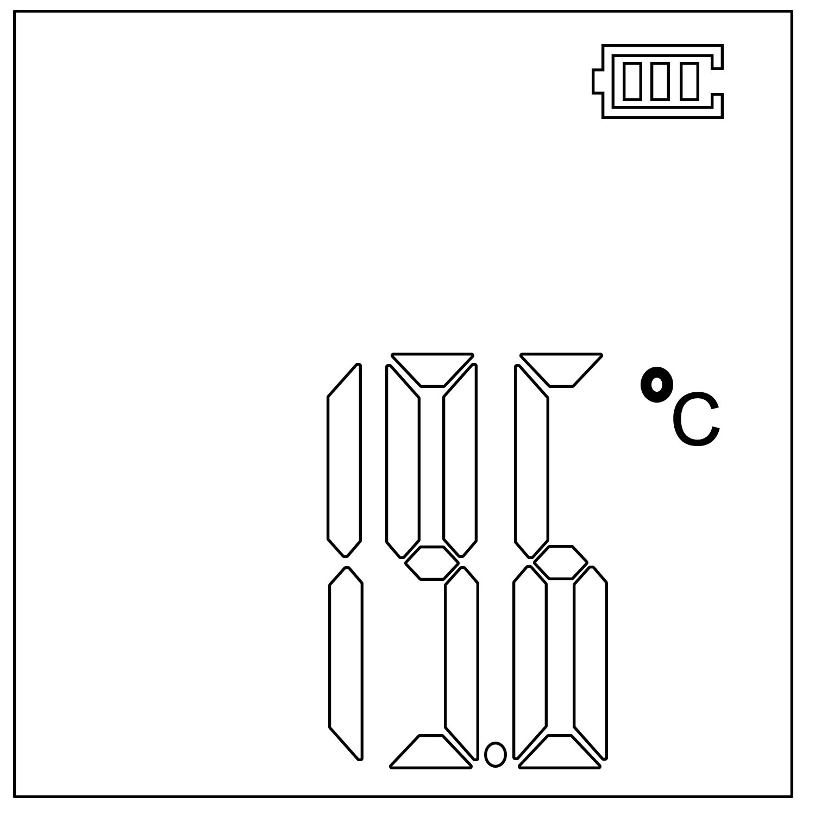
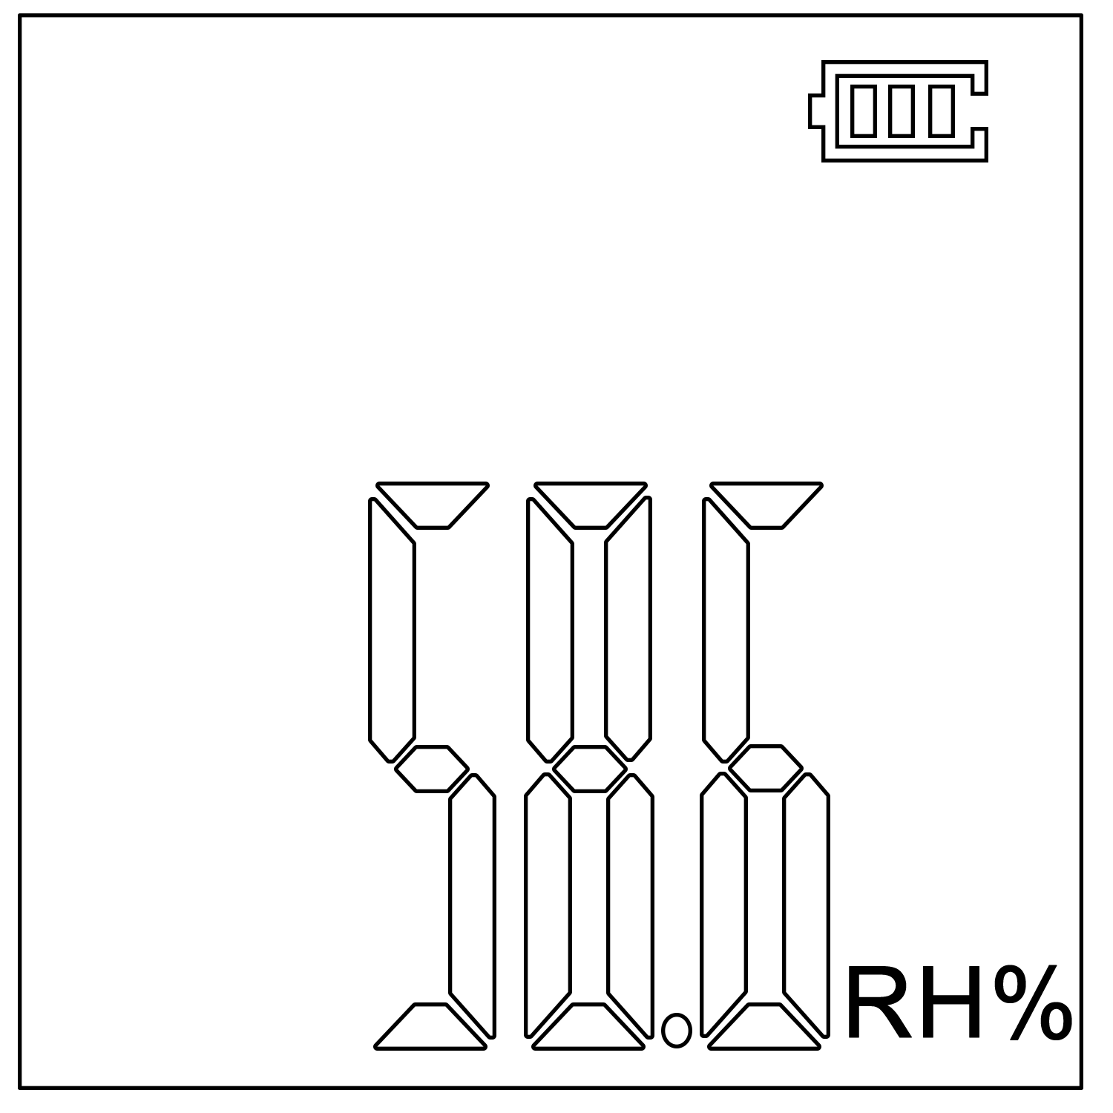

①Real-time Temperature Interface ②Real-time Humidity Interface
(Initialization) (Initialization)

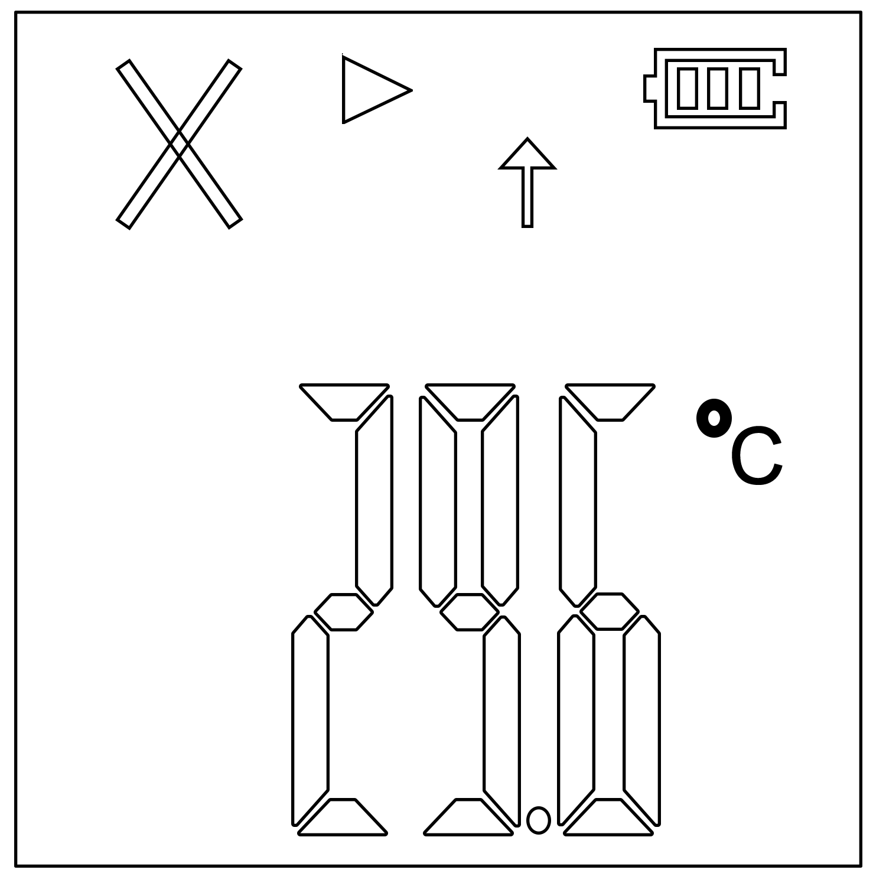
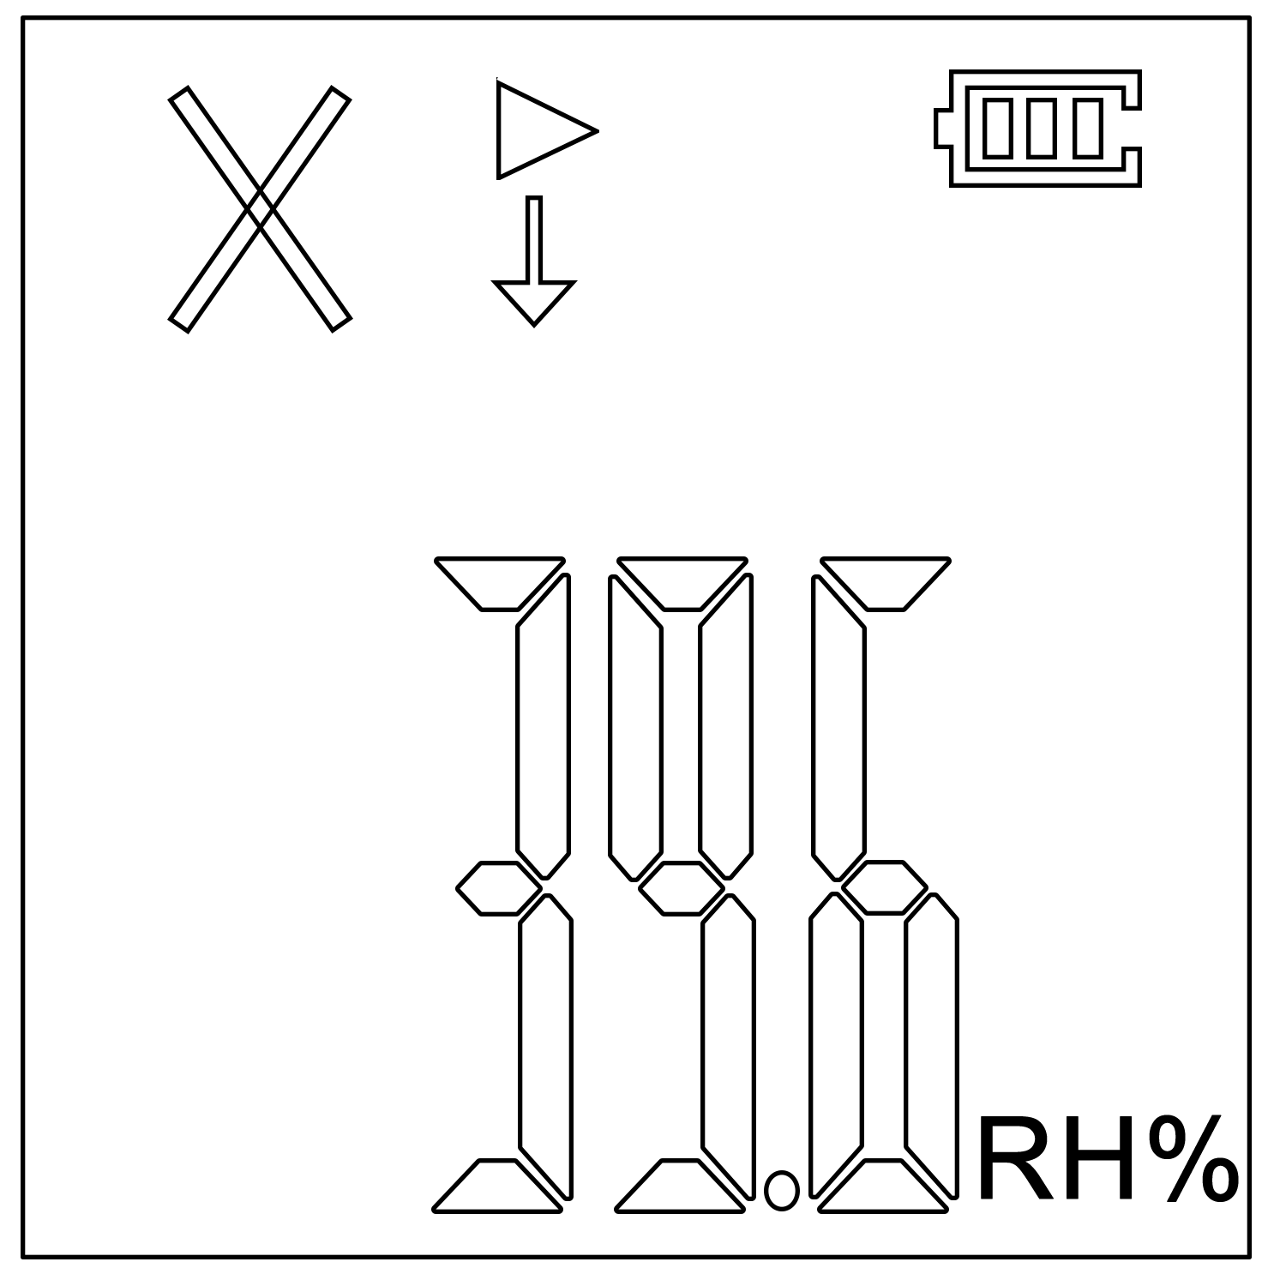

③Real-time Temperature Interface ④Real-time Humidity Interface
(Above Upper Limit) (Below Lower Limit)
6

At the real time temperature / humidity interface:
If the symbol “▶” lights, indicating the data logger is recording;
If the symbol “■” lights, indicating the data logger has stopped recording;
If the “WAIT” lights, indicating the data logger is in the status of start delay;
If the symbol “√” lights, it means that the temperature and humidity are within the normal range;
If the symbol “×” and “↑” light, indicating the measured temperature/humidity exceeds its temperature/humidity upper limit;
If the symbol “×” and “↓” light, indicating the measured temperature/humidity exceeds its temperature/humidity lower limit.
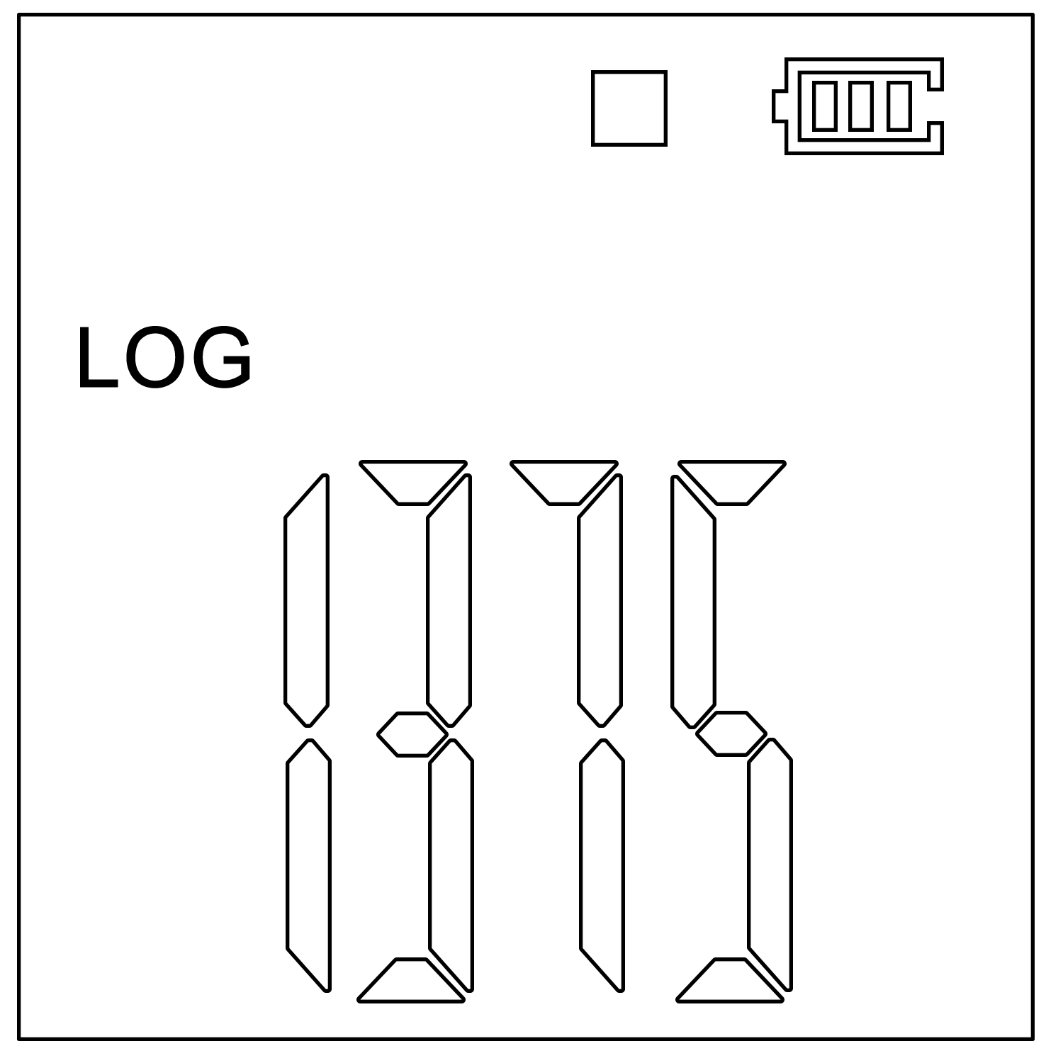
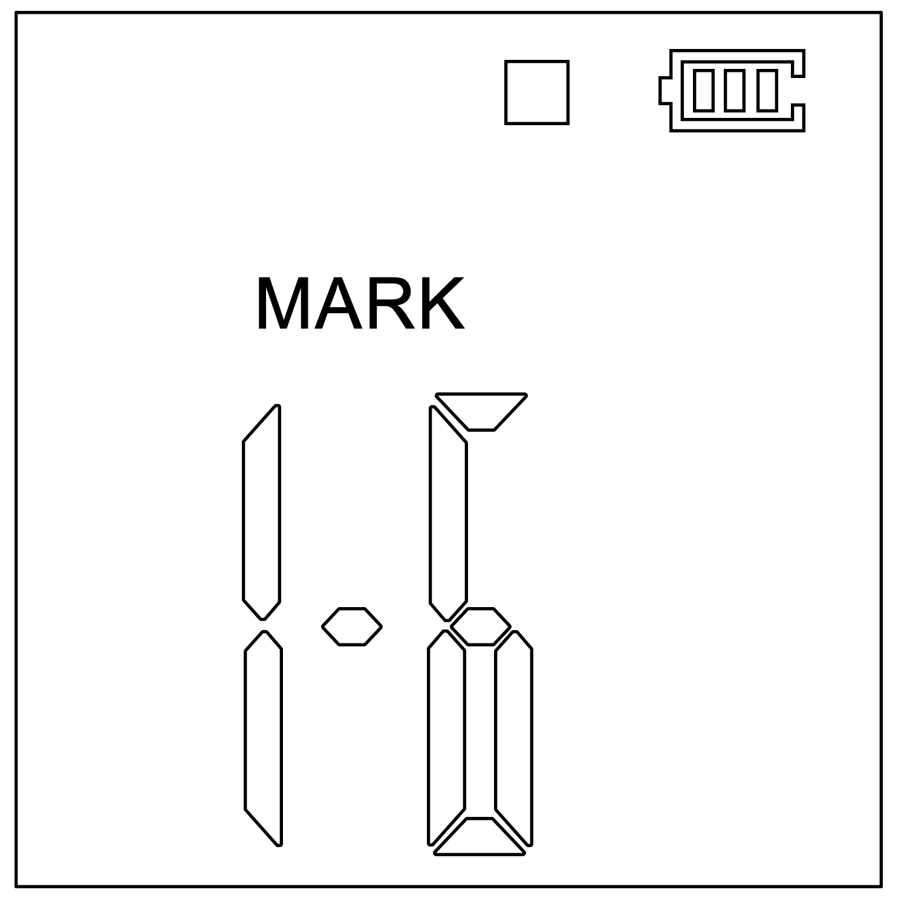

⑤LOG Interface ⑥MARK Interface
(Stop recording status) (Stop recording status)

7

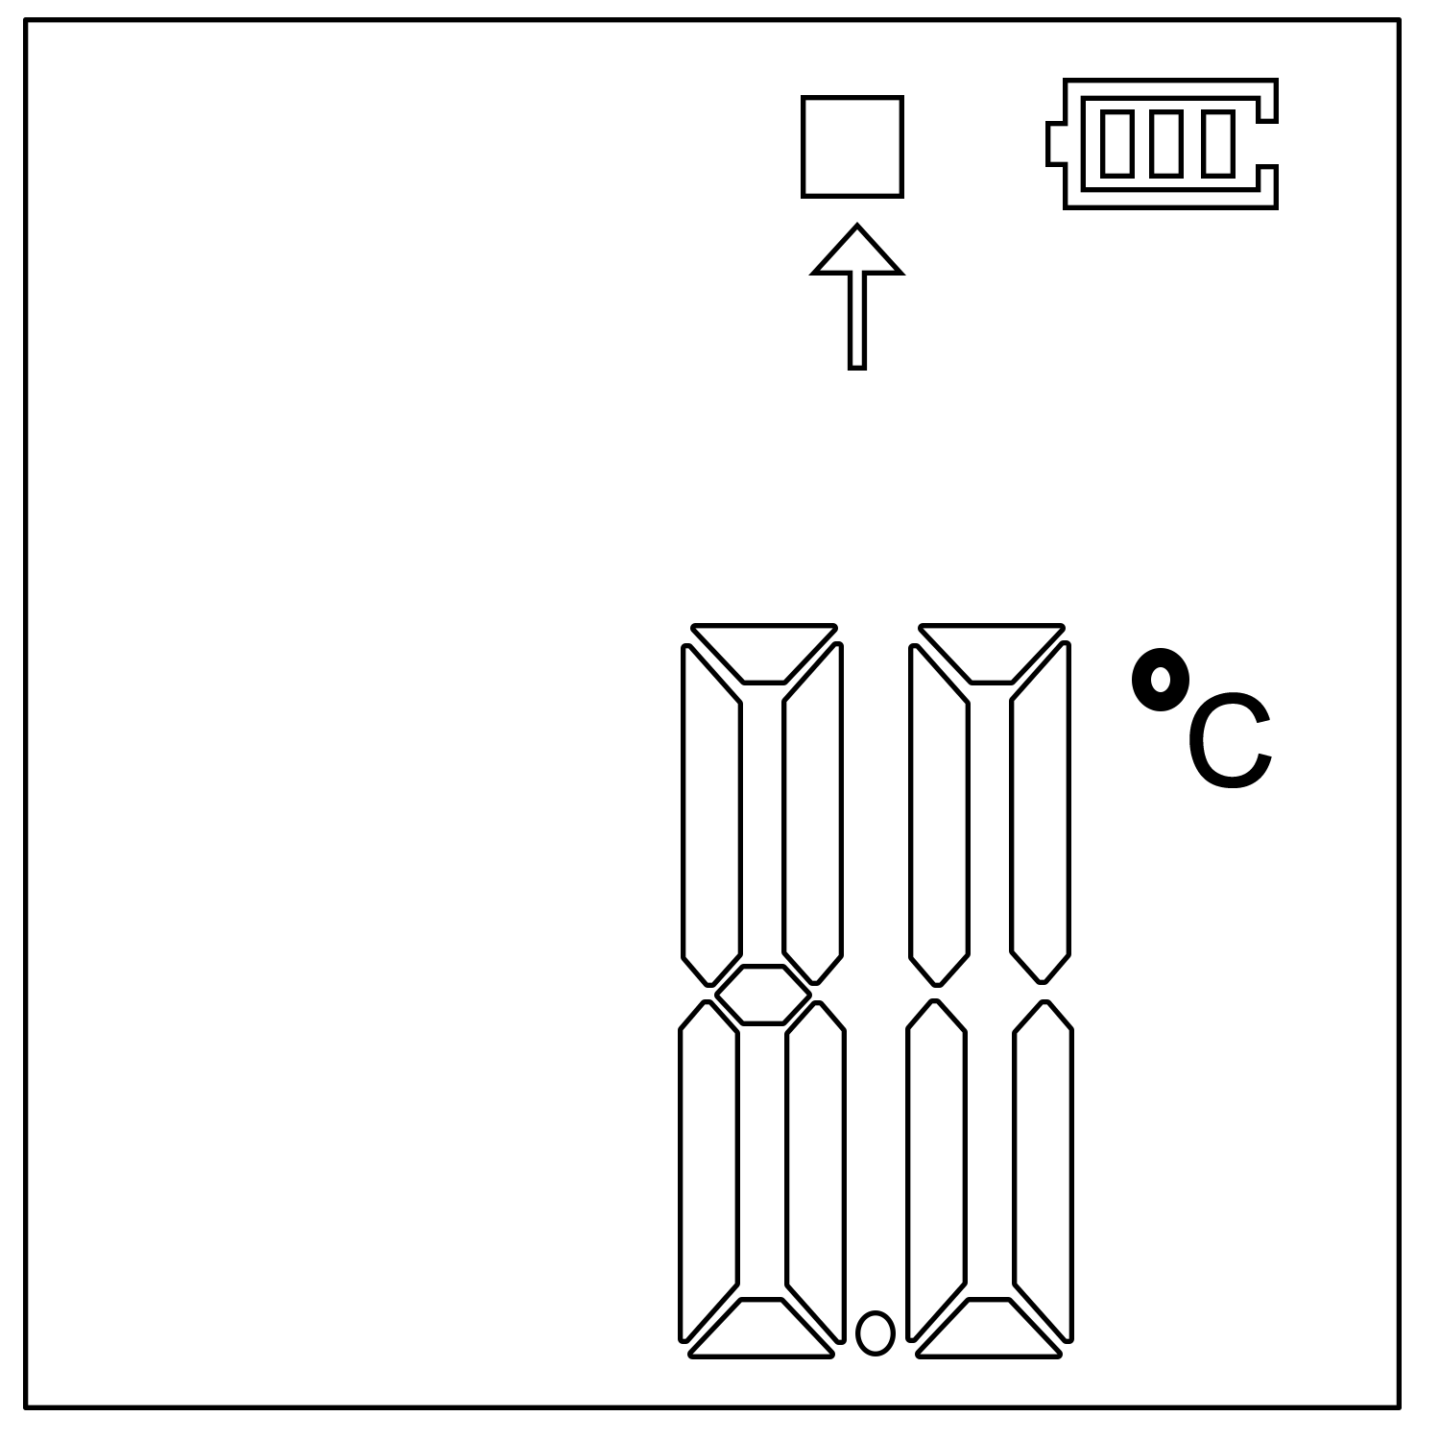
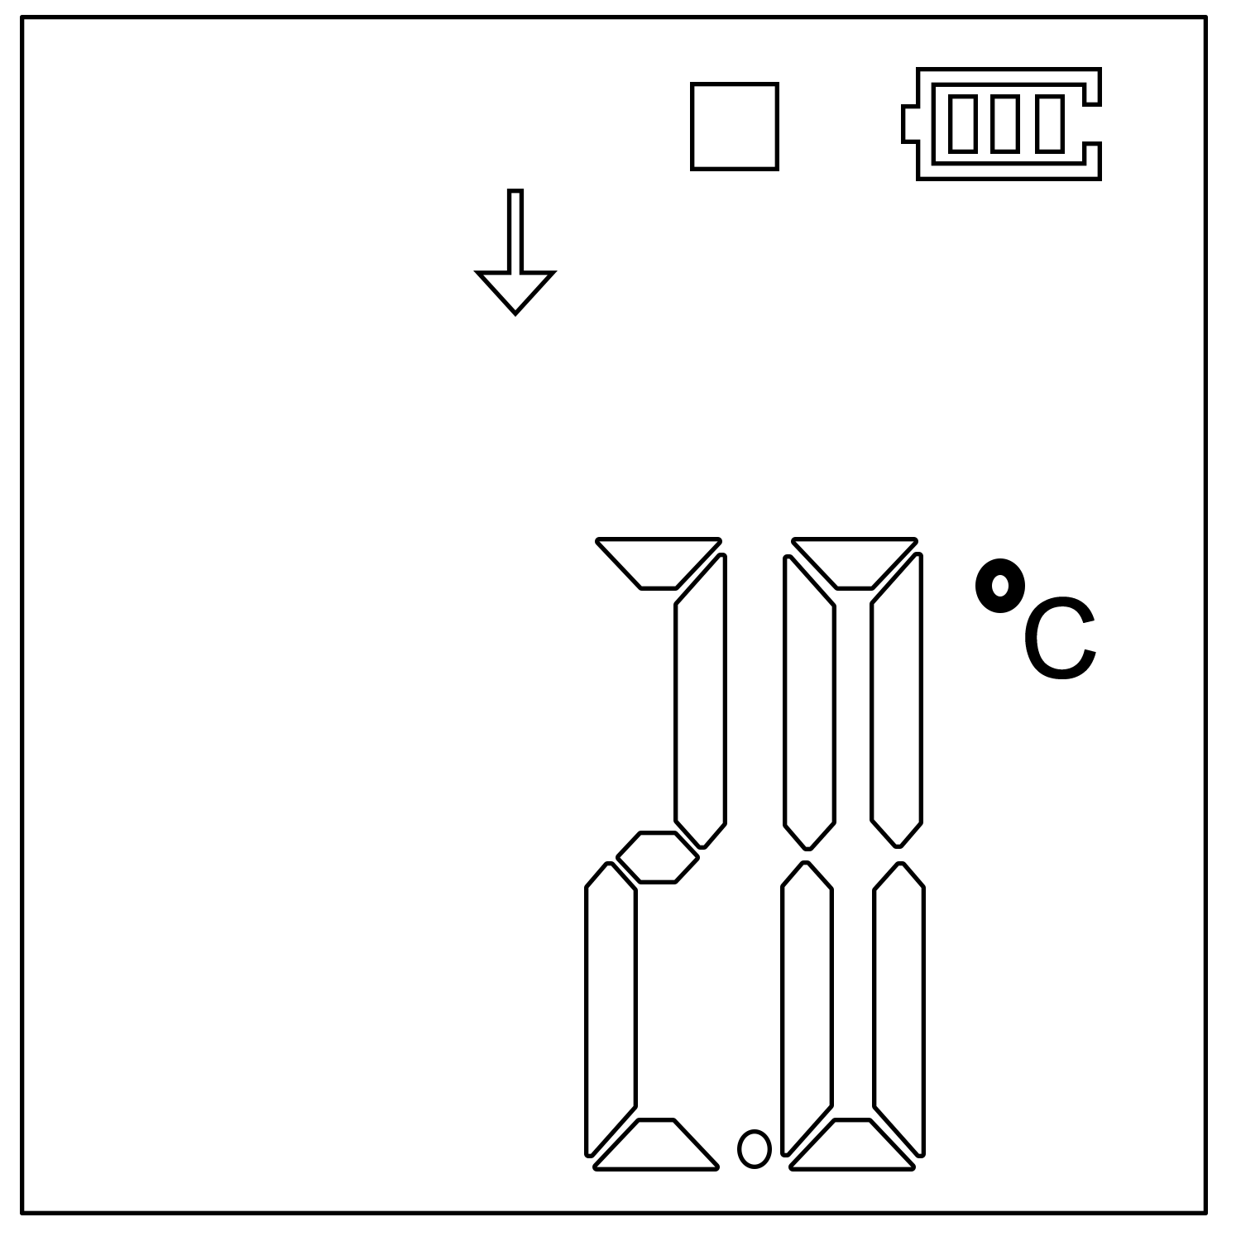

⑦Temperature: Above Upper Limit ⑧Temperature: Below Lower Limit
(Stop recording status) (Stop recording status)

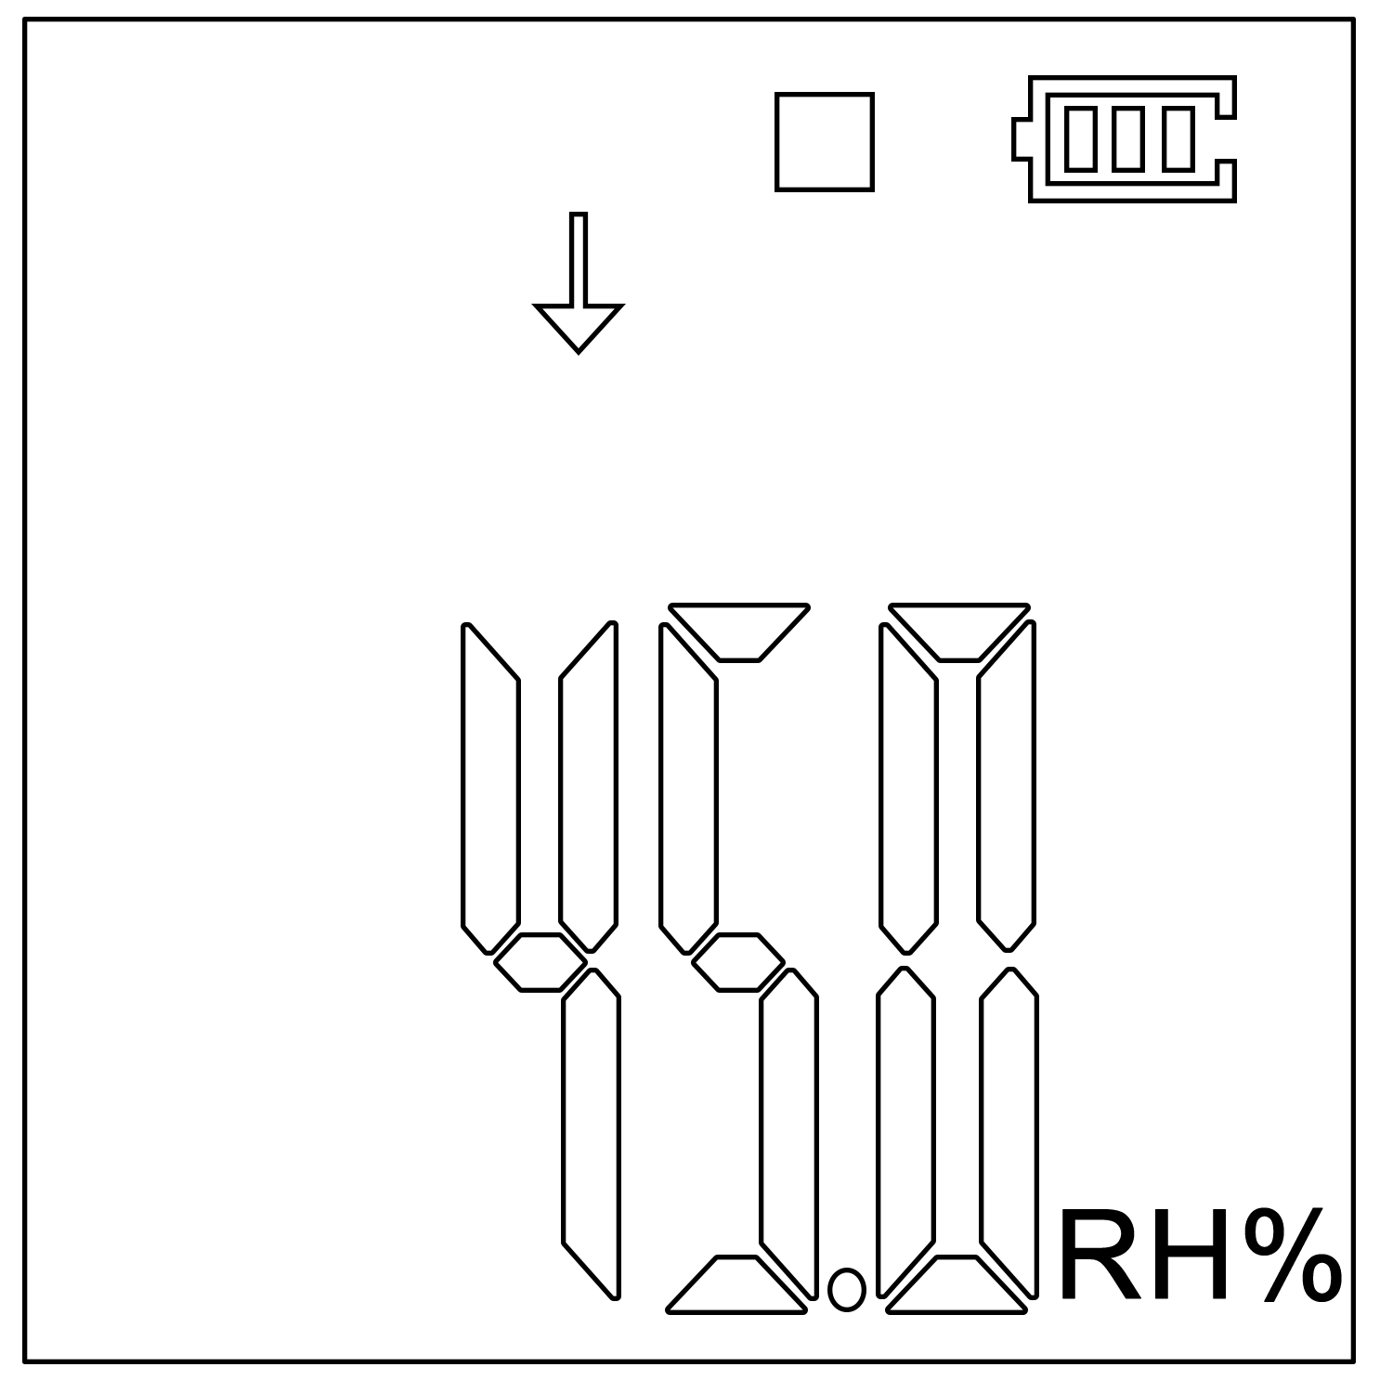
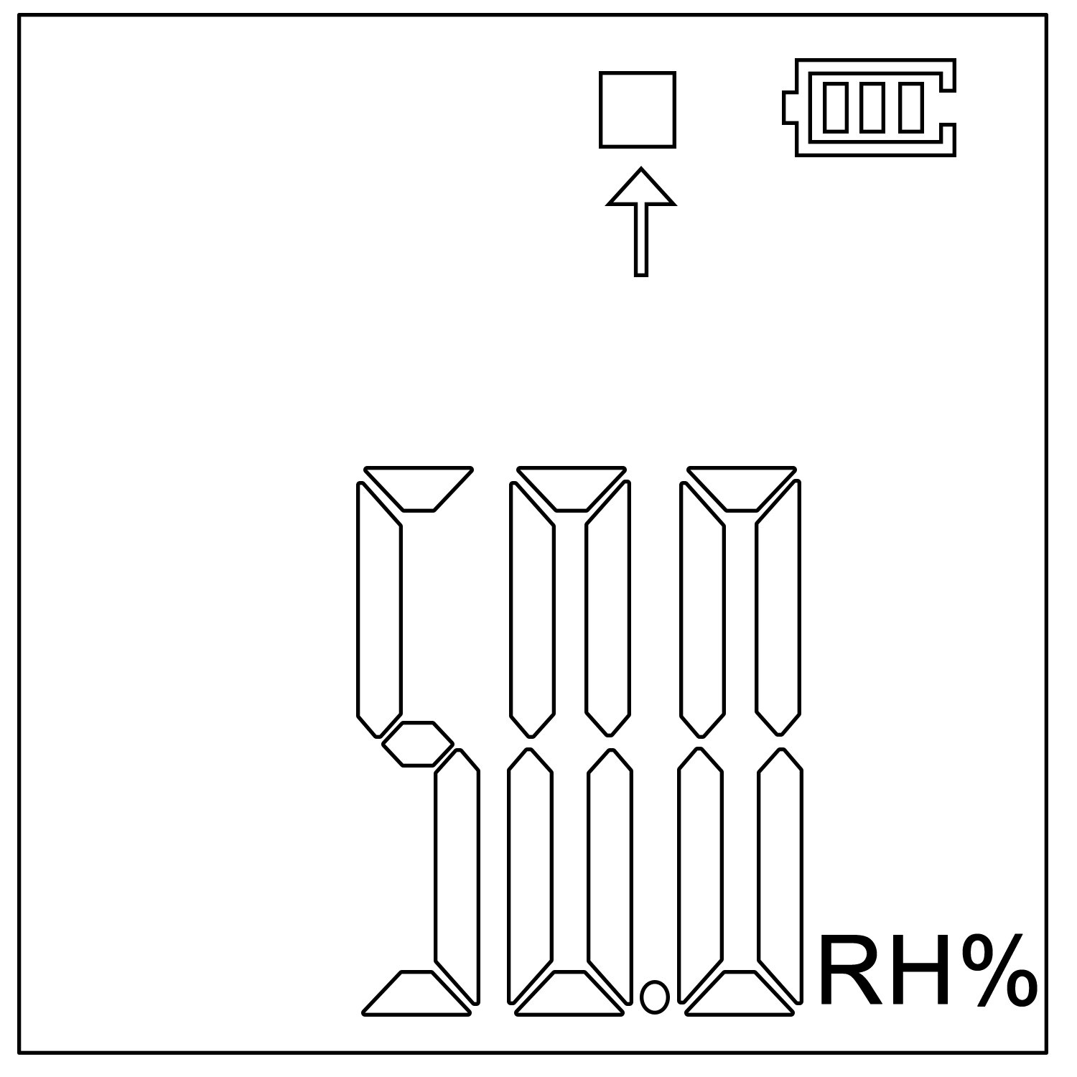

⑨Humidity: Above Upper Interface ⑩Humidity: Below Lower Limit
(Stop recording status) (Stop recording status)

8

LED Indicator Description
Status | Operation | Indicator status
Inactivated | Short press the button | The “OK” (green light) and the “Alarm” (red light) will flash simultaneously.
Activated | During the recording process, the device will automatically flash every 10s.  If the “OK” (green light) flashes every 10s, it means that there is not over temperature/humidity limit during the recording process.  If the “Alarm” (red light) flashes every 10s, it means there is over temperature/humidity limit during the recording process.  Note: As long as over limit is found during the recording process, the “OK” light will no longer flash.
Stopped | Not press the button | The “OK” (green light) and “Alarm” (red light) don’t flash.
Stopped | Short press the button | The “OK” (green light) flashes, indicating there is not over limit during the recording process.
Stopped | Short press the button | The “Alarm” (red light) flashes, indicating it is over limit during the recording process.
9

Button | Indicator light | Status
Press and hold the “▶” button for 3s for the first time. | The “OK” (green light) will light for 3s. | Start Recording
After turning on, press and hold the “■” button for 3s. | The “Alarm” (red light) will light for 3s. | Stop Recording
Battery Status Indication
Battery Status Indication | Capacity
 | 40% ~ 100%
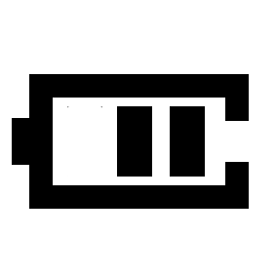 | 15% ~ 40%
 | 5% ~ 15%
 | < 5%
Note: When the battery power is lower than 5%, please replace the CR2032 battery with a new one.

10

Battery Replacement
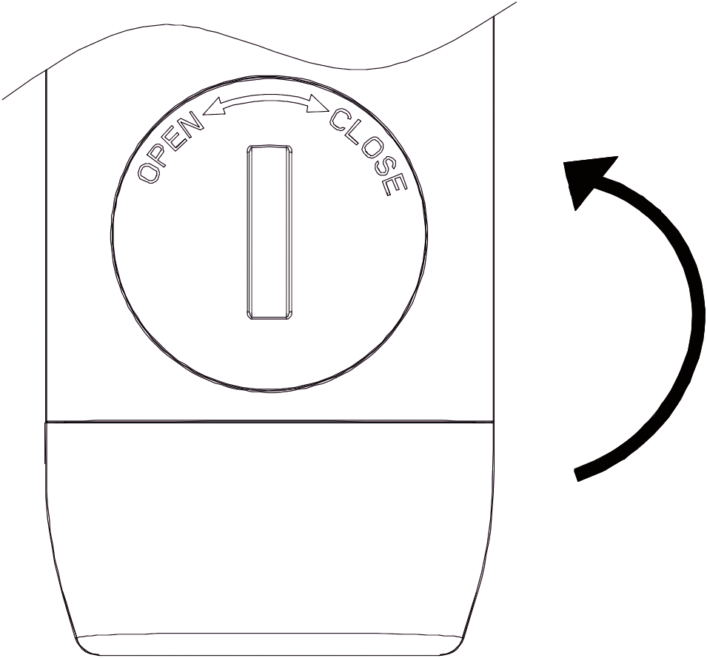 Step 1 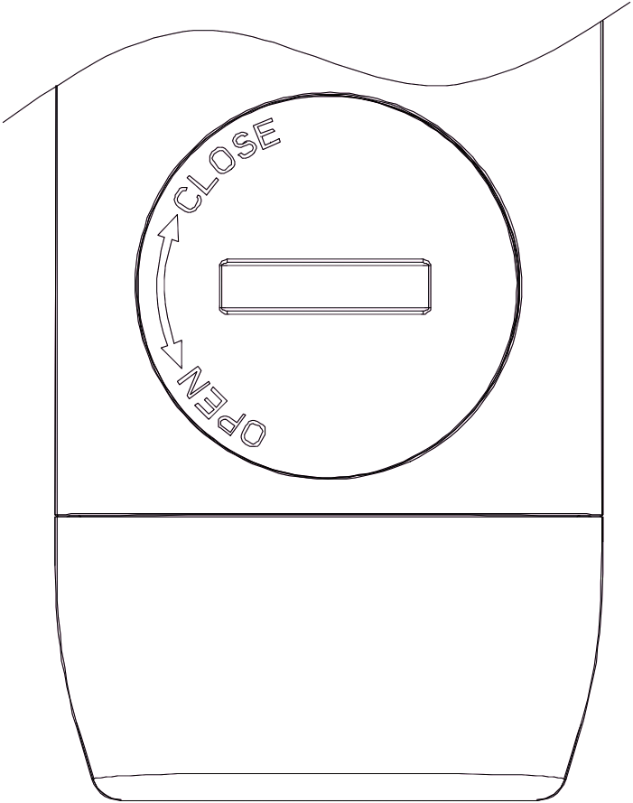 Step 2 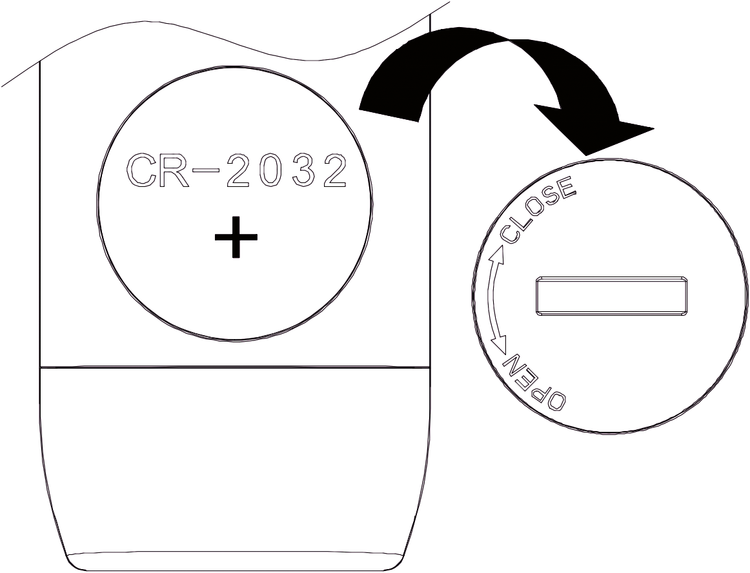 Step 3 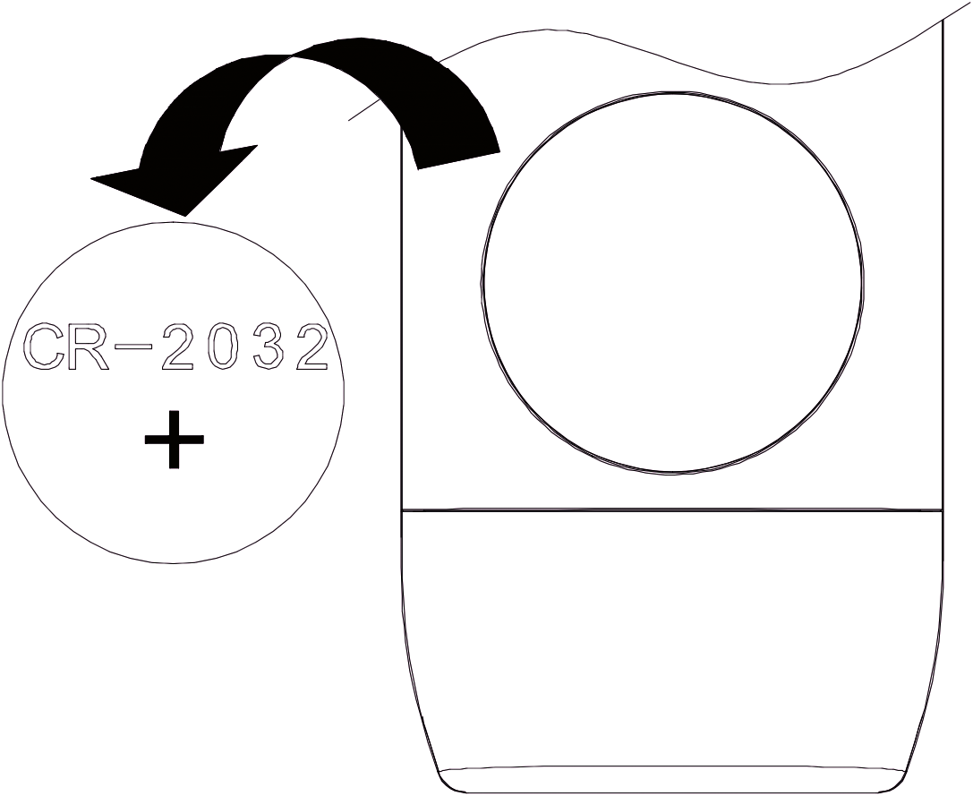 Step 4
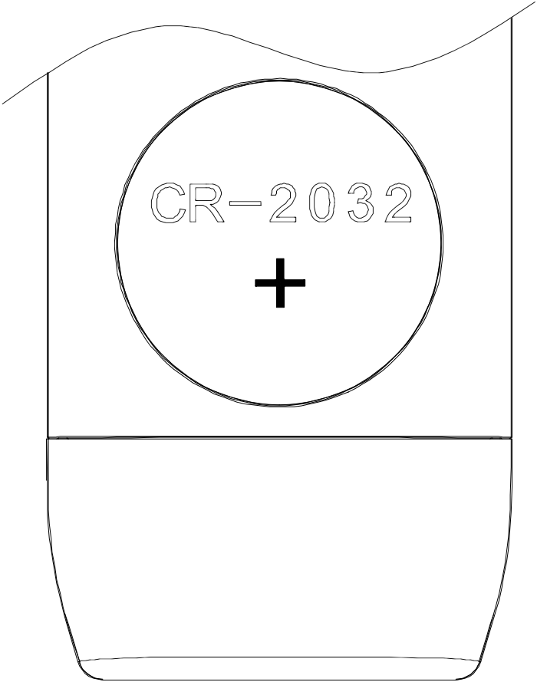 Step 5 Step 6
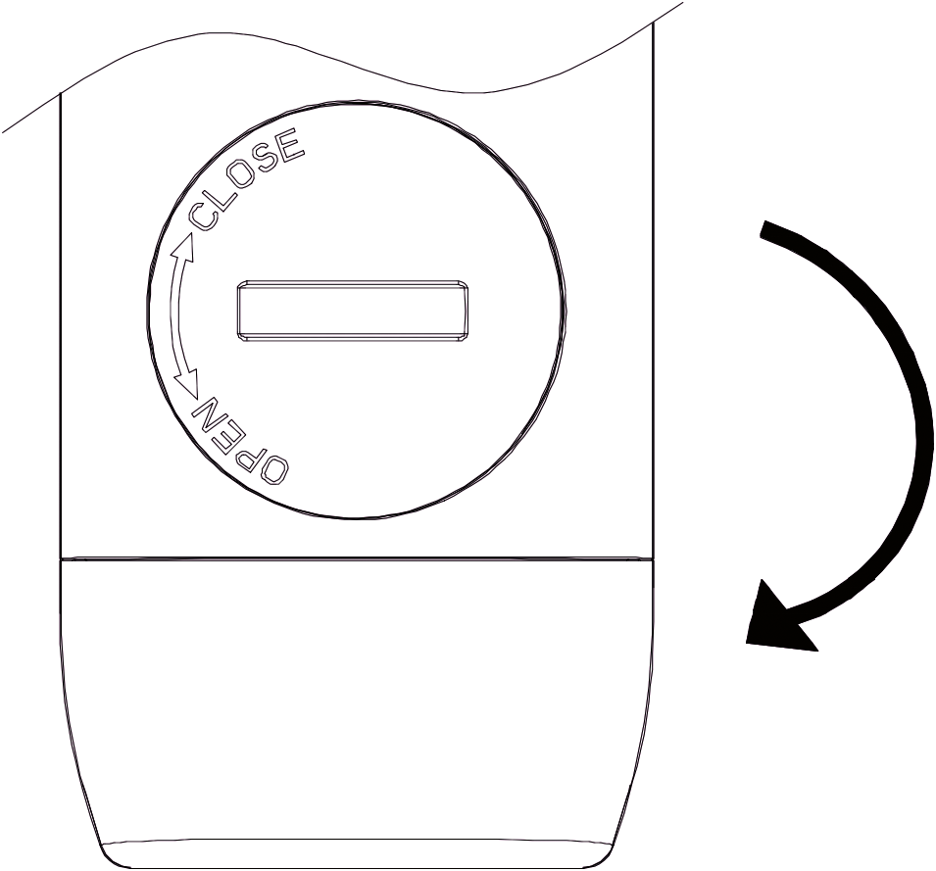 Step 7 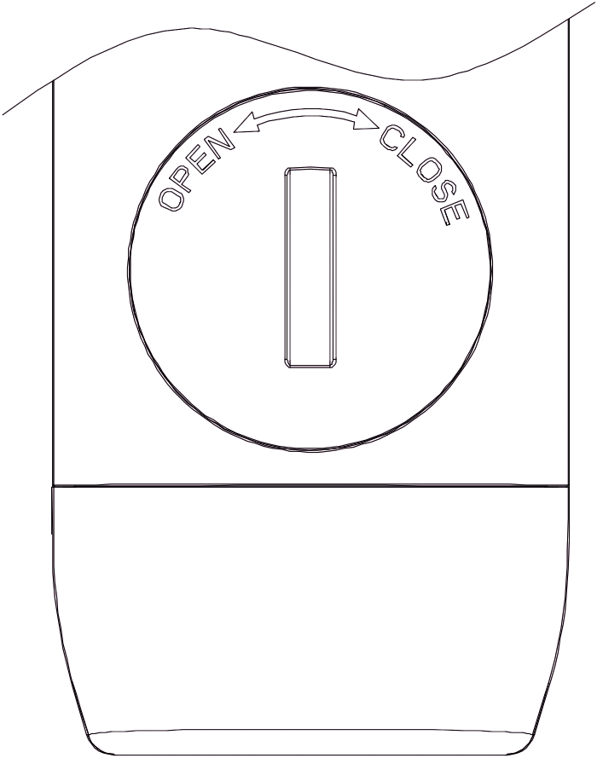 Step 8

11

Step1: Turn the battery cover anticlockwise to open it.
Step2: The battery cover position is as shown, indicating that it has been rotated to the accordant position.
Step3: Take off the battery cover.
Step4: Remove the CR2032 battery.
Step5: Replace the battery. (Please note that the positive and negative anodes)
Step6: Please install the battery cover as the direction shown.
Step7: Cover the battery and clockwise rotate it to close.
Step8: The battery cover is oriented as shown, indicating that the battery cover is installed tightly.

Note:
It is recommended to check the battery status before restarting the logger to ensure that the remaining battery capacity could finish the recording task.

When the logger is connected to computer under the status of recording or pause status, it is prohibited to plug out the logger without battery power supply.

12

