Multi-Use USB Temp&RH Data Logger
User Manual

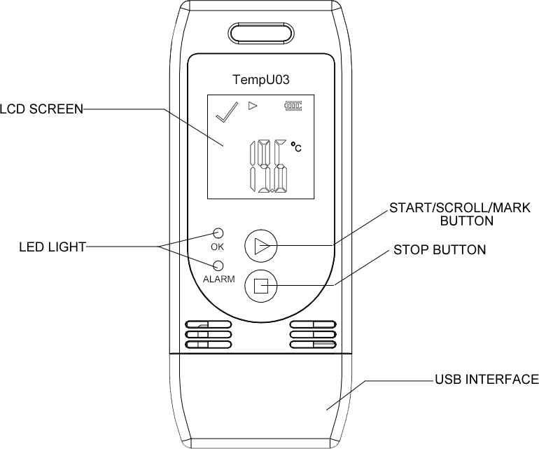

1
Product Introduction
The device is mainly used to monitor the temperature and humidity of food, medicine, and other products during storage and transportation. After recording, insert it into the USB port of PC, it will automatically generate reports without any driver.

Main Features
- Multi-use temperature & humidity measuring and recording
- Widely measuring range, high accuracy and large data memory
- Statistics available on LCD screen
- No software needed to generate
PDF and CSV report
- Parameter programmable by configure software
2
Specification
Item | Parameter
Temp Scale | ℃ or ℉
Accuracy | ±3%RH;±0.5℃(-20℃ ~+40℃), ±1.0℃(other)
Range | -30℃ ~ 60℃;0%~85%RH
Resolution | 0.1
Capacity | 32,000 readings
Startup Mode | Button or software
Interval | Optional  Default: 10 mins
Start Delay | Optional  Default: 30 mins
Alarm Delay | Optional  Default: 10 mins
Alarm Range | Optional  Default: <2℃ or >8℃, <40%RH or >80%RH
Shelf Life | 1 year (replaceable)
Report | Automatic PDF and CSV
Time Zone | UTC +0:00 (Default)
Dimension | 89mm*36mm*16mm
3
How to use

- Start Recording
Press and hold the “▶” button for more
than 3s until the “ OK” light is on and the “▶” or “WAIT” displays on the screen, which indicates the logger is started.
- Mark
When the device is recording, press and hold the “▶” button for more than 3s, and the screen will switch to the “MARK” interface. The number of “MARK” will increase by one, indicating
data was marked successfully.
(Note: One record interval can mark one time only, the logger can mark 6 times in one recording trip. Under status of start delay, the mark operation is disabled.)
4
- Stop Recording
Press and hold the “■” button for more than 3s until the “ALARM” light is on, and
the “■” displays on the screen, indicating stopping recording successfully.
(Note: If the logger is stopped during the status of start delay, a PDF report generated when inserted into PC but without data.)

LCD Display Instruction
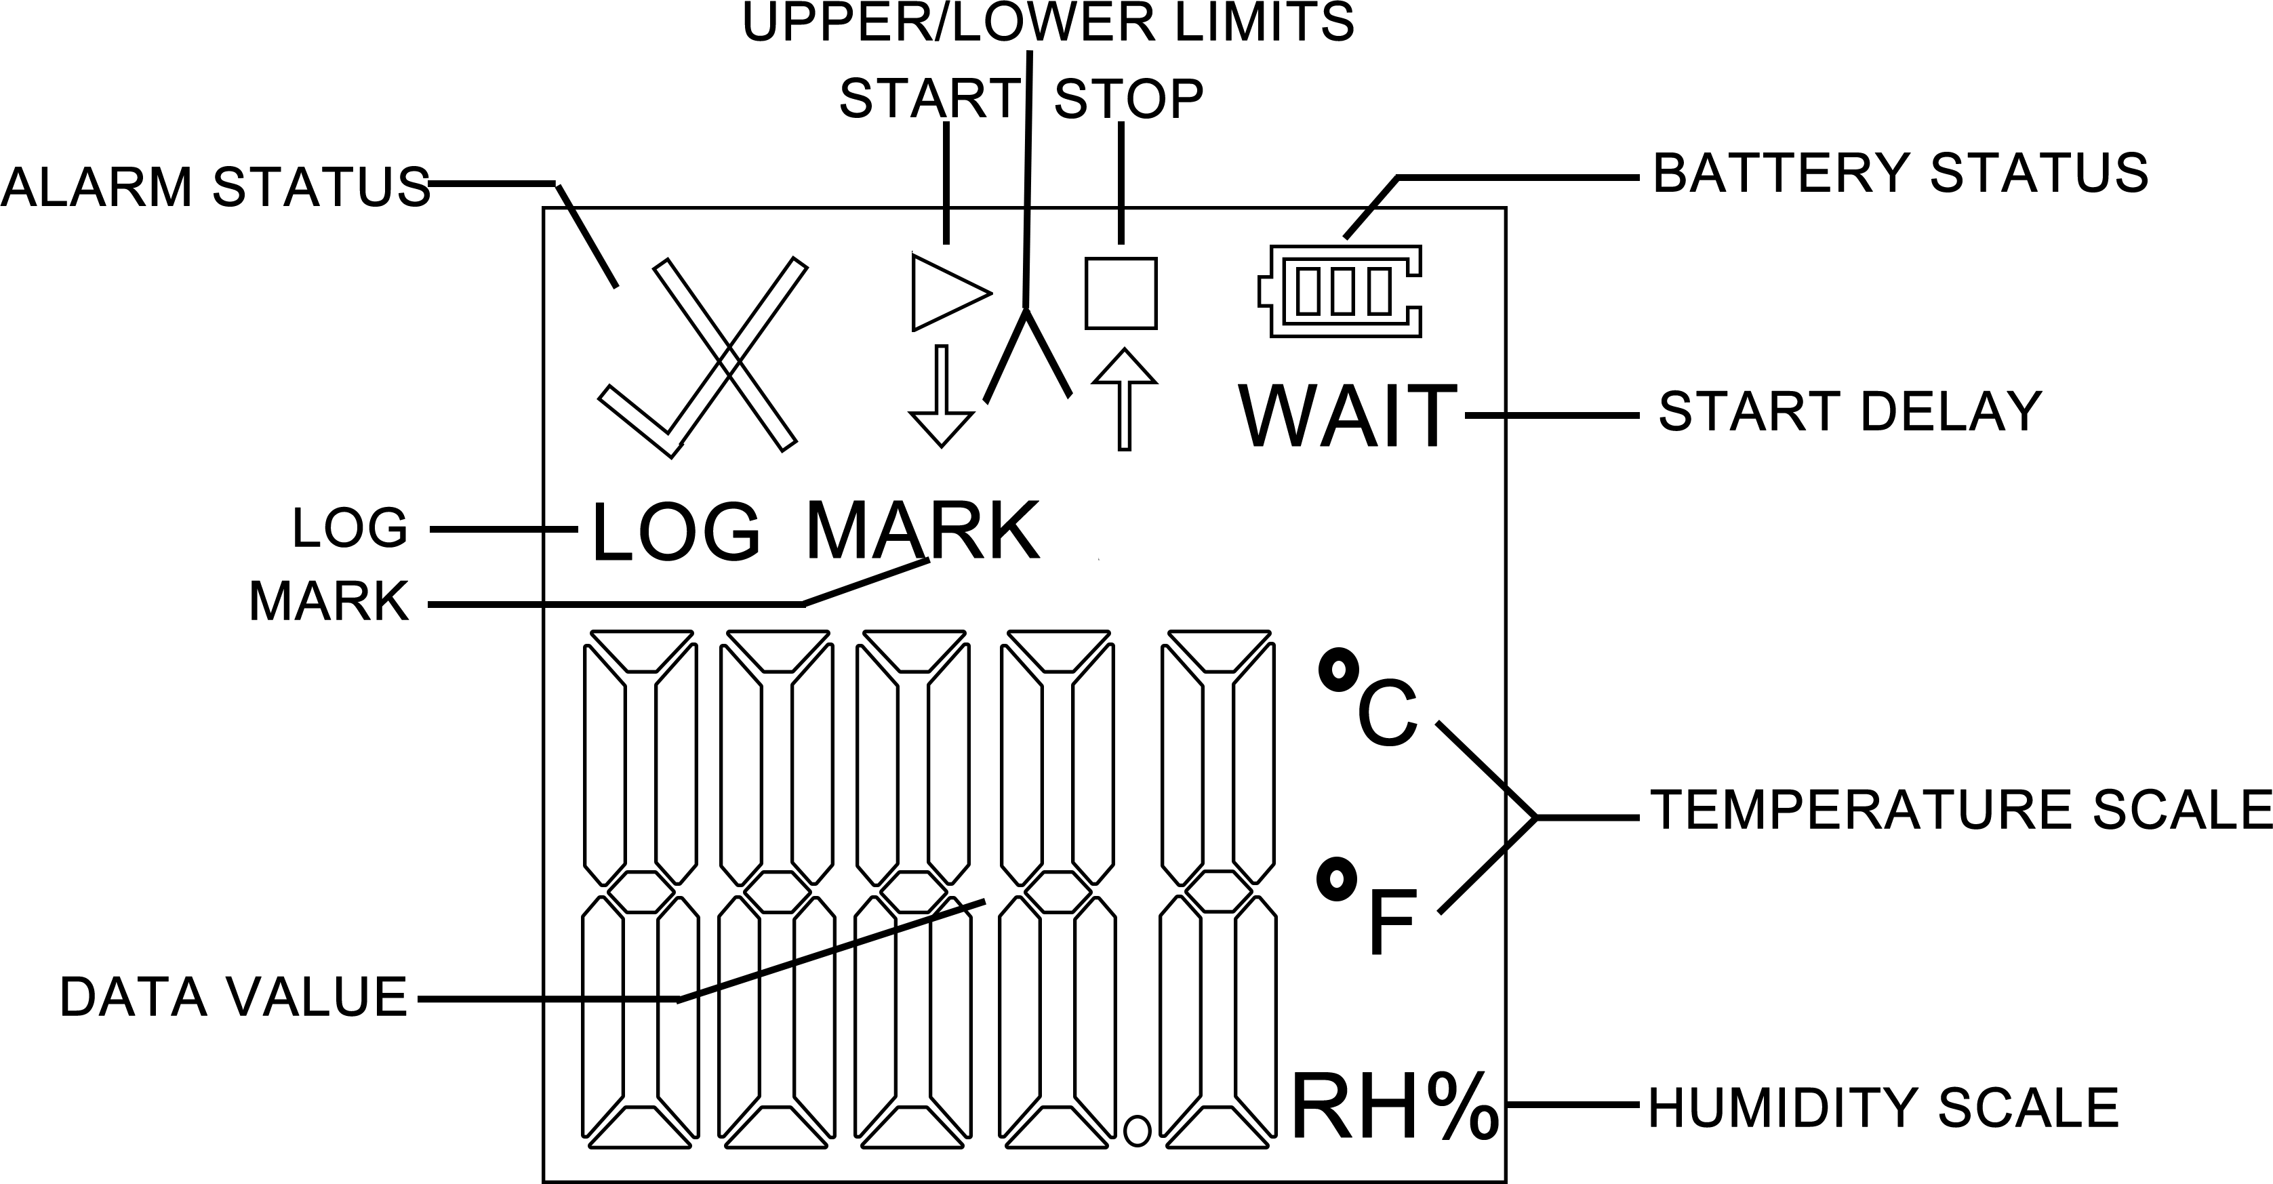
5
During normal recording process, shortly press “▶” to switch to different display interface. The interfaces shown in sequence are respectively:
Real-time Temperature Interface → Real-time Humidity Interface → LOG Interface → MARK Interface → Temperature Upper Limit Interface → Temperature Lower Limit Interface → Humidity Upper Limit Interface → Humidity Lower Limit Interface.
Note:
- If the device is used for the first time or after re-configuration, the real-time temperature interface will be the initialization interface.
- Real-time temperature and humidity interface is update every 10s.
6
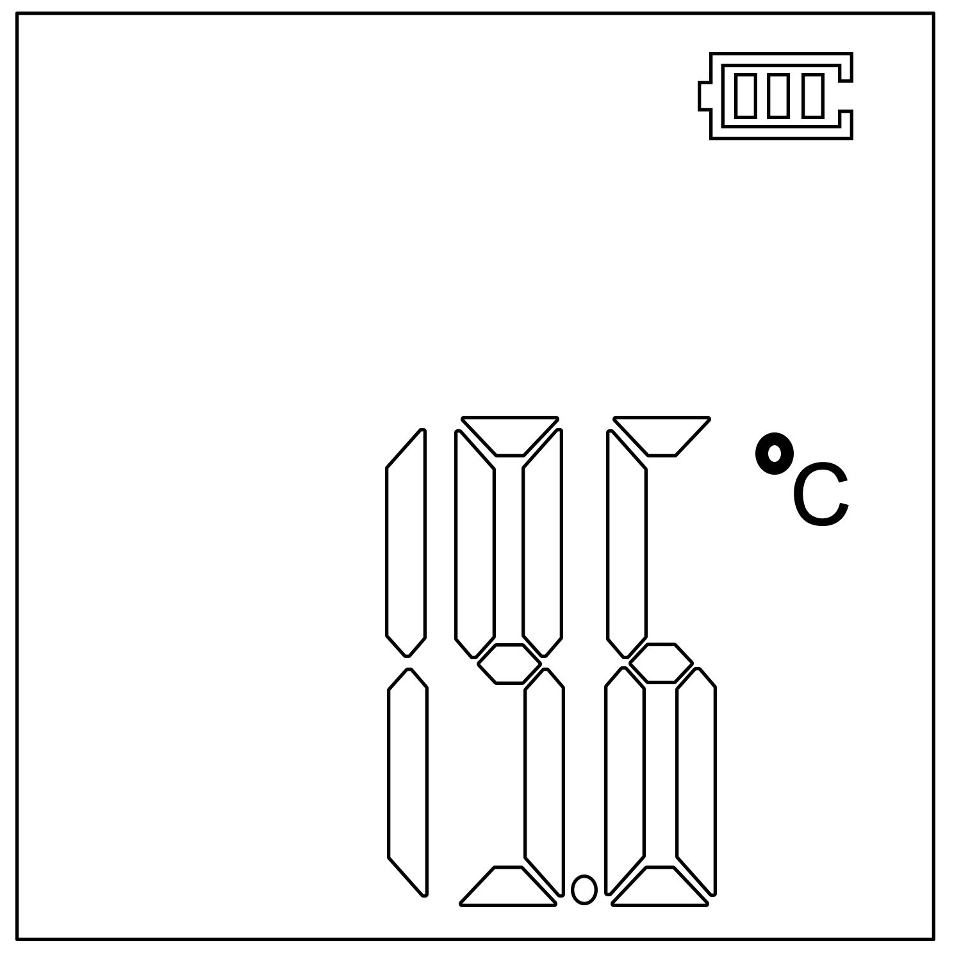
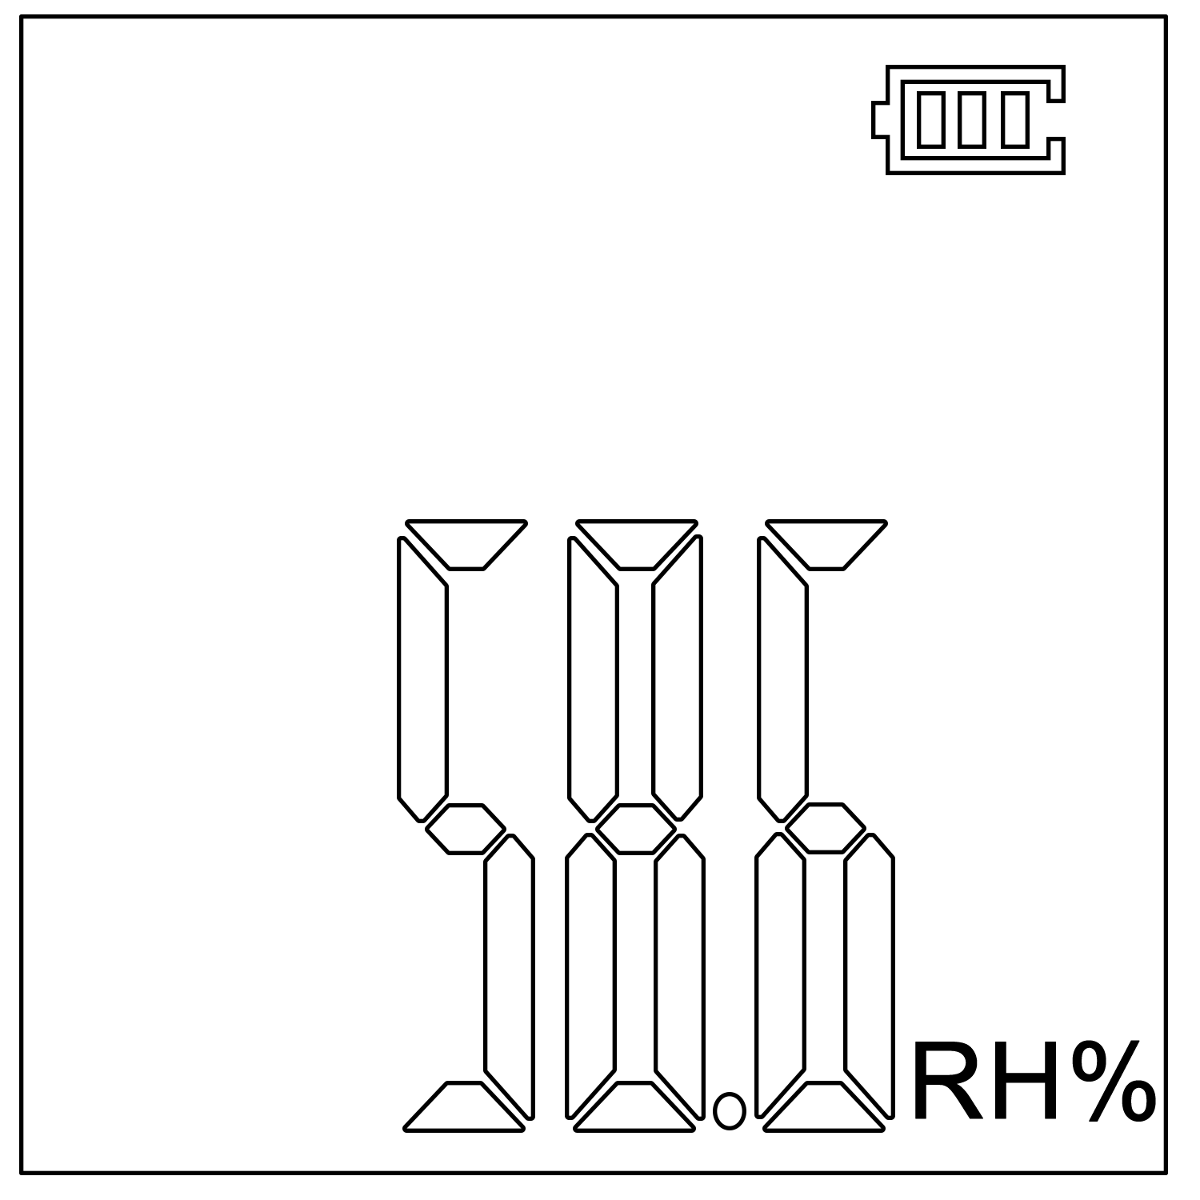

①Initialization (Temp) ②Initialization(RH)
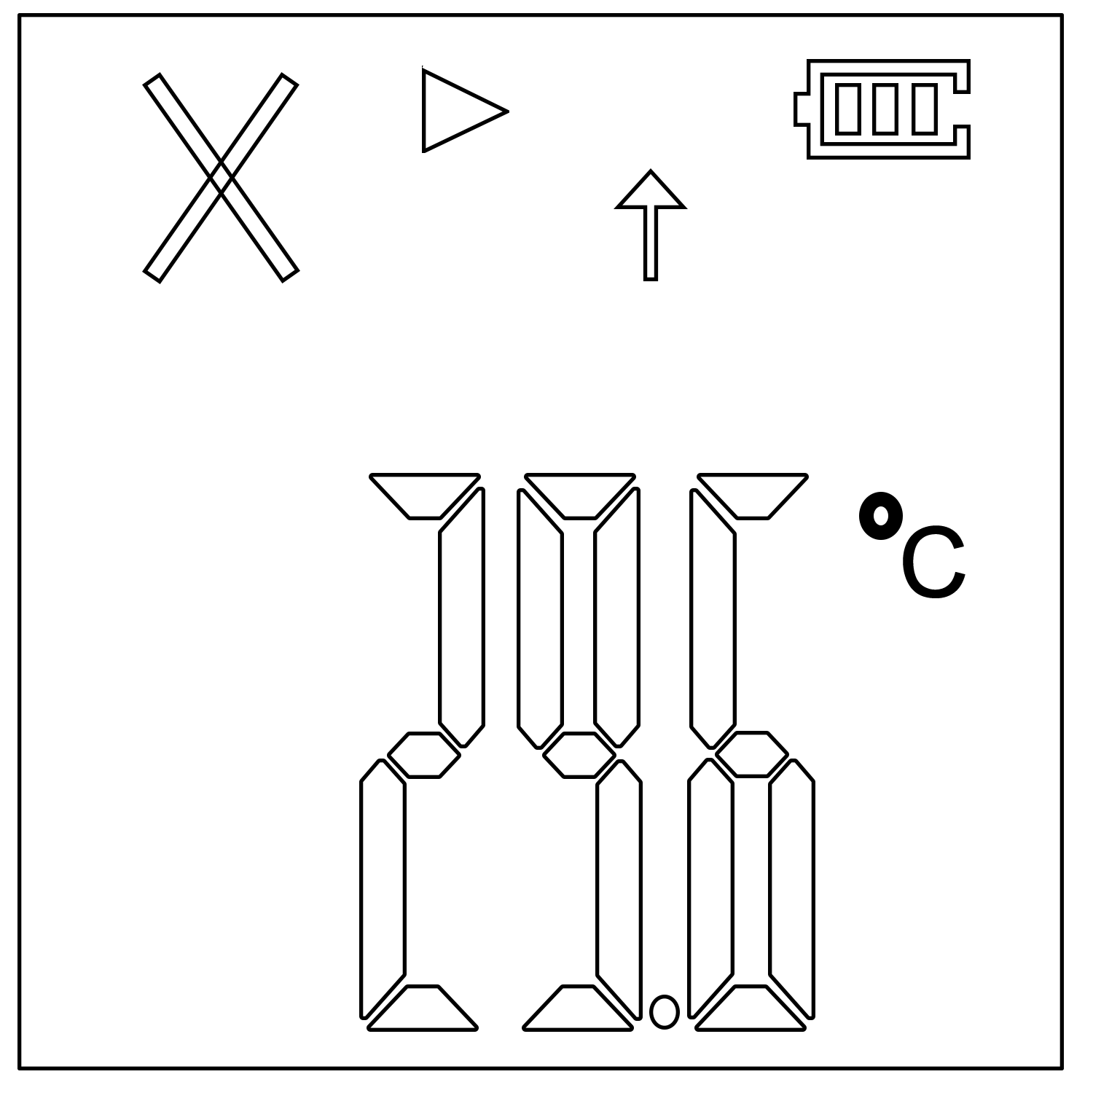
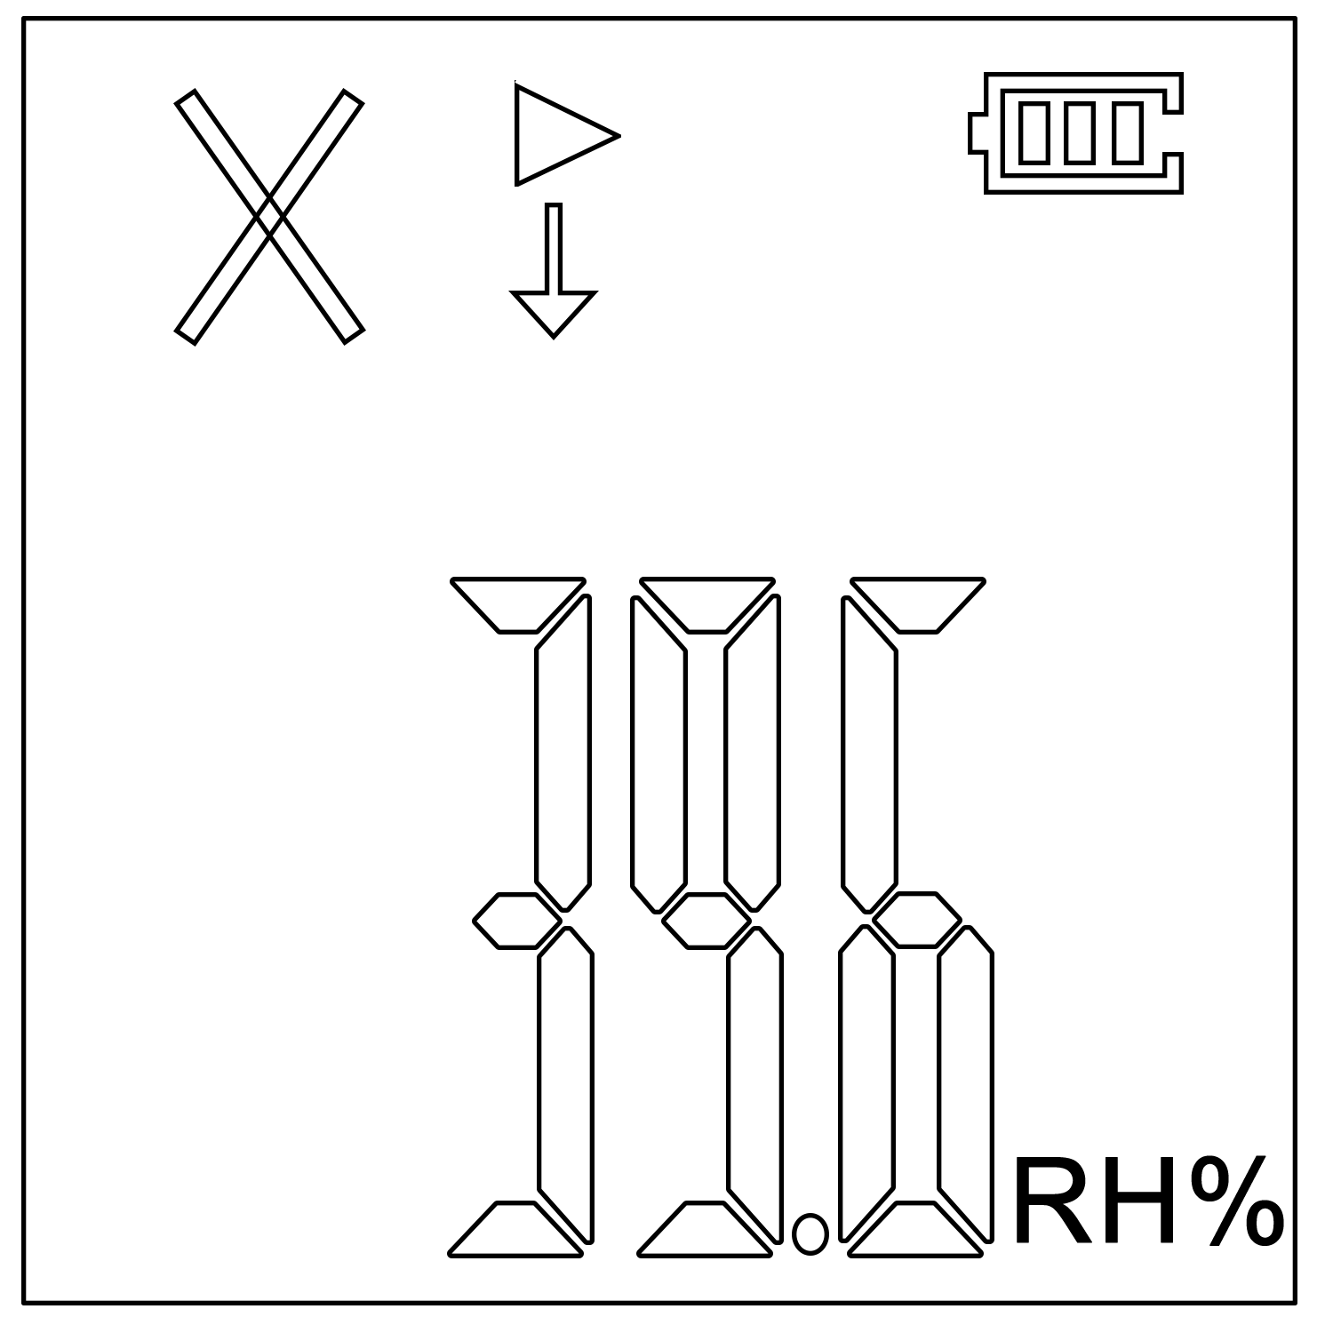

③Upper limit(Temp) ④Lower limit(RH)
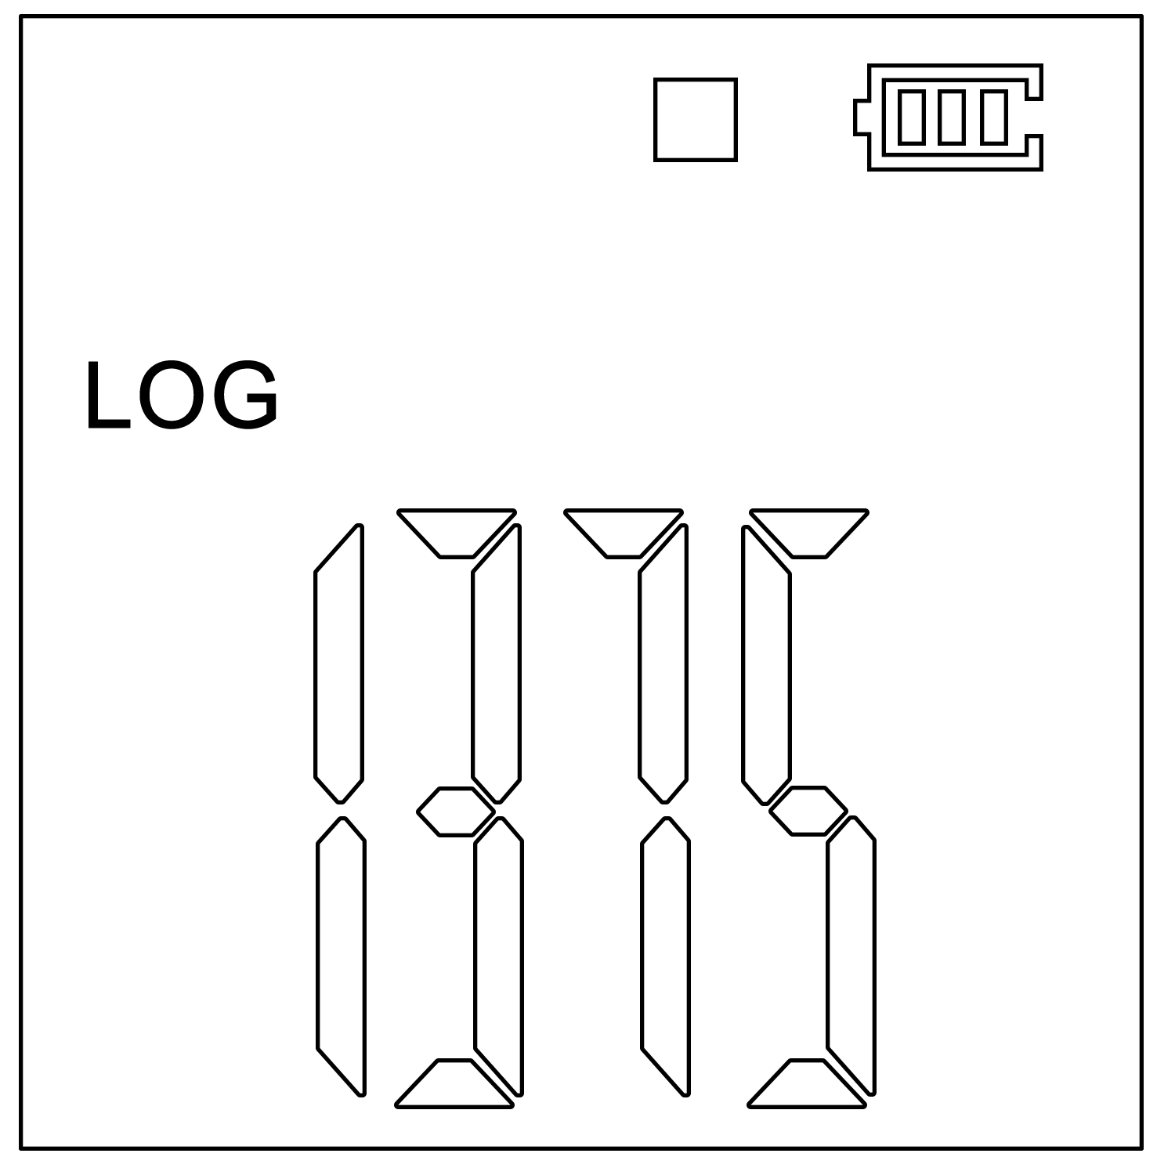
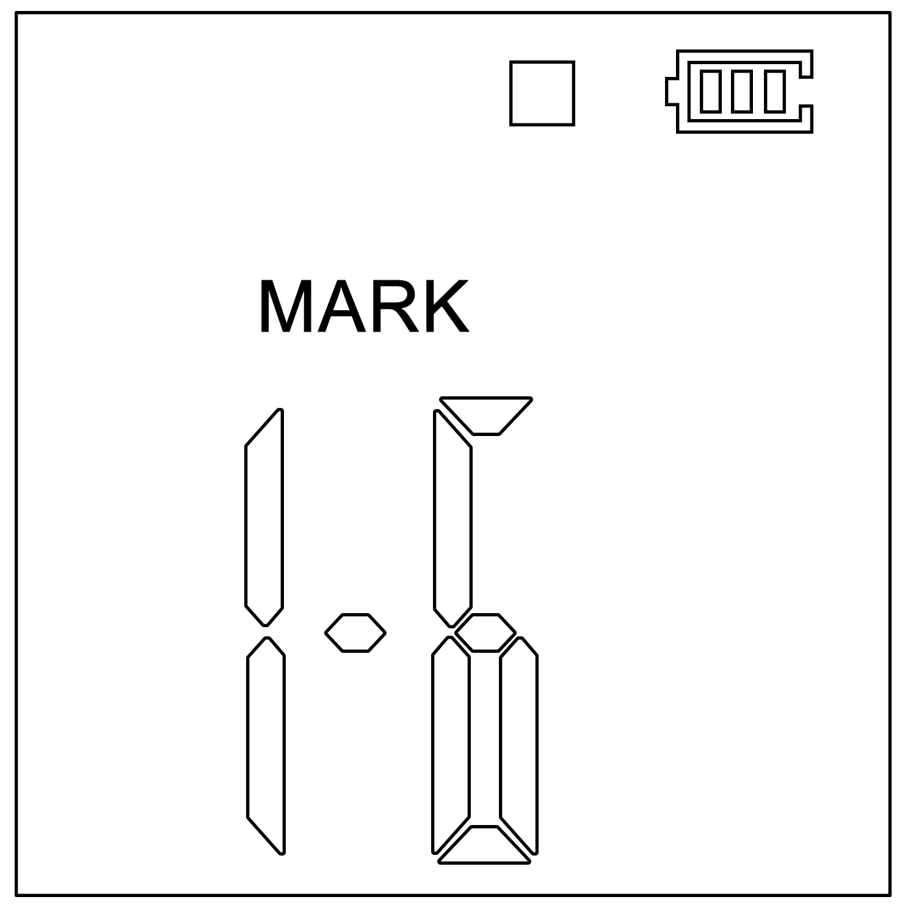

⑤Log interface ⑥Mark interface

7
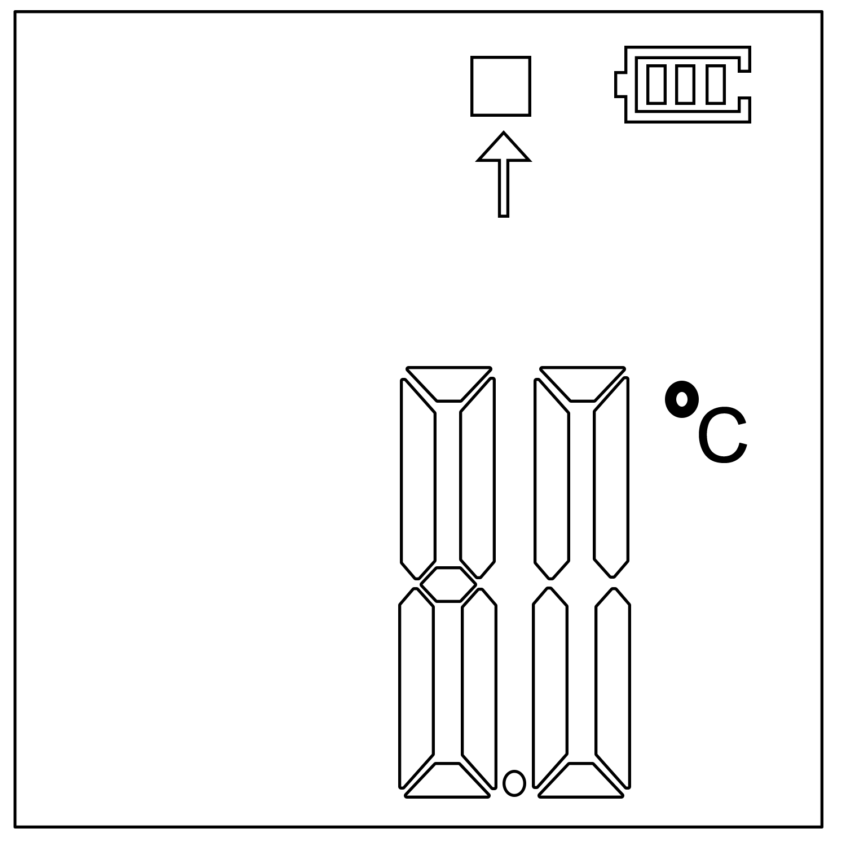
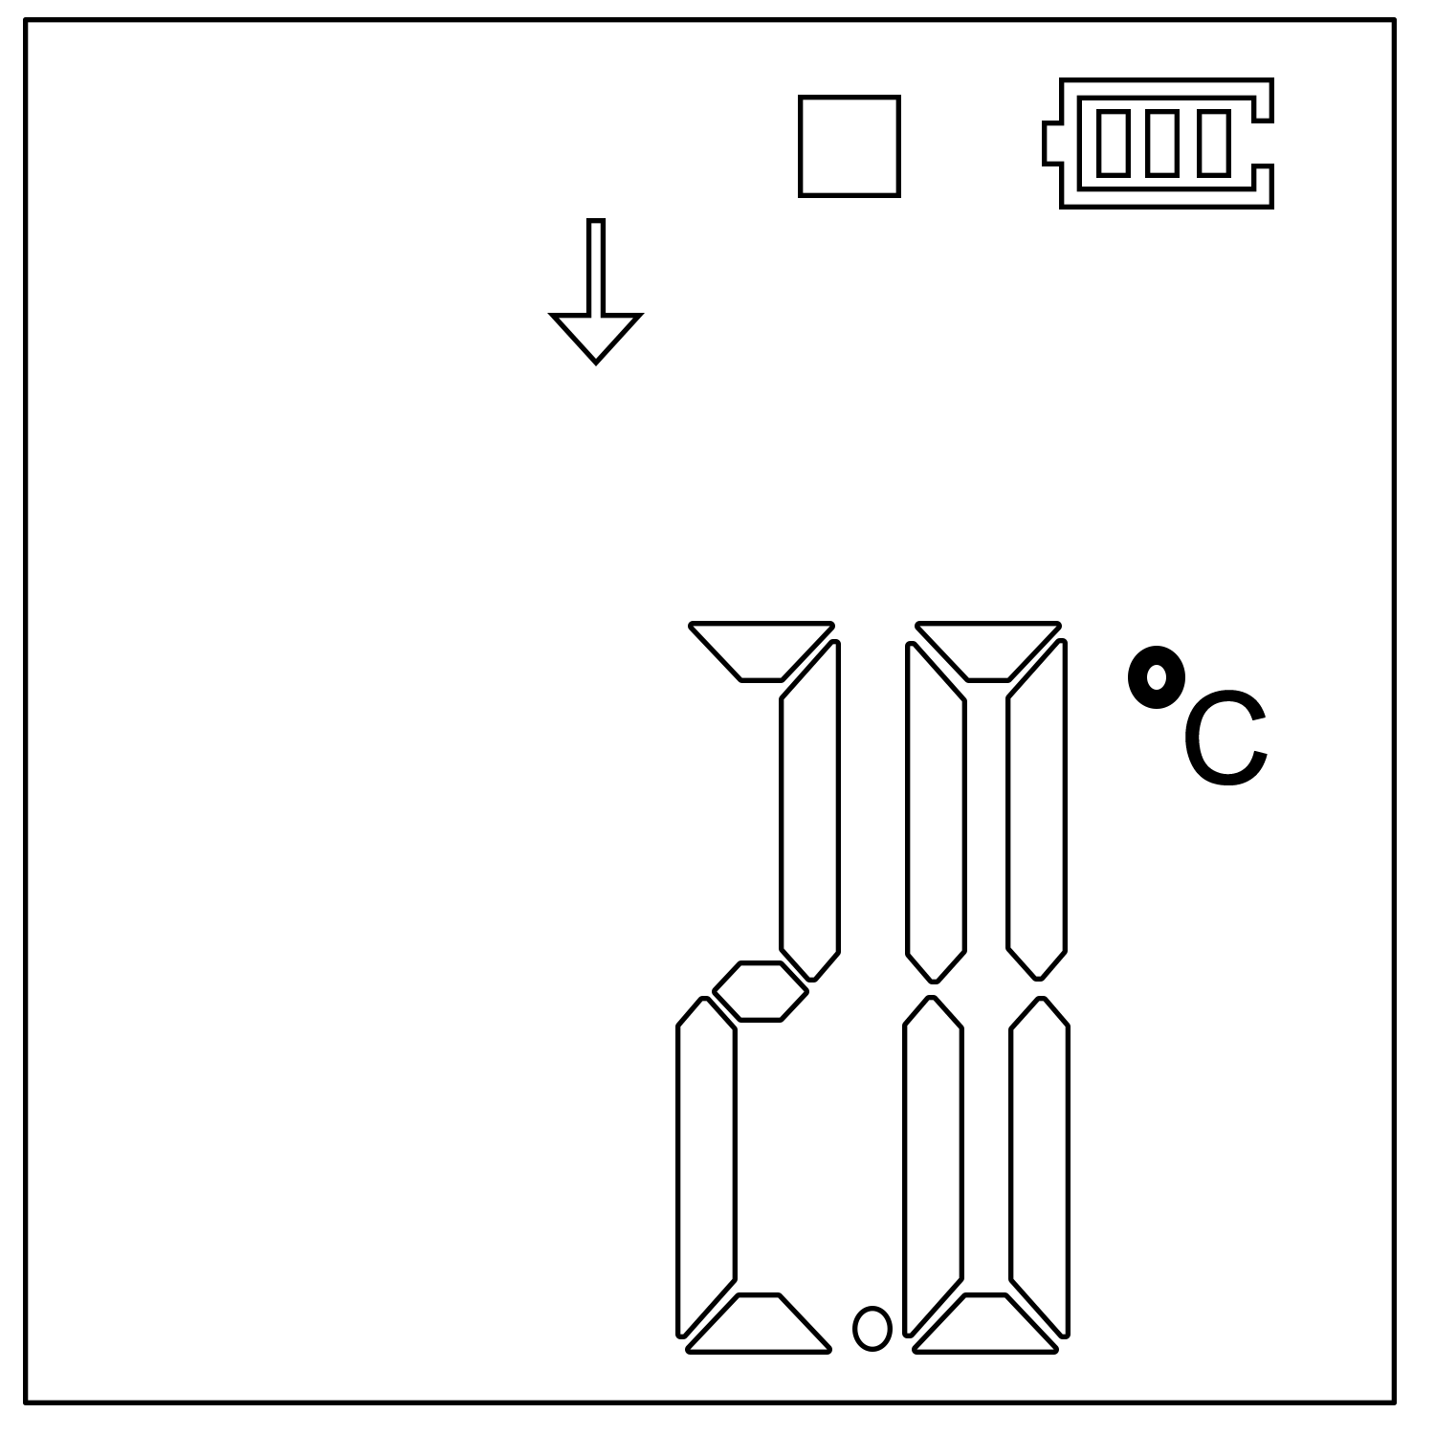

⑦Upper limit(Temp) ⑧Lower limit(Temp)
(Stop recording) (Stop recording)
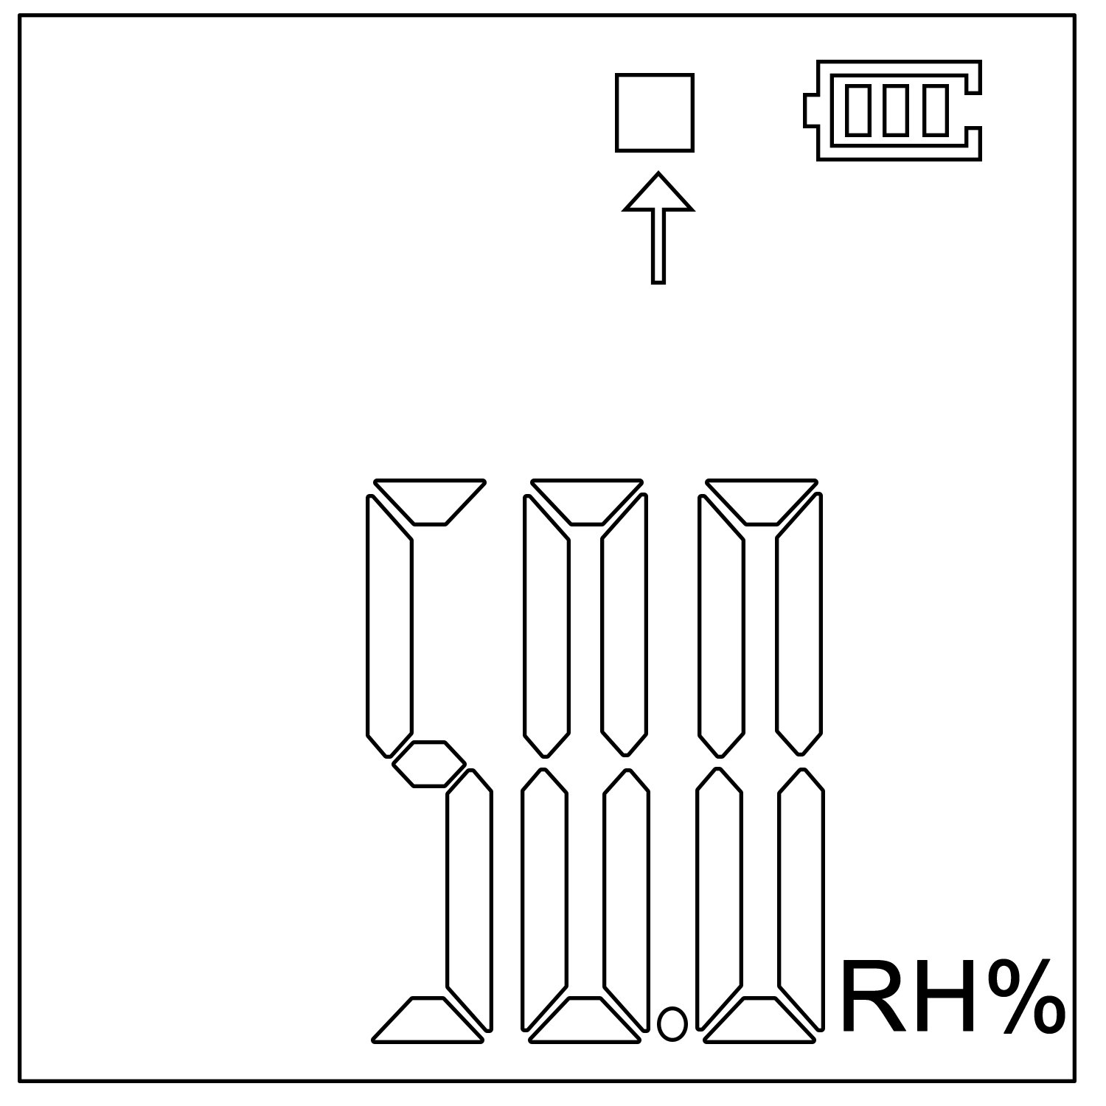
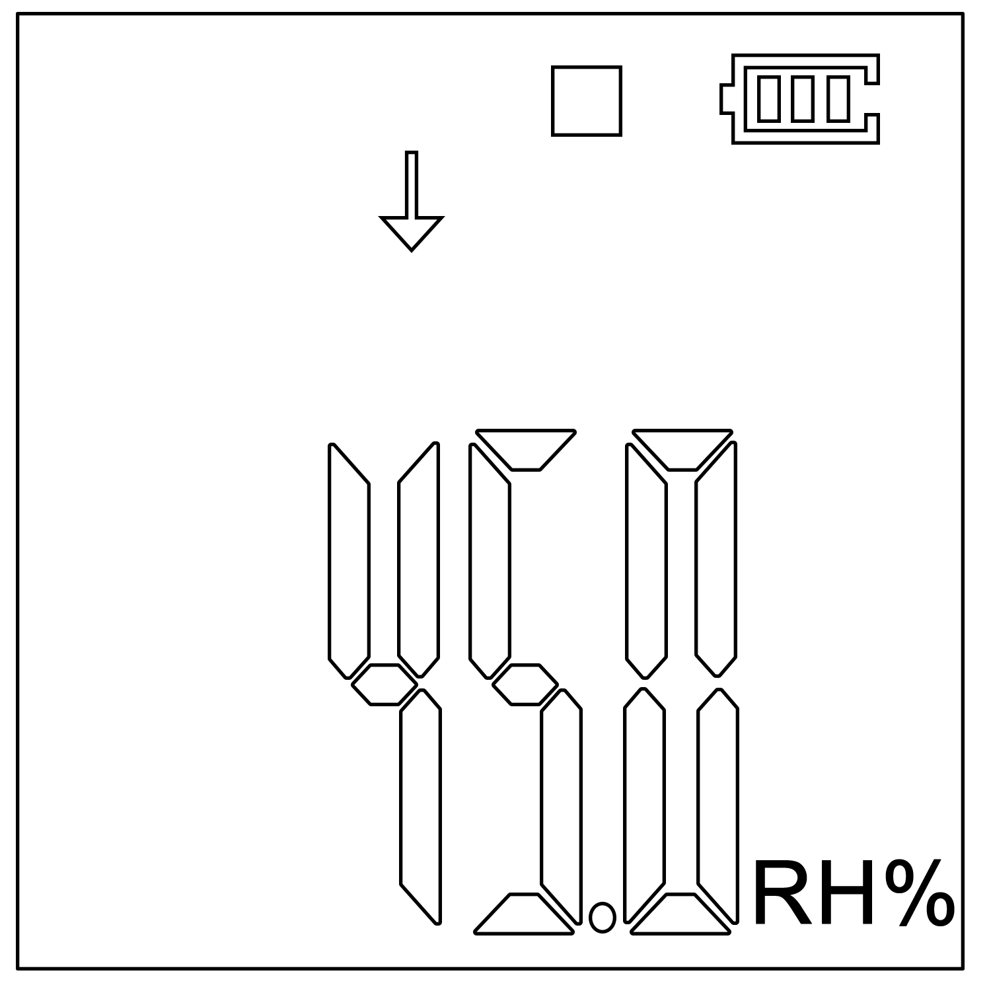

⑨Upper limit(RH) ⑩Lower limit(RH)
(Stop recording) (Stop recording)

8
▶ | Data logger is recording
■ | Data logger has stopped recording
WAIT | Data logger is in the status of start delay
√ | Temperature and humidity is within the limited range
“×” and “↑” light | Measured temperature and humidity exceeds its upper limit
“×” and “↓” light | Temperature and humidity exceeds its lower limit

9
Battery Replacement
- Turn the battery cover counterclockwise to open it.

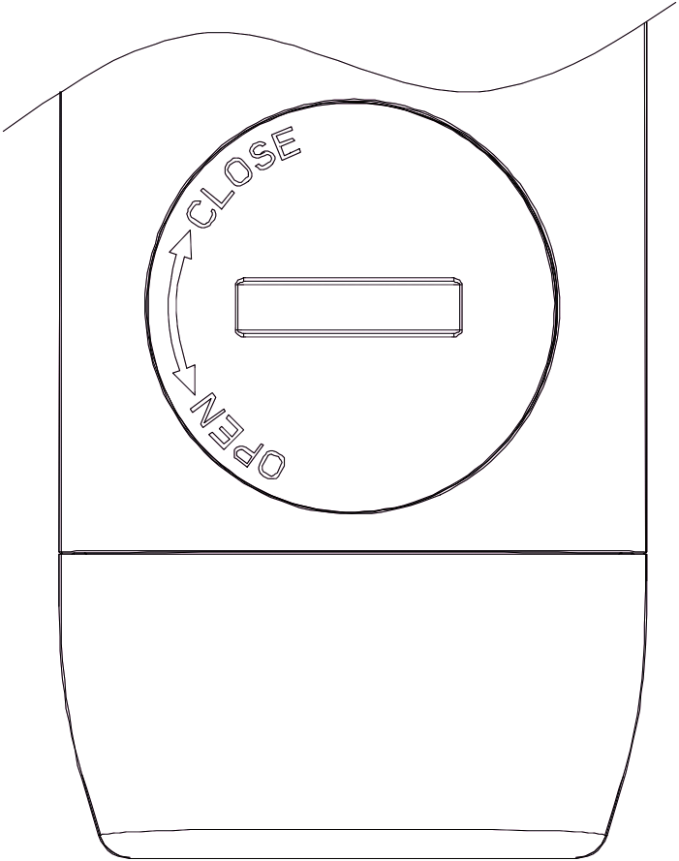
(Open status)
- Put in a new CR2032 button battery, with the negative inward.
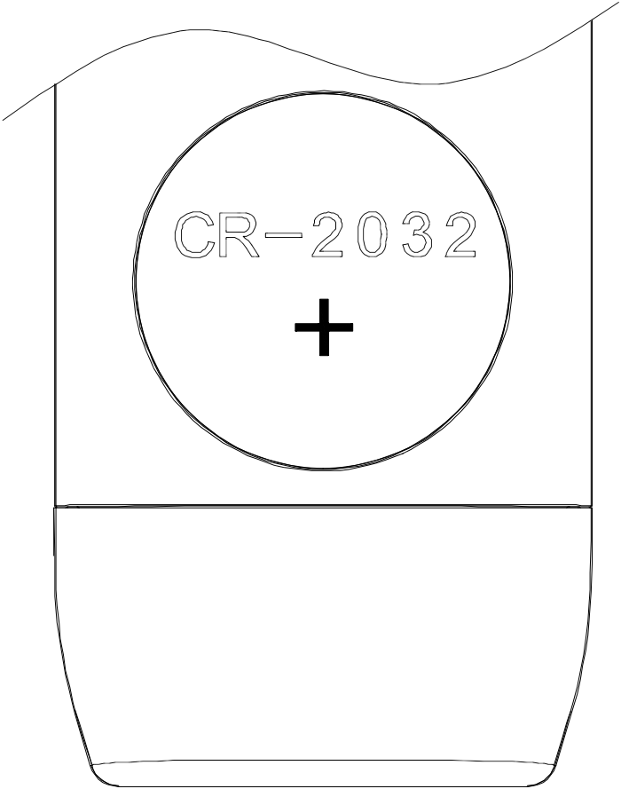
- Turn the battery cover clockwise to close it.
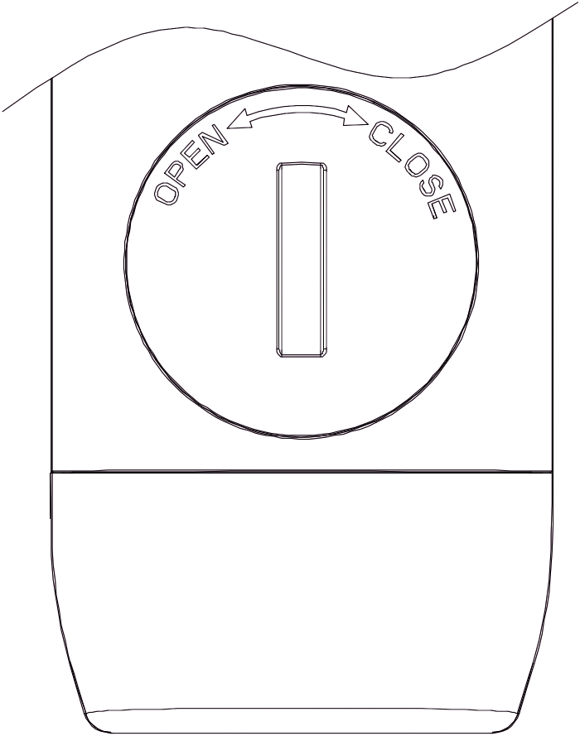
(Closed status)
10
Battery Status Indication
Battery | Capacity
 | Full
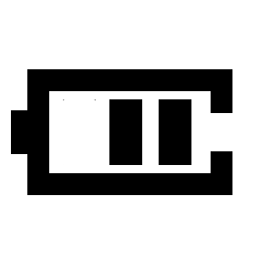 | Good
 | Medium
 | Low(please replace batery)
Precautions
- Please read the manual carefully before using the logger.
- It is recommended to check the battery status before restarting the logger to ensure that the remaining battery capacity could finish the recording task.
- The LCD screen will be off after 10 seconds of inactivity. Please press the “▶” button to lighten it.
11
- Never dismantle the battery. Do not remove it if the logger is running.
- Replace old battery with a new CR2032 button cell with the negative inward.
12

