54,5a,00,42,24,24,04,07,01,05,00,00,01,80,32,10,00,00,00,33,15,04,0c,10,2d,28,00,00,00,17,02,0a,03,10,02,60,27,bb,00,00,31,da,0a,03,10,02,60,27,bb,00,00,33,ba,00,0b,aa,00,0f,37,01,8a,00,f4,01,e2,00,00,93,42,b7,0d,0a

545a = TZ Start bits (convert to ASCII code)
0042 = 66 Packet length (Packet length from Protocol number
to CRC, Convert to decimal) means the packet length is 66 bytes
2424 = $$ Protocol number (convert to ASCII code)
0407 = 0407 Hardware type (Convert to decimal,means the hardware type is 0407)
0105 0000 = 1.05 Firmware version （Convert to decimal,means the firmware version is 1.05)
0180 3210 0000 0033=180321000000033 IMEI
（Ignore the upper four bits of the first byte，no need convert,
the IMEI is 180320000000003）
15 04 0c 10 2d 28 =2021 year, April, 12th, 16:45:40 ( convert each byte to decimal, the year byte need add 20 after convert)
00 00=0000 fixed code no mean
00 17=23 LBS length(Convert to decimal，means LBS data length is 23 bytes)
02= 2 The number of LBS（Convert to decimal）
0a= 00001010 Single LBS information（Convert to Binary， the bit 7-6 means the base station type, 00H-2G，01H-NB，10H-CATM1, the bit 3-0 convert to decimal means single LBS data length is 10）
03 10=310 MCC(no need convert)
02 60=260 MNC(no need convert)
27 bb= 10171 LAC （Convert to decimal）
00 00 31 da=12762 CELL ID（Convert to decimal）
0a=10 Single LBS information（Convert to decimal，means single LBS data length）
03 10=310 MCC(no need convert)
02 60=260 MNC(no need convert)
27 bb=10171 LAC （Convert to decimal）
00 00 33 ba=13242 CELL ID（Convert to decimal）
00 0b= 11 Status data length （ Convert to decimal ）
aa=alarm type( no need convert) AA means interval gprs data( means this data is normal data, no alarm)
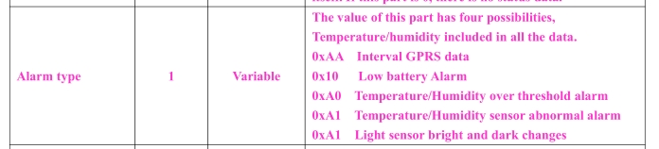
00=00 Terminal information（Convert to decimal）
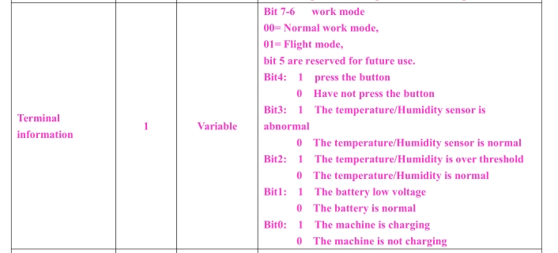
0f=15 CSQ value(GMS signal strength, Convert to decimal ）
37= 00110111 GSM state （convert to Binary）
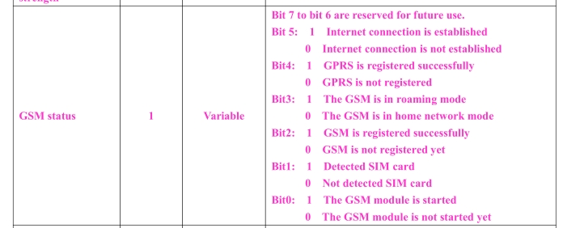
01 8a=3.94V Battery voltage （ Convert to decimal 394，unit：10mv）
00 f4=24.4 ℃ temperature
00 f4 covert to Binary 0000000011110100
bit15 if temperature sensor is normal or abnormal：0-normal，1-abnormal
Bit 14 means ± (0-means +，1-means -)
bit0-13 temperature value
0000011110100 Convert to decimal=244, unit：0.1℃，24.4℃
01 e2=48.2% humidity (Convert to decimal 482，unit：0.1%，48.2%)
00= dark( light sensor, convert to Binary，bit=0，light，bit=1，dark)
00 93= 147 Packet index（ Convert to decimal , means the 147th data）
42 b7=42b7 CRC（no need convert）
0d 0a= Stop bit（ convert to ASCII code ）

