**Run the TZ-TT18 easily and FAQ (V2.1)**

**Steps how to run the machine easily.**

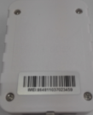 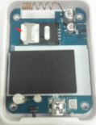

Step1: Unscrew the device Step2: Install the GRPS SIM card

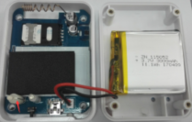 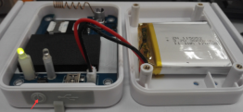

Step3: Plug in the battery Step4: Turn on by pressing the button for 5~8 seconds

Note: 1. The left LED light will blink for 10 second in red and green exchange when do the Step3.

2. The left LED light will blink for 10 second in red and green exchange after releasing the button when do the step4.

3. There are two possibilities if the left LED light doesn’t blink after pressing the button.

a. The pressing time of the button is over 8 seconds

b. The device is on turn on mode already. You can check the device working status by pressing the button for 0.5 second.

Please note that the device can only be turned on instead of turning off by the button. Please send the “005” command by SMS or configure software or the server downstream if you’d like to turn off the device.

You can monitor the real-time temperature and humidity data on the web cloud platform, TT18 default every 5 minutes send a data to server

**Two ways to monitor the temperature and humidity data**

1. Temperature and humidity web cloud platform.

Website: **<http://t.tzonedigital.cn/>**

Please register an account and add your device to the platform. Then there will be real-time data on the platform after 5 mins once your device is running.

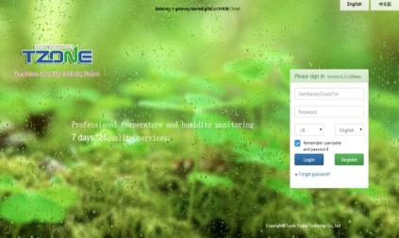 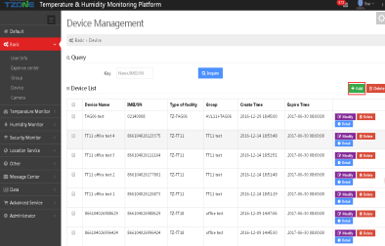 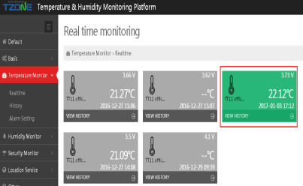

1. Open temperature and humidity platform for quering data quickly.

Website: **http://t-open.tzonedigital.cn/**

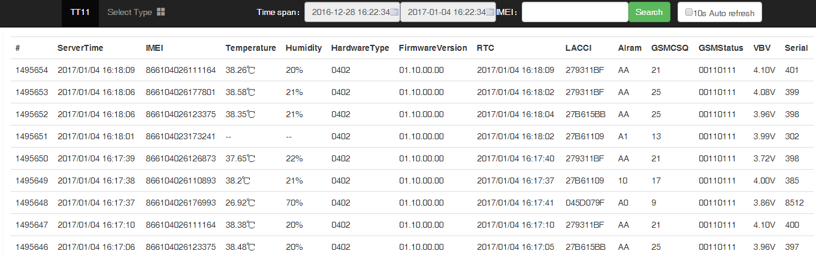

Remark: 1. Please choose your device type before quering.

2. There are seven-days data at most on the platform at the same time.

**FAQ**

Q1. **Already run the machine, but there is still no data appeared on the temperature web cloud platform. (<http://t.tzonedigital.cn/>)**

Please kindly press the button for 0.5 seconds and release it. Check the left LED light working status.

If the left LED light blinks in green, it shows that the device works well.

(1) please kindly query the data on the open platform (http://t-open.tzonedigital.cn/) to see whether there is data. If there is data on the open platform. The problem may be that you added wrong IMEI to the temperature web cloud platform.

If the left LED light blinks in red, it shows that there is something wrong with the device. Please skip the step(1) and continue to test the device according to the following step (2)

1. Test the SIM card on your cellphone to see whether you can send massage and surf the Internet successfully. If not, please kindly change a SIM card with telephone bill and traffic. If yes, please continue to test the device according to the step (3)
2. Please insert the SIM card to the device and using your cellphone to send a command via SMS to the device. (Command *000000,000# )

If there is massage replied: the GSM signal is normal, the client has to set the APN of the SIM card.

If there is no massage replied: the GSM signal is not normal. Please check whether the SIM card is installed well. Or suggest to get a new SIM card from another operator.

1. If there is still no data appeared on the temperature web cloud platform after tried above (1)(2)(3)steps. Please using the USB configure cable to connect the device and computer. Read the LOG of the device via the configuration software. And send the LOG data to us for analysis. The more information, please contact with your sales representative.

**Q2. There is intermittent data on the temperature web cloud platform**

A2: Please query the data on the open platform <http://t-open.tzonedigital.cn/> to see the CSQ value.

If the CSQ value is below 10, then the GSM signal is not good. Please move the device to another environment test.

If the CSQ value is higher than 15, then the GSM signal is normal. It may be caused by the bad GSM internet. Please wait for a while. If the data is still intermittent, then suggest to get a new SIM card test from another operator.