Portable Thermal Printer
SP-RMTⅢ/T10

Commands Manual
(VER 1.00)

Beijing Spirit Technology Development Co., Ltd.

www.sprt-printer.com

Index
Character control command 3
HT 3
LF 3
CR 3
DLE EOT n 4
ESC SP n 5
ESC ! n 6
ESC $ nL nH 7
ESC % n 7
ESC & y c1 c2 [x1 d1...d(y × x1)]...[xk d1...d(y × xk)] 7
ESC * m nL nH d1... dk 9
ESC - n 11
ESC 2 12
ESC 3 n 12
ESC = n 12
ESC ? n 12
ESC @ 13
ESC D n1...nk NUL 13
ESC E n 14
ESC G n 14
ESC J n 14
ESC M n 15
ESC R n 15
ESC U n 16
ESC V n 16
ESC W n 16
ESC \ nL nH 17
ESC a n 17
ESC c n 18
ESC c 5 n 18
ESC d n 18
ESC i 19
ESC t n 19
ESC { n 20
FS I n 21
FS P n 21
GS ! n 22
GS ( A pL pH n m 23
GS ( D pL pH m [a1 b1] … [ak bk] 23
GS * x y d1...d(x × y × 8) 24
GS / m 25
GS B n 25
GS I n 26
GS L nL nH 27
GS P x y 28
GS W nL nH 28
GS a n 29
Chinese Control Commands 31
FS ! n 31
FS & 32
FS – n 32
FS . 33
FS 2 c1 c2 d1...dk 33
FS C n 34
FS S n1 n2 34
FS W n 35
Commands of printing 1D barcode 36
GS H n 36
GS f n 36
GS h n 36
① GS k m d1...dk NUL②GS k m n d1...dn 37
GS w n 39
Print commands of 2D code 40
GS Z n 40
ESC Z m n k dL dH d1 …dn 40
① GS k m v r d1...dn NUL ②GS k m v r nL nH d1...dn 41
GS v 0 m xL xH yL yH d1 … dk 43
Appendix A: 128 code 44
Appendix B: the pre-print black mark description 48
Appendix C：Thai Character Rules 48

Format specification
This section shows how to read and use the instructions of the manual. Please read it before programming.
This commands manual includes the below parts：
- Description of Name and function of the command. This is the first part of the command instruction, which provide the command of ASCII form and the function description.
- 2) Format. In this part, using three kinds of form: the ASCII,HEX and Decimal, to describe the command. The default is Decimal if have no especial description, For example: 1 ≤ n ≤ 4,1 is Decimal 1, not the ASCII code 1.
- Scope. Provide the scope of the Variable。
- Description. Provide the detailed explanation of the command.。
- Notice. Provide some notes of the command. Commands under different mode, or coordinating with different commands may cause interaction, so we provide some details here.
- Reference. Provide some other commands which are interrelated or similar.

---> DLE EOT n Real time transmission status
---> [Format] ASCII DLE EOT n
Hex 10 04 n
Decimal 16 4 n
---> [Range] 1 ≤ n ≤ 4
---> [Description] Sending the printer state that designated by parameter n just in time
---> [Notice] When printer receives the command, returns to the interrelated status immediately….
---> [Reference]

Character control command

HT

[Name] Horizontal tab
[Format] ASCII HT
Hex 09
Decimal 9
[Description] Moves the print position to the next horizontal tab position.
[Notice] • This command is ignored unless the next horizontal tab position has been set.
• If the next position of horizontal tab exceeds the printing area, the current position will be set as [printing width+1].
• Horizontal tab positions are set with ESCD.
•If the current position is at [ printing width+1] when receives the command, the printer will carry out the action in row buffer and move the printing position to the Zero position of next line.
•The default value of tab position is every 8 standard ASCII characters (12*24) a tab.
•When the current row buffer is full,the printer will carry out the action below:
Under standard mode,printer prints the content of current row and sets the
Printing position at the zero position of next line
[Reference] ESC D

LF
[Name] Printing and feeding line
[Format] ASCII LF
Hex 0A
Decimal 10
[Description] Printing the datas in the print buffer and feeds one line
[Notice] This command sets the print position to the beginning of the line.
[Reference] ESC 2, ESC 3

CR

[Name] Printing and entering
[Format] ASCII CR
Hex 0D
Decimal 13
[Description] the same as LF when the command is permitted, if not , it will be ignored.
[NOTICE] ·Setting the printing position at the beginning of the line.
[Reference] LF

DLE EOT n

[Name] Real time status transmission
[Format] ASCII DLE EOT n
Hex 10 04 n
Decimal 16 4 n
[Range] 1 ≤ n ≤ 4
[Description] Sending the printer state that designated by parameter n just in time：
n=1：Sending state of the printer
n=2：Sending off line state
n=3：Sending error state
n=4：Sending state of paper sensor
[Notice] ·-When printer receives the command, returns to the interrelated status immediately
··Avoiding to put this command in the command sequence of more than2
characters.
·This command will beal so valid even though the printer is set to be forbidden by the Command of ESC=(selectingperpheral).
· When sending printer current state,each state is indicated by 1byte
·Transmission state value of the printer cannot confirm whether the master
Computer received or not.
·Printer will carry out the command immediately once received
·This command is unavailable to the parallel printer. The printer will carry out the command immediately under any state
n = 1: Printer status
Bit | 0/1 | HEX | Decimal | Fuction
0 | 0 | 00 | 0 | Fix as 0
1 | 1 | 02 | 2 | Fix as 1
2 | 0 | 00 | 0 | Fix as 0
3 | 0 | 00 | 0 | online
3 | 1 | 08 | 8 | offline
4 | 1 | 10 | 16 | fix as 1
5,6 | - | - | - | fix as 1
7 | 0 | 00 | 00 | fix as 0
n = 2: off line status
Bit | 0/1 | HEX | Decimal | Function
0 | 0 | 00 | 0 | fix as 0
1 | 1 | 02 | 2 | fix as 1
2 | 0 | 00 | 0 | fix as 0
3 | 0 | 00 | 0 | Not holding down the feed button
3 | 1 | 08 | 8 | holding down the feed button
4 | 1 | 10 | 16 | fix as 1
5 | 0 | 00 | 0 | Printer is not out of paper
5 | 1 | 20 | 32 | Printer is out of paper
6 | 0 | 00 | 0 | No error state
6 | 1 | 40 | 64 | error state
7 | 0 | 00 | 0 | fix as 0
n = 3: error state
Bit | 0/1 | HEX | Decimal | Function
0 | 0 | 00 | 0 | fix as 0
1 | 1 | 02 | 2 | fix as 1
2 | - | - | - | undefined
3 | 0 | 00 | 0 | fix as 0
4 | 1 | 10 | 16 | fix as 1
5 | 0 | 00 | 0 | fix as 0
6 | 0 | 00 | 0 | noun auo recoverable error
6 | 1 | 40 | 64 | have auto recoverable error
7 | 0 | 00 | 0 | fix as 0
n = 4: paper sensor status
Bit | 1/0 | HEX | Decimal | 功能
0 | 0 | 00 | 0 | fix as 0
1 | 1 | 02 | 2 | fix as 1
2,3 | 0 | 00 | 0 | fix as 0
4 | 1 | 10 | 16 | fix as 1
5,6 | 0 | 00 | 0 | lack of paper sensor: have paper
5,6 | 1 | 60 | 96 | lack of paper sensor: noun paper
7 | 0 | 00 | 0 | fix as 0
[Reference] DLE ENQ, GS a, GS r

ESC SP n
[Name] Setting the right space of characters
[Format] ASCII ESC SP n
Hex 1B 20 n
Decimal 27 32 n
[Range] 0 ≤ n ≤255
[Description] Setting the right space of character for [n*units of vertial or lateral shifting]
[Note] -When the character enlarges, the space enlarges the sametimes.
- This command is valid for both Characters and Chinese.
- Units of vertical or lateral shifting area pointed by GSP. Changing units of vertical or lateral shifting does not change the current right space.
- The maximum right space is 255/203 inches. If setting beyond this value, it will
automatically change into the maximum distance.
[Default] n = 0
[Reference] GS P

ESC ! n
[Name] selecting print mode
[Format] ASCII ESC ! n
Hex 1B 21 n
Decimal 27 33 n
[Range] 0 ≤ n ≤ 255
[Description] Setting character print mode according to value of n

Bit | 1/0 | HEX | Decimal | Function
0 | 0 | 00 | 0 | Standard ASCII style A (12×24)
0 | 1 | 01 | 1 | Compressing ASCII style B(9×17)  ( When choosing ESC/POS commands set; Font is 8x16; 16x16)
1,2 | 0 | 00 | 0 | Undefined
3 | 0 | 00 | 0 | Cancel bold font
3 | 1 | 08 | 8 | Select bold font
4 | 0 | 00 | 0 | Cancel double height mode
4 | 1 | 10 | 16 | Select double height mode
5 | 0 | 00 | 0 | Cancel double width mode
5 | 1 | 20 | 32 | Select double width mode
6 | 0 | 00 | 0 | undefined
7 | 0 | 00 | 0 | Cancel underline mode
7 | 1 | 80 | 128 | Select underline mode

[Notice] -When selected double height or double width mode, double size characters are printed.
-Any character can be added underline except the space set by HT and the
characters clock wise 90 degrees.
-Underline is not related to characters but confirmed by ESC-. This command is one dot width.
-When some characters in a line are double or more height, all the characters on the line are aligned at the base line.
-ESC E can also select or cancel bold font. However, the command of the setting of the last received command is effective.
-ESC- can also turn on or off underline mode. However, the setting of the last received command is effective.
-GS ! can also set the character boundary. However, the setting of the last received command is effective.
- All effects are valid to both Characters and Chinese.
[Default] n = 0
[Reference] ESC -, ESC E, GS !

ESC $ nL nH
[Name] Setting absolute print position
[Format] ASCII ESC $ nL nH
Hex 1B 24 nL nH
Decimal 27 36 nL nH
[Range] 0≤nL ≤ 255
0 ≤nH≤255
[Description] Setting the distance from the beginning of the line to the position at which（nL+
nH×256）×(vertical or horizontal motion unit)
[Notice] ·This command is ignored if the setting position is out of the printing area.
·Vertical and horizontal motion units are set by GS P.
[Reference] ESC \, GS $, GS \, GS P

ESC % n
[Name] Selecting/Canceling self defined character
[Format] ASCII ESC % n
Hex 1B 25 n
Decimal 27 37 n
[Range] 0 ≤ n ≤ 255
[Description] Selecting/Canceling self defined character
·When n(LSB)=0，cancel user defined characterset.
·When n(LSB)=1，select user defined characterset.
[Notice] ·When cancel user defined character set, auto select built in character set.
· only n in LSB is available.
[Default] n = 0
[Reference] ESC &, ESC ?

ESC & y c1 c2 [x1 d1...d(y × x1)]...[xk d1...d(y × xk)]
[Name] Define user defined character
[Format] ASCII ESC & y c1 c2 [x1 d1...d(y × x1)]...[xk d1...d(y × xk)]
Hex 1B 26 y c1 c2 [x1 d1...d(y × x1)]...[xk d1...d(y × xk)]
Decimal 27 38 y c1 c2 [x1 d1...d(y × x1)]...[xk d1...d(y × xk)]
[Range] y = 3
32 ≤ c1 ≤ c2 ≤ 126
0 ≤ x ≤ 12 standard ASCII style A(12×24)
0 ≤ x ≤ 9 compressing ASCII style B (9 × 17)
0 ≤ d ≤ 255
k = c2 – c1 +1
[Description] Define user defined character
· y specify the vertical byte number
·c1 specify the code of initial character, c2 specify the code of terminal character.
·x specify the vertical byte number
[Notice] · The code range of defined character:from<20>H to<7E>H. (90 characters)
· Can define the continuous codes for several characters.When only one character is needed,c1=c2.
·d is the dot data of the downloaded character. Data of each dot begins from the left.
· Defining the data of user defined character is (y×x)bytes.
· Each dot of data is 1 to print this dot; or 0 to not print.
· The user defined characters will be deleted in the following situation:
- ESC @ is carried out
- ESC ？ is carried out
- FS q is carried out
- GS * is carried out
- Two barcode printing is carried out.
- The printer reset or power off.
- ·Only the MSB is valid at the vertical third byte when the selt defined characters are style B(9*17).
[Default] Built incharacter set.
[Reference] ESC %, ESC ?
[Example] ·When select the standard ASCII style(12×24)
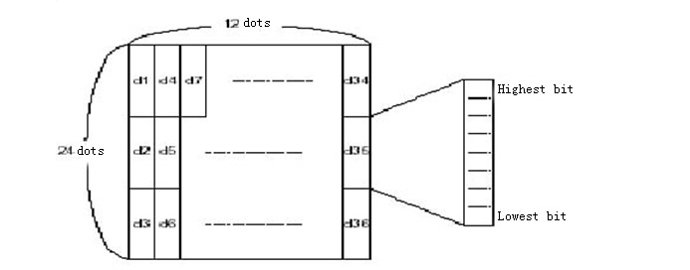
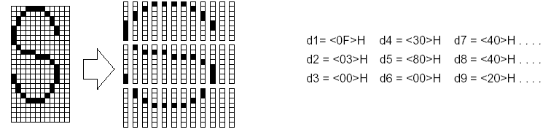

· When select the compressing ASCII style (9×17)
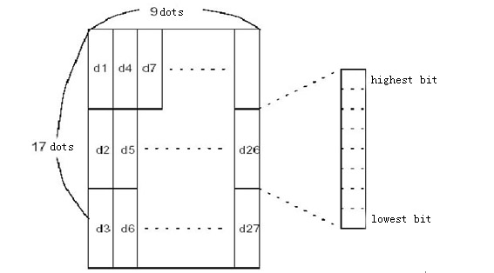
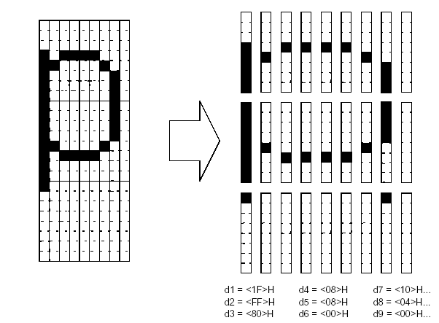

ESC * m nL nH d1... dk
[Name] Selecting bit map mode
[Format] ASCII ESC * m nL nH d1...dk
Hex 1B 2A m nL nH d1...dk
Decimal 27 42 m nL nH d1...dk
[Range] m = 0, 1, 32, 33
0 ≤ nL ≤ 255
0 ≤ nH ≤ 3
0 ≤ d ≤255
[Description] Selects a bit map mode appointed by m for the number of dots specified by nL and nH, as follows:
m | Mode | Vertical |  | Horizontal
m | Mode | dots | Dpi | Dpi | No.of datas（k）
0 | 8SD | 8 | 68 DPI | 101 DPI | nL + nH × 256
1 | 8DD | 8 | 68 DPI | 203 DPI | nL + nH × 256
32 | 24SD | 24 | 203 DPI | 101 DPI | ( nL + nH × 256) × 3
33 | 24DD | 24 | 203 DP | 203 DPI | ( nL + nH × 256) × 3

[Notice] ·If the value of m goes beyond the range,nl and the datas later will be regarded as normal datas to deal with.
· The dots number of horizontal printing depends on nL and nH,total number is nL+nH×256。
·The part of the bit map that goes beyond the current area will be cut off
·d is the data of bit map. Printing when the relevant position of every byte is1, and when it is 0,will not print this point.
·The printer will return to the mode of normal data processing after send the data of bit map.
·Except inversion mode, this command will not be influenced by other modes.（black、double print、underline、enlarge character and invert）
·Relationship between data and printing point is as below：
· chosing 8 dots density：
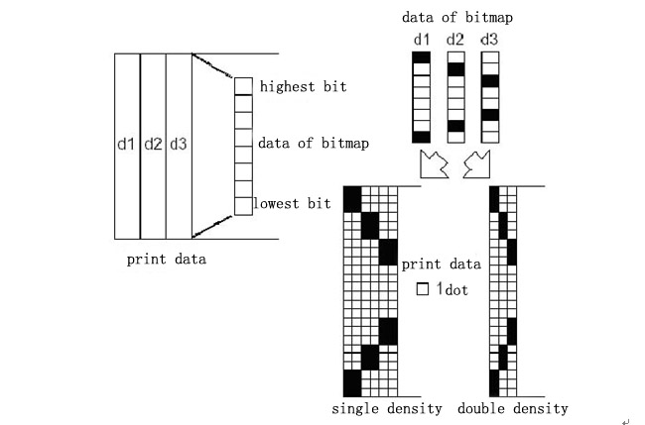

· chosing 24 dots density：
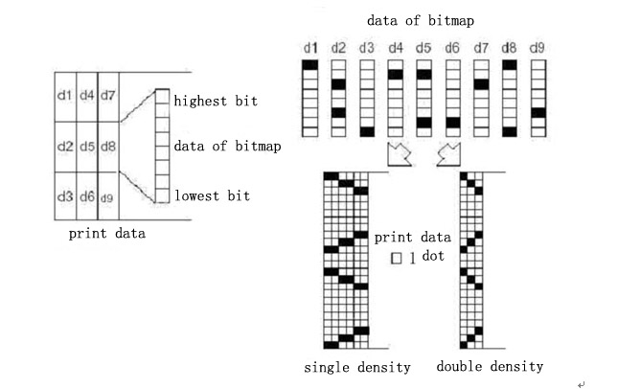

ESC - n
[Name] Select／cancel underline
[Format] ASCII ESC - n
Hex 1B 2D n
Decimal 27 45 n
[Range] 0 ≤ n ≤2, 48 ≤ n ≤ 50
[Description] Selecting or canceling the underline mode according to the value of n
n | Function
0, 48 | Cancel underline mode
1, 49 | Select underline mode(1dot width)
2, 50 | Select underline mode(2dots width)
[Notice] ·Underline can be added under all characters (including right spacing),but not including the space set by HT
·The underline cannot act on the characters of clockwise 90 degrees and inverting
·The width of the underline will not be changed, and the character rest will not be underlined when cancel the underline mode. The default width is 1dot width.
·Changing the character boundary will not influence the current underline width
·Selecting/canceling the underline can also be set by ESC!.However,the setting
of the last received command is effective.
·The command doesn’t affect the Chinese character setting.
[Default] n = 0
[Reference] ESC !

ESC 2
[Name] Setting default height of line
[Format] ASCII ESC 2
Hex 1B 32
Decimal 27 50
[Description] Selecting32 dots（4mm，about 1、7inch）line height
[Reference] ESC 3

ESC 3 n
[Name] Setting the height of the line
[Format] ASCII ESC 3 n
Hex 1B 33 n
Decimal 27 51 n
[Range] 0 ≤ n ≤ 255
[Description] Setting[n*units of vertial or lateral shifting]inches as the height of the line
[Notice] ·Units of vertial or lateral shifting are set by GSP,changing this setting will not influences current height of line
[Default value] The default height of line is 4mm(about1/6inch)
[Reference] ESC 2, GS P

ESC = n
[Name] Selecting printer
[Format] ASCII ESC = n
Hex 1B 3D n
Decimal 27 61 n
[Range] 0≤ n ≤ 255
[Description] Selecting printer,the printer selected can receive the data sent by main computer：
n | Function
1, 3 | Permiting printer
2 | Forbidding printer
[Notice] · When the printer is forbidden, the printer ignores all the commands except the real time command (DLEEOT, DLEENQ,DLEDC4) until the command is allowed.
[Default value] n = 1

ESC ? n
Cancel user self-defined character
[Format] ASCII ESC ? n
Hex 1B 3F n
Decimal 27 63 n
[Range] 32 ≤ n ≤127
[Description] Cancel user self-defined character
[Notice] · Cancel the character code n of user self-defined character. The character use built-in characters set after cancelling.
· The command deletes from the matrix which is selected by the mould concentrates to the specified code of the selective ESC !
·The command is ignored if the self-defined characters have no the character.
[Reference] ESC &, ESC %

ESC @
[Name] Initializing the printer
[Format] ASCII ESC @
Hex 1B 40
Decimal 27 64
[Description] Clearing the data in the printing buffer;The printing mode is set to the default
[Notice] ·Retaining the content in command buffer
·Retaining the macro definition
·Flash bit map is not erased
·Flash user data is not erased
·Servicing counter value is not erased
·The set value specified by GS(E is not erased.

ESC D n1...nk NUL
[Name] Setting horizontal tab positions
[Format] ASCII ESC D n1... nk NUL
Hex 1B 44 n1...nk 00
Decimal 27 68 n1...nk 0
[Range] 1 ≤ n1 ≤n2 ≤…≤nk≤ 255
0 ≤ k ≤ 32
[Description] Setting horizontal tab positions
·N specifies the column number for setting a horizontal tab position from the beginning of the line.
·There are k tab positions.
[Notice] ·Horizontal tab positions can be gotten by the following formula:
The horizontal tab position is stored as a value of [characterwidth×n]measured from the beginning of the line.The character width includes the right side character spacing,and double width characters are set with twice the width of normal characters.
·This command cancels the previous horizontal tab settings.
·When setting n=8,the print position is moved to column 9
·Up to 32 tab positions (k=32)can be set. Data exceeding 32tab positions is
processed as normal data
·Tab position is ordered by as sending and the end mark is NUL
·When[n]k is less than or equal to the preceding value[n]k-1,tab setting is
finished and the following data is processed as normal data.
·ESC D NUL cancels all horizontal tab positions.
·The previously specified horizontal tab positions do not change, even if the
character width changes
·The character width is independence under standard and page mode
[Default] The default tab positions are at intervals of 8 characters for font A(12´24).
[Reference] HT

ESC E n
[Name] Select／Cancel bold font print
[Format] ASCII ESC E n
Hex 1B 45 n
Decimal 27 69 n
[Range] 0 ≤ n ≤ 255
[Description] Select／Cancel bold font print
When the lowest bit of n is 0,cancel bold font print
When the lowest bit of n is1,select bold font print
[Notice] ·Only the lowest bit of n is effective.
·Selecting/canceling bold font print can also be set by ESC!. However,the setting of the last received command is effective.
[Default value] n = 0
[Reference] ESC !

ESC G n
[Name] Selecting/canceling double print mode
[Format] ASCII ESC G n
Hex 1B 47 n
Decimal 27 71 n
[Range] 0 ≤ n ≤ 255
[Description] Selecting/canceling double print mode
·When the lowest bit of n is 0,canceling double print mode
·When the lowest bit of n is 1,selecting double print mode
[Notice] ·Only the lowest bit of n is effective.
·The effect of this command is the same as bold font printing.
[Default value] n = 0
[Reference] ESC E

ESC J n
[Name] Printing and feeding paper
[Format] ASCII ESC J n
Hex 1B 4A n
Decimal 27 74 n
[Range] 0 ≤ n ≤ 255
[Description] Printing data in print buffer and feeding paper for [n*units of vertical or lateral
shifting] inches
[Notice] ·The current print position will be set to the beginning of the line after printing.
·The ESC 2 and ESC 3 commands set does affect the feeding distance.
·Units of vertical or lateral shifting are set by GSP
· The maximum distance of feeding paper is 1016mm (40inches).If it is beyond this distance, taking the maximum distance.
[Reference] GS P

ESC M n
[Name] Select font
[Format] ASCII ESC M n
Hex 1B 4D n
Decimal 27 77 n
[Range] n = 0, 1, 48, 49
[Description] select font
n | Function
0,48 | select standard ASCII style(12*24)
1,49 | select compressing ASCII style (9*17)  When ESC/POS commands set is used, Font is 8x16, 16x16.
[Default value] n = 0

ESC R n
[Name] Selecting international characters set
[Format] ASCII ESC R n
Hex 1B 52 n
Decimal 27 82 n
[Range] 0 ≤ n ≤ 15
[Description] Selecting an international character set n from the table below
n | Character Set
0 | U.S.A.
1 | France
2 | Germany
3 | U.K.
4 | DenmarkⅠ
5 | Sweden
6 | Italy
7 | Spain Ⅰ
8 | Japan
9 | Norway
10 | Denmark Ⅱ
11 | Spain Ⅱ
12 | Latin
13 | Korea
14 | Slovenia/Croatia
15 | China
[Default] n = 15 ［GBK］
n = 0 ［the model except GBK］

ESC U n
[Name]：Enlarge in Horizontal direction
[Format]：ASCII ESC U n
Hex 1B 55 n
Decimal 27 85 n
[Range] 1 ≤ n ≤ 8
[Description]: The characters and bitmaps will be printed at the speed of n times of normal speed after this command is input. n = 1~8
[Default] n = 1

ESC V n
[Name]：Enlarge in Vertical direction
[Format]：ASCII ESC V n
Hex 1B 56 n
Decimal 27 86 n
[Range] 1 ≤ n ≤ 4
[Description] : The characters and bitmaps will be printed at the speed of n times of normal speed after this command is input. n = 1~4
[Default] n = 1
[Notice] · When ESC/POS commands set is choose, this command is same as FS I (1C 49).

ESC W n
[Name]：Enlarge in Horizontal&Vertical direction
[Format]：ASCII ESC W n
Hex 1B 57 n
Decimal 27 87 n
[Range] 1 ≤ n ≤ 8
[Description] : The characters and bitmaps will be printed at the speed of n times of normal speed after this command is input. n = 1~8
Because the max times to enlarge in vertical direction is 4, when n is larger than 4, the times to enlarge in vertical direction is 4.
[Default] n = 1

ESC \ nL nH
[Name] Setting relative printing position
[Format] ASCII ESC \ nL nH
Hex 1B 5C nL nH
Decimal 27 92 nL nH
[Range] 0 ≤ nL ≤ 255
0 ≤ nH ≤ 255
[Description] Sets the lateral relative position based on the current position by using the
Horizontal or vertical motion unit
·This command sets the distance from the current position to n[(nL+nH×
256) horizontal motion unit]
[Notice] ·Any setting that exceeds the printable area is ignored.
·When printing position moves to the right：nL+nH×256=N
·When printing position moves to the left,using radix complement：nL+nH×256=65536–N。
·The print starting position moves from the current position to[N×horizontal motion unit]
·Vertical and horizontal motion units are set by GSP command.
[Reference] ESC $, GS P

ESC a n
[Name] Selecting alignment mode
[Format] ASCII ESC a n
Hex 1B 61 n
Decimal 27 97 n
[Range] 0 ≤ n ≤ 2, 48 ≤ n ≤ 50
[Description] Making all the printing datas array in appointed alignment
Relationship between value of n and alignment are as below:
n | Alignment
0, 48 | Alignleft
1, 49 | Aligncenter
2, 50 | Alignright
[Notice] ·This command is just available at the zero position of the line and under Standard mode.
·This command just changes the internal mark position under page mode.·
·This command revises the blank area according to HT,ESC$ or ESC\.
[Default] n = 0
[Example]
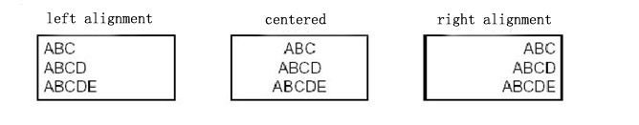

ESC c n
[Name] Permitting/Forbidding Reverse Printing
[Format] ASCII ESC c n
Hex 1B 63 n
Decimal 27 99 n
[Range] 0 ≤ n ≤ 255
[Description] Permitting/Forbidding Reverse Printing
· The effect is same as ESC { ，select/cancel invert printing mode
· When n = 0, forbid reverse printing
· When n = 1, permit reverse printing
[Notice] In invert printing mode, printer will print after the printed line is rotated 180°
[Default] n = 0

ESC c 5 n
[Name] Permitting/Forbiding keystoke
[Format] ASCII ESC c 5 n
Hex 1B 63 35 n
Decimal 27 99 53 n
[Range] 0 ≤ n ≤ 255
[Description] Permitting/Forbidding keystoke.
·When the lowest bit of n is 0,keystoke works
·When the lowest bit of n is 1,keystoke is forbidden.
[Notice] ·Only the lowest bit of n is effective.
·When the keystoke is forbidden, it does not work
[Default] n = 0

ESC d n
[Name] Printing and feeding paper forward for n lines
[Format] ASCII ESC d n
Hex 1B 64 n
Decimal 27 100 n
[Range] 0 ≤ n ≤ 255
[Description] Printing the datas in print buffer and feeding paper forward for n lines(character row)
[Notice] ·This command sets the loading position at the beginning of the row
·This command does not influence the line space which is set by ESC 2 or ESC 3
·The maximum distance of feeding paper is 1016mm.If it is beyond this distance, taking the maximum distance.
[Reference] ESC 2, ESC 3

ESC i
[Name] Permitting/Forbidding anti-white Printing
[Format] ASCII ESC I n
Hex 1B 69 n
Decimal 27 105 n
[Description] When n=1, permit anti-white printing; n=0，forbid anti-white printing.
Anti-white printing is to print white characters on the black background.
[Default] n = 0

ESC t n
[Name] Selecting character codepage
[Format] ASCII ESC t n
Hex 1B 74 n
Decimal 27 116 n
[Range] 0 ≤n ≤ 255
[Description] Selecting code page n from character code table.Selection of n are as below:
n | 代码页 | Code Page
0 | CP437 [美国，欧洲标准] | CP437 [U.S.A., Standard Europe]
1 | KataKana [片假名] | Katakana
2 | PC850 [多语言] | PC850 [Multilingual]
3 | PC860 [葡萄牙] | PC860 [Portuguese]
4 | PC863 [加拿大-法语] | PC863 [Canadian-French]
5 | PC865 [北欧] | PC865 [Nordic]
6 | WCP1251 [斯拉夫语] | WCP1251 [Cyrillic]
7 | CP866 斯拉夫2 | CP866 Cyrilliec #2
8 | MIK[斯拉夫/保加利亚] | MIK[Cyrillic /Bulgarian]
9 | CP755 [东欧，拉脱维亚 2] | CP755 [East Europe，Latvian 2]
10 | [伊朗，波斯] | Iran
11 | 保留 | reserve
12 | 保留 | reserve
13 | 保留 | reserve
14 | 保留 | reserve
15 | CP862 [希伯来] | CP862 [Hebrew]
16 | ＷCP1252 [拉丁语 1] | ＷCP1252 Latin I
17 | WCP1253 [希腊] | WCP1253 [Greek]
18 | CP852 [拉丁语 2] | CP852 [Latina 2]
19 | CP858 [多种语言拉丁语 1+欧元符] | CP858 Multilingual Latin Ⅰ+Euro)
20 | 伊朗Ⅱ[波斯语] | Iran II
21 | 拉脱维亚 | Latvian
22 | CP864 [阿拉伯语] | CP864 [Arabic]
23 | ISO-8859-1 [西欧] | ISO-8859-1 [West Europe]
24 | CP737 [希腊] | CP737 [Greek]
25 | WCP1257 [波罗的海] | WCP1257 [Baltic]
26 | [泰文1] | Thai 1
27 | CP720[阿拉伯语] | CP720[Arabic]
28 | CP855 | CP855
29 | CP857[土耳其语] | CP857[Turkish]
30 | WCP1250[中欧] | WCP1250[Central Eurpoe]
31 | CP775 | CP775
32 | WCP1254[土耳其语] | WCP1254[Turkish]
33 | WCP1255[希伯来语] | WCP1255[Hebrew]
34 | WCP1256[阿拉伯语] | WCP1256[Arabic]
35 | WCP1258[越南语] | WCP1258[Vietnam]
36 | ISO-8859-2[拉丁语2] | ISO-8859-2[Latin 2]
37 | ISO-8859-3[拉丁语3] | ISO-8859-3[Latin 3]
38 | ISO-8859-4[波罗的语] | ISO-8859-4[Baltic]
39 | ISO-8859-5[斯拉夫语] | ISO-8859-5[Cyrillic]
40 | ISO-8859-6[阿拉伯语] | ISO-8859-6[Arabic]
41 | ISO-8859-7[希腊语] | ISO-8859-7[Greek]
42 | ISO-8859-8[希伯来语] | ISO-8859-8[Hebrew]
43 | ISO-8859-9[土耳其语] | ISO-8859-9[Turkish]
44 | ISO-8859-15[拉丁语9] | ISO-8859-15 [Latin 3]
45 | [泰文2] | Thai2
46 | CP856 | CP856
[Default] n = 0
[Notice] · Thai characters are specially handled to conform the writing rules of Thai. When Codepage 26 or 45 is chose, the characters will be arranged according to the Thai manner. Detailed rules can be checked in Appendix C.

ESC { n
[Name] Selecting/canceling invert printing mode
[Format] ASCII ESC { n
Hex 1B 7B n
Decimal 27 123 n
[Range] 0 ≤ n ≤ 255
[Description] Selecting/canceling invert printing mode
·When the lowest bit of n is 0, canceling invert printing mode
·When the lowest bit of n is 1, selecting invert printing mode.
[Notice] ·Only the lowest bit of n is effective.
·Under invert printing mode, the printer will rotate the line of being printed for 180 degree firstly before printing.
[Default] n = 0
[Example
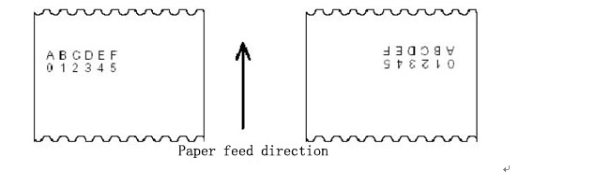

FS I n
[Name] Selecting/canceling rotating 90 clockwise.
[Format] ASCII FS I n
Hex 1C 49 n
Decimal 28 73 n
[Range] 0 ≤ n ≤ 2, 48 ≤ n ≤ 50
[Description] Selecting/canceling rotating 90 clockwise.
Value of n is as below:
n | Function
0，48 | Canceling rotating 90 clockwise
1，49  2，50 | Selecting rotating 90 clockwise
[Notice] ·The underline will be not rotated 90 clockwise when select the underline mode.
· The double height and double width under 90 clcokwise rotating model are be rotated in the opposite direction of the normal mode.
[Default] n = 0
[Reference] ESC !, ESC -

FS P n
[Name] Printing the prestored bit map
[Format] ASCII FS P n
Hex 1C 50 n
Decimal 28 80 n
[Range] 0 ≤ n ≤ 7
[Description] This command prints the 2 value bit map which is pre-stored in the printer and
not easily lost.The bit map in memory which is not easily lost can be produced
and written by the tool in PC. The max width is 576dots and max size is 64kb.
[Notice]·Before the destination bit map code has not been defined, this command is not available.
·The bit map must be the 2 value bit map
·This command will not be influenced by printing mode.(bold、overlap、underline、character dimension or inverse print).
· If this command is under Page Mode, it will just change the inner mark position.
·If the width of being printed beyond one line, the out profile will not be printed.
·It needs special purpose tools to print the downloaded bit map, Please see Setting Toll of printer. The bit map by this mode will not be lost, unless download other bitmap to cover it .

GS ! n
[Name] Selecting character boundary
[Format] ASCII GS ! n
Hex 1D 21 n
Decimal 29 33 n
[Range] 0 ≤ n ≤ 255
（1≤longitudinal magnification multiple≤4，1≤lateral magnification multiple≤4）
[Description] Using 0 to 2 bits to select character height,4 to7 bits to select character width
As follows:
Bit | 0/1 | Hex | Decimal | Function
0~3 | Selecting character height, see table1
4~7 | Selecting character width, see table2

table1 table2
Selecting character height |  |  | Selecting character width
Hex | Decimal | longitudinal magnification | Hex | Decimal | lateral magnification;
00 | 0 | 1（normal） | 00 | 0 | 1 （normal）
01 | 1 | 2（double height） | 10 | 16 | 2 （double width）
02 | 2 | 3 | 20 | 32 | 3
03 | 3 | 4 | 30 | 48 | 4
[Notice] · This command is effective to all the characters(ASCII and Chinese characters) except HRI characters
· If n is out of the range, this command will be neglected.
· Under standard mode, lengthways is the direction of feeding paper,landscape is
perpendicular to the direction of feeding paper. But when the character rotates 90 degree clockwise, lengthways and landscape are reversed
· All the character are aligned baseline when the character of the same line
enlarge different times
· Selecting/canceling the double width and double height of the character can also
be set by ESC ! command. However, the setting of the last received command is
Effective.
[Default] n = 0
[Reference] ESC !

GS ( A pL pH n m
[Name] Carry out test printing
[Format] ASCII GS ( A pL pH n m
Hex 1D 28 41 pL pH n m
Decimal 29 40 65 pL pH n m
[Range] ( pL+ pH × 256)=2 (pL=2, pH=0)
0 ≤ n ≤ 2, 48 ≤ n ≤ 50
1 ≤ m ≤ 3, 49 ≤ m ≤ 51
[Description] · Carry out test printing. The printing method is decided by n, m.
· pL, pH(pL+pH×256) means the number of bytes of parameter (n,m) after pH.
n means the tested paper type
n | Paper type
0, 48 | Basic type (roll paper)
1, 49 | Roll paper
2, 50 | Roll paper

m decides the printed content
m | Printed content
1, 49 | Hex unloading printing
2, 50 | Inner configuration information printing
3, 51 | Circulation characters printing

[Notic] · This command is only valid at the beginning of line
· When this command ends, the printer will cut paper.
· When carrying this command, the printer is in busy status, so can’t receive other commands.

GS ( D pL pH m [a1 b1] … [ak bk]
[Name] Permit/Forbid Real time command
[Format] ASCII GS ( D pL pH m [a1 b1] … [ak bk]
Hex 1D 28 44 pL pH m [a1 b1] … [ak bk]
Decimal 29 40 68 pL pH m [a1 b1] … [ak bk]
[Range] 3 ≤ (pL + pH × 256) ≤ 65535 (0 ≤ pL ≤ 255, 0 ≤ pH ≤ 255)
m = 20
a = 1, 2
b = 0, 1, 48, 49
[Description] Confirm to permit or forbid real time command through a
· pL,pH(pL+pH×256) means the bytes number of parameter (m,[a1 b1]…[ak bk]) after pH.
a | b | Function
1 | 0, 48 | DLE DC4 fn m t (fn = 1): no processing（forbid）
1 | 1, 49 | DLE DC4 fn m t (fn = 1): processing（Permit）
2 | 0, 48 | DLE DC4 fn a b (fn = 2): no processing（forbid）
2 | 1, 49 | DLE DC4 fn a b (fn = 2): processing（Permit）
[Notice] · If the graphic data includes the same data with DLE DC4 (fn = 1 or 2), it suggests to forbid real time command by this command in advance.

GS * x y d1...d(x × y × 8)
[Name] Defining downloaded bit map
[Foramt] ASCII GS * x y d1...dk
Hex 1D 2A x y d1...dk
Decimal 29 42 x y d1...dk
[Range] 1 ≤ x ≤ 255
1 ≤ y ≤ 48
x × y ≤ 700
0 ≤ d ≤ 255
k=x× y× 8
[Description] Use appointed bit number by x and y to define the downloaded bit map
· x is the dot number of horizontal
· y is the dot number of vertical
· d is data of specified bit map
[Notice] · x*8 is the dot number of horizontal.；y*8 is the dot number of vertical.
· If x*y is of flimit,then the command is unvalid.
· d means the image data.1 print, 0 not print
·In the following circumstances，clear the downloaded bit image.：
- carry out ESC@ command
- carry out ESC & command
- carry out FS q command
- carry out two-dimension barcode printing
- Turn off the printer power or restoration.
Relationship between print data and download bit map is as below：
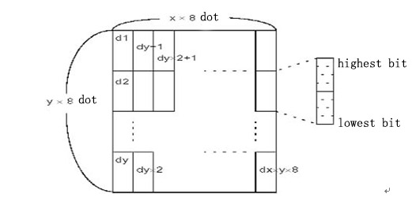
[Reference] GS /

GS / m
[Name] Printing downloaded bitmap
[Format] ASCII GS / m
Hex 1D 2F m
Decimal 29 47 m
[Range] 0 ≤ m ≤ 3, 48 ≤ m ≤ 51
[Description] Printing mode is appointed by m when print a bit map
m printing mode selections are as below：
m | mode | vertical (DPI) | horizontal (DPI)
0, 48 | normal | 203 | 203
1, 49 | Double width | 203 | 101
2, 50 | Double height | 101 | 203
3, 51 | Double width  and height | 101 | 101
[Notice] ·This command will be ignored if the downloaded bit map is not defined.
·The command is effective only when the reisno data in the printing buffer under
standard mode
·Except inversion mode,other modes have no effect on it(include bold、double print、underline、enlarge font and invert printing，etc.
·The out profile will not be printed if the bit map out of the range.
. This command prints the bit map downloaded in RAM but not Flash.
[Reference] GS *

GS B n
[Name] Selecting/canceling black white revert printing mode
[Format] ASCII GS B n
Hex 1D 42 n
Decimal 29 66 n
[Range] 0 ≤ n ≤ 255
[Description] Selecting/canceling black white revert printing mode
·When the lowest bit of n is 0,canceling black white reverse printing mode.
·When the lowest bit of n is 1,selecting black white reverse printing mode.
[Notice] · Only the lowest bit of n is effective
·This command is available to all the characters (except HRI characters)
·After selecting black white reverse printing,the space between characters
which is set by ESC SP command is also reversing.
·This command does not influence bit map, user defined bit map, barcode, HRI
character and blank space which is set by HT,ESC $ and ESC\
·This command does not influence the blank space between lines.
·Priority of black white reverse printing mode is higher than it of underline mode.
When selecting black white reverse printing mode,underline mode is not effective.It will be effective after canceling black white reverse printing mode.
[Default] n = 0

GS I n
[Name] Inquire priner ID number
[Format] ASCII GS I n
Hex 1D 49 n
Decimal 29 73 n
[Range] 1 ≤ n ≤ 3, 49 ≤ n ≤ 51, 65 ≤ n ≤ 69
[Description] Inquiry printer ID number. The ID number type is decided by value of n.
n | Printer ID number | Return Parameter | ID (hexadecimal)
1, 49 | Printer ID number | SP-T58 series | 20
2, 50 | Printer Type ID | As below table
3, 51 | ROM Type ID | Related with printer model and Production Date
65 | Firmware Type ID | Related with printer model and Production Date
66 | Manufacturer | Related with actual manufacturer
67 | Printer name | Related with actual printer name
68 | Printer Serial number | Related with printer model and Production Date
69 | Chinese Type supported | Simplified Chinese：Chinese  Traditional Chinese：Chinese-BIG5  Traditional Chinese：Chinese-GB12345  Japan Chinese：Japanese-ShiftJIS

n = 2, printer type ID
Bit | 1/0 | Hex | Decimal | Function
0 | 0 | 00 | 0 | Double byte character code non supported
0 | 1 | 01 | 1 | Double byte character code supported
1 | 0 | 00 | 0 | Without cutter
1 | 1 | 02 | 2 | With cutter
2 | 0 | 00 | 0 | Non used
3 | 0 | 00 | 0 | Non used
4 | 0 | 00 | 0 | Fix as 0
5 | - | - | - | Defined
6 | - | - | - | Defined
7 | 0 | 00 | 0 | Fix as 0

[Notice] · When 1 ≤ n ≤ 3 or 49 ≤ n ≤ 51, printer will return single byte ID
· When 65 ≤ n ≤ 69, the return format is as below:
Header information: Hexadecimal = 5FH / Decimal = 95 (1 byte)
Data: Printer information
NUL: Hexadecimal = 00H / Decimal = 0 (1 byte)

GS L nL nH
[Name] Setting left margin
[Format] ASCII GS L nL nH
Hex 1D 4C nL nH
Decimal 29 76 nL nH
[Range] 0 ≤ nL ≤ 255
0 ≤ nH ≤ 255
[Description] ·Setting left margin by nL and nH
·Setting left margin at [(nL+nH×256)×horizontal motion unit)] inches.
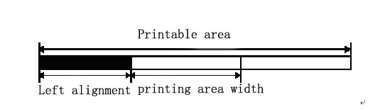
[Notice] ·This command is just available at the zero position of the line and under standard
·It is not available under page mode,the printer will handle it as normal datas
·This command does not influence the printing under page mode
·Taking the Max-width is it goes beyond the max printing width
·Vertical and horizontal motion units are set by GSP.Changing the motion will not influence the current left margin.
[Default] nL = 0, nH = 0
[Reference] GS P, GS W

GS P x y
[Name] Setting horizontal and vertical motion units
[Format] ASCII GS P x y
Hex 1D 50 x y
Decimal 29 80 x y
[Range] 0 ≤ x ≤ 255
0 ≤ y ≤255
[Description] · Setting horizontal motion units as near 25.4/xmm（ 1/x inch）Setting vertical
Motion units as near 25.4/ymm（1/y inch）
·When x and y are all 0， x and y are setting as default value
[Notice] ·Direction is perpendicular to the feeding is horizontal, the feeding direction is vertical.
No matter x or y is used for the below command, it will not be changed even though rotating characters, inversion or rotating 90° clockwise.
①  Using x command：ESC SP, ESC $, ESC \, FS S, GS L, GS W
②  Using y command：ESC 3, ESC J, GS V
· This command doesn’t affect the set position previously.
·The minimum motion distance is the result of combined action of this and other commands
·a inch=25.4mm
[Default value] x=203,y=203，now a motion unit is a printing dot.Horizontal motion distance is 1/8mm，and vertical motion distance is 1/8mm。
[Reference] ESC SP, ESC $, ESC 3, ESC J, ESC W, ESC \, GS $, GS L, GS V, GS W, GS \

GS W nL nH
[Name] Setting the width of printing area
[Format] ASCII GS W nL nH
Hex 1D 57 nL nH
Decimal 29 87 nL nH
[Range] 0 ≤ nL ≤ 255
0 ≤ nH ≤ 255
[Description] Setting the width of printing area by nL and nH
·Setting width of printing area to [( nL + nH × 256) × horizontal motion unit)]
inches.
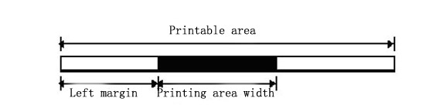
[Notice] ·This command is just available at the zero position of the line and under standard mode.
·If [left margin+width of printing area]goes beyond the print able area,the width of
printing is it of[printable area width–left margin]
·Vertical and horizontal motion units are set by GSP.Changing them will not Influence the current left margin and area width
·Using horizontal motion units to count the width of printing area
[Default] (nL + nH × 256 ) = 576 ［80mm paper width，72mm printing width］
(nL + nH × 256 ) = 512 ［80mm paper width，64mm printing width］
(nL + nH × 256 ) = 384 ［58mm paper width］
[Reference] GS L, GS P

GS a n
[Name] Enable/disable Automatic Status Back (ASB)
[Format] ASCII GS a n
Hex 1D 61 n
Decimal 29 97 n
[Range] 0 ≤ n ≤ 255
[Description] Enables or disables basic ASB (Automatic Status Back). The meaning of n is as below,
Bit | 1/0 | Hex | Decimal | ASB related status
0 | 0 | 00 | 0 | Reserved
1 | 0 | 00 | 0 | Forbid Online/offline status
1 | 1 | 02 | 2 | Permit Online/offline status
2 | 0 | 00 | 0 | Forbid error status
2 | 1 | 04 | 4 | Permit error status
3 | 0 | 00 | 0 | Forbid paper sensor status
3 | 1 | 08 | 8 | Permit paper sensor status
4~7 | - | - | - | Reserved
[Notice] · If any item in the above table is permitted, when this status is changed, the printer will return four bytes status automatically.
· If all items are forbidden, ASB is also forbidden.
· Whether the host is ready or not cannot be confirmed from whether the printer return the status bytes.
· This command is carried out in sequential execution with other commands together. So there is some period delay when receiving returned status after sending this command.
· Although printer is set to be invalid status by command ESC =, the printer will still return the status automatically as setting.
· Auto returned status is as below:
The first byte (Printer information)
Bit | 1/0 | Hex | Decimal | Printer status
0 | 0 | 00 | 0 | Fix as 0
1 | 0 | 00 | 0 | Fix as 0
2 | 0 | 00 | 0 | Fix as 0
3 | 0 | 00 | 0 | Printer online
3 | 1 | 08 | 8 | Printer offline
4 | 1 | 10 | 16 | Fix as 1
5 | 0 | 00 | 0 | Fix as 0
6 | 0 | 00 | 0 | Not use feed button to feed paper
6 | 1 | 40 | 64 | Use feed button to feed paper
7 | 0 | 00 | 0 | Fix as 0
The second byte (Printer information)
Bit | 1/0 | Hex | Decimal | Printer status
0 | - | - | - | Reserved
1 | - | - | - | Reserved
2 | - | - | - | Reserved
3 | 0 | 00 | 0 | Fix as 0
4 | 0 | 00 | 0 | Fix as 0
5 | 0 | 00 | 0 | No unrecovered error
5 | 1 | 20 | 32 | Unrecovered error
6 | 0 | 00 | 0 | No auto-recovered error
6 | 1 | 40 | 64 | Auto-recovered error
7 | 0 | 00 | 0 | Fix as 0
Bit 5: Such as paper jam, etc, which are recovered errors. These errors can be recovered by command DLE ENQ n (1 ≤ n ≤ 2) after the error reasons are found.
Such as control board damage, etc, which are unrecovered errors.

Bit 6: Such as over-heat of printing head is auto-recovered error.

The third byte (Paper sensor information)
Bit | 1/0 | Hex | Decimal | Printer status
0, 1 | 0 | 00 | 0 | Fix as 0
2, 3 | 0 | 00 | 0 | Paper out sensor: paper exists
2, 3 | 1 | 0C | 12 | Paper out sensor: paper out
4 | 0 | 00 | 0 | Fix as 0
5, 6 | - | - | - | Reserved
7 | 0 | 00 | 0 | Fix as 0
The forth byte (Paper sensor information)
Bit | 1/0 | Hex | Decimal | Printer status
0~3 | - | - | - | Reserved
4 | 0 | 00 | 0 | Fix as 0
5, 6 | - | - | - | Reserved
7 | 0 | 00 | 0 | Fix as 0
[Default] n = 0

Chinese Control Commands

FS ! n
[Name] Setting Chinese characters mode
[Format] ASCII FS ! n
Hex 1C 21 n
Decimal 28 33 n
[Range] 0 ≤ n ≤ 255
[Descriptiom] Using value of n to set the printing mode of Chinese characters
Bit | 0/1 | Hex | Decimal | Function
0, 1 |  |  |  | Undefined
2 | 0 | 00 | 0 | Canceling double width
2 | 1 | 04 | 4 | Selecting double width
3 | 0 | 00 | 0 | Canceling double height
3 | 1 | 08 | 8 | Selecting double height
4~6 | - | - | - | Undefined
7 | 0 | 00 | 0 | Canceling underline
7 | 1 | 80 | 128 | Selecting underline
[Notice] ·When double width and double height are set together,portrait and landscape will been larged two times together(including left and right space).
·Printer can add underline to all the characters,including left and right space.But
can not add underline to the space caused by HT command (horizontaltab),either the 90 degree clockwise characters.
·The width of underline is set by FS,has no relation to the character boundary
·When the height of the character in one line is not the same,all the characters
Align the base line
·Using FS W and GS! can make the characters bold,the setting of the last received command is effective.
·Also can use FS- to select or cancel the underline,the setting of the last received
command is effective.
[Default value] n = 0
[Reference] FS - , FS W, GS !

FS &
[Name] Selecting Chinese character mode
[Format] ASCII FS &
Hex 1C 26
Decimal 28 38
[Description] Selecting Chinese character mode
[Notice] ·When select Chinese character mode,printer will judge whether the character is
Hanzi interal code,if it is,dealing with the first byte in advance.Then the second one.
[Reference] FS . , FS C

FS – n
[Name] selecting/canceling Chinese underline mode
[Format] ASCII FS - n
Hex 1C 2D n
Decimal 28 45 n
[Range] 0 ≤ n ≤ 2, 48 ≤ n ≤ 50
[Description] selecting or canceling Chinese underline according to value of n
n | Function
0, 48 | canceling Chinese underline
1, 49 | selecting Chinese underline（1dot width）
2, 50 | selecting Chinese underline（2dots width）
[Note] ·Printer can add underline to all the characters,including left and right space.But
Can not add underline to the space caused by HT command(horizontaltab),either the 90 degree clockwise characters.
·It does not carry out the underline printing after canceling underline mode，but the previous set does not change。The default underline width is 1dot。
·The underline width does not change even if changing the character dimension。
·Can use FS ! to select or cancel the underline,the setting of the last received
command is effective
[Default value] n = 0
[Reference] FS !

FS .
[Name] canceling chinese mode
[Format] ASCII FS .
Hex 1C 2E
Decimal 28 46
[Description] canceling chinese mode
[Notice] ·When the Chinese mode is canceled，all the characters are the same as ASCII style，and deal with one byte once
[Reference] FS &, FS C

FS 2 c1 c2 d1...dk
[Name] defining user self-defined Chinese
[Format] ASCII FS 2 c1 c2 d1...dk
Hex 1C 32 c1 c2 d1...dk
Decimal 28 50 c1 c2 d1...dk
[Range] c1，c2 represent the code of defined characters。
c1 = FEH
A1H ≤ c2 ≤ FEH
0 ≤ d ≤ 255
k = 72
[Description] Defining the Chinese specified by c1，c2.
[Notice] · C1，c2 represent user self-defined Chinese code，c1 specifies the first byte，c2 specifies the second byte。
· d represent data。Every bit of byte is 1 represents to print the dot，0 means does not print。
·It can define 4 chinese the most
[Default value] no self-defined Chinese
The relation between self-defined Chinese font and data as follows：
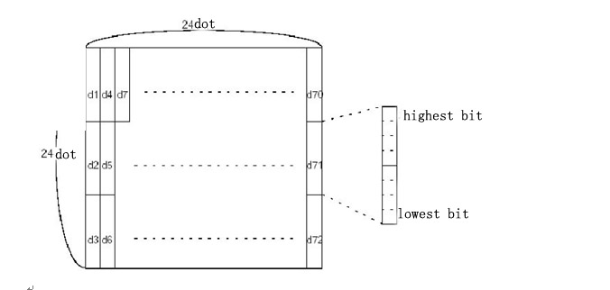

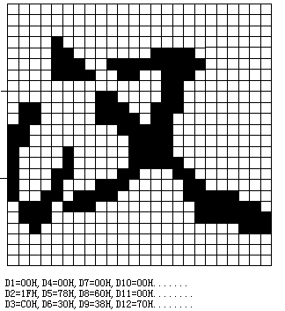

FS C n
[Name] selecting Chinese code system
[Format] ASCII FS C n1 n2
Hex 1C 43 n1 n2
Decimal 28 67 n1 n2
[Range] n=0, 1, 48, 49
[Description] selecting Chinese code system
n | selecting Chinese code system
0, 48 | Simplified Chinese（GB18030）
1, 49 | Traditional Chinese（BIG5）
2,50 | Traditional Chinese（GB12345）
3,51 | Japanese（ShiftJIS）
[Notice] ·The command does not change the parameter set of flash
· It returns to default after carried out ESC @ command、power off or reset
[Default value] n = 0 Simplified Chinese（GB18030）
n = 1 Traditional Chinese（BIG5）
n = 2 Traditional Chinese（GB12345）
n = 3 Japanese（ShiftJIS）。

FS S n1 n2
[Name] Setting the left and right space of Chinese character
[Format] ASCII FS S n1 n2
Hex 1C 53 n1 n2
Decimal 28 83 n1 n2
[Range] 0 ≤ n1 ≤ 255
0 ≤ n2 ≤ 255
[Description] Setting the space of left and right are n1，n2.
·When the printer have GSP command，the left space is[n1*lateral or vertical motion unit]inch,the right space is[n2*lateral or vertical motion unit]inch.
[Notice] The left and right space will be doubled after setting the double width mode.
·The shifting unit is setted by the command GS P.The former character space does not change even if the lateral and vertical units are changed.
·Using the laterial shifting unit under the standard mode.
·Selecting to use the laterial or vertical shifting unit according to the printing area under page mode.
1.Using horizontal shifting when the beginning position is the top left or lower right corner of the printing area
2.Using vertical shifting when the beginning position is the lower left or top right corner of the printing area
3. The maximum distance of Chinese is36mm.If it is beyond this distance,taking the maximum distance.
[Default] n1 = 0, n2 = 0
[Reference] GS P

FS W n
[Name] selecting/canceling Chinese double height or width
[Format] ASCII FS W n
Hex 1C 57 n
Decimal 28 87 n
[Range] 0 ≤ n ≤ 255
[Description] Selecting/canceling Chinese double width mode
·Cancel Chinese double width mode when the lowest bit is 0
·Select Chinese double width mode when the lowest bit is 1.
[Notice] ·only the lowest bit of n is effective.
·To print Chinese dimension under double width mode is the same as to select both double width and double height.
·The Chinese dimension is printed normally after canceling the Chinese double width mode.
·When the height of the character in one line is not the same, all the characters
align the baseline
·Also using FS! or GS！can select or cancel Chinese double height and width mode，the setting of the last received command is effective.
[Default] n = 0
[Reference] FS !, GS !

Commands of printing 1-D barcode

GS H n

[Name] Selecting the printing position of HRI character
[Format] ASCII GS H n
Hex 1D 48 n
Decimal 29 72 n
[Range] 0 ≤ n ≤ 3, 48 ≤ n ≤ 51
[Description] When printing the barcode,selecting the printing position for HRI character
N appoints the printing position of HRI
n | Printing position
0, 48 | No printing
1, 49 | Above the barcode
2, 50 | Below the barcode
3, 51 | Both above and below the barcode
·HRI is the character of content note of barcode
[Note] ·The style of HRI character is appointed by GS f.
[Default value] n = 0
[Reference] GS f, GS k

GS f n
[Name] Selecting font of HRI used
[Format] ASCII GS f n
Hex 1D 66 n
Decimal 29 102 n
[Range] n = 0, 1, 48, 49
[Description] When printing barcode,selecting a style for HRI character
Selecting style by n is as below：
n | Style
0, 48 | Standard ASCII character(12×24)
1, 49 | Compressed ASCII character(9 × 17)
[Notice] ·HRI character is the note of barcode content
·HRI character printing position is set by GS H command
[Default value] n = 0
[Reference] GS H, GS k

GS h n
[Name] Selecting height of barcode
[Format] ASCII GS h n
Hex 1D 68 n
Decimal 29 104 n
[Range] 1 ≤ n ≤ 255
[Description] Selecting height of barcode
The height of barcode is n dots
[Default value] n = 60
[Reference] GS k

GS k m d1...dk NUL②GS k m n d1...dn
[Name] Printing barcode
[Format] ①ASCII GS k m d1...d k NUL
Hex 1D 6B m d1...d k 00
Decimal 29 107 m d1...d k 0
②ASCII GS k m n d1... dn
Hex 1D 6B m n d1... dn
Decimal 29 107 m n d1... dn
[Range] ①0 ≤ m ≤ 6 （Value range of k and d is decided by its type）
②65 ≤ m ≤ 73 （Value range of k and d is decided by its type）
[Description] Selecting a kind of barcode and printing
m is used to select type of barcode,as follows：
m |  | Barcode type | Number of character | d
① | 0 | UPC-A | 11 ≤ k ≤ 12 | 48 ≤ d ≤ 57
① | 1 | UPC-E | 11 ≤ k ≤ 12 | 48 ≤ d ≤ 57
① | 2 | JAN13 (EAN13) | 12 ≤ k ≤ 13 | 48 ≤ d ≤ 57
① | 3 | JAN 8 (EAN8) | 7 ≤ k ≤ 8 | 48 ≤ d ≤ 57
① | 4 | CODE39 | 1 ≤ k ≤ 255 | 45 ≤ d ≤ 57, 65 ≤ d ≤ 90, 32, 36, 37,43
① | 5 | ITF | 1 ≤ k ≤ 255 | 48 ≤ d ≤ 57
① | 6 | CODABAR | 1 ≤ k ≤ 255 | 48 ≤ d ≤ 57, 65 ≤ d ≤ 68 , 36, 43, 45,46,47,58
② | 65 | UPC-A | 11 ≤ n ≤ 12 | 48 ≤ d ≤ 57
② | 66 | UPC-E | 11 ≤ n ≤ 12 | 48 ≤ d ≤ 57
② | 67 | JAN13 (EAN13) | 12 ≤n ≤ 13 | 48 ≤ d ≤ 57
② | 68 | JAN 8 (EAN8) | 7 ≤n ≤ 8 | 48 ≤ d ≤ 57
② | 69 | CODE39 | 1 ≤ n ≤ 255 | 45 ≤ d ≤ 57, 65 ≤ d ≤ 90, 32, 36, 37,43  d1 = dk = 42
② | 70 | ITF | 1 ≤ n≤ 255 | 48 ≤ d ≤ 57
② | 71 | CODABAR | 1 ≤ n≤ 255 | 48 ≤ d ≤ 57 65 ≤ d ≤ 68, 36, 43,45,46,47 58
② | 72 | CODE93 | 1 ≤ n≤ 255 | 0 ≤ d ≤ 127
② | 73 | CODE128 | 2 ≤ n≤ 255 | 0 ≤ d ≤ 127
[Notice ①]
·This command is ended by NULL under this format
·When selecting code of UPC-A or UPC-E，after receiving 12 bytes data,printer will handle the rest as normal character
·When selecting type of JAN13(EAN13)，after receiving13 bytes data,printer will
handle the rest as normal character
· When selecting type of JAN8(EAN8)，after receiving 8 bytes data,printer will
handle the rest as normal character
·Number of ITF code data must be aeven number.If entering code data of odd
number,the last data will be ignored
[Notice②]
·N is used to appoint the number of pointing barcode data.The printer will handle
then byte data follow as barcode data
·If n goes beyond the specified range,the printer will not handle this command,and
handle the data following as normal data
[Notice(Standard mode)]
·If the barcode d goes beyond the specified range,this command is invalid.
·If the cross wise of barcode goes beyond printing area,invalid
·No matter what is the height set by ESC 2 or ESC 3,the distance of feeding paper is the same as the height of barcode.
·This command only available when there is no data in printing buffer,if not,the command will be ignored.
·The printing position will be set at the beginning of the line after printing the barcode.
·Other mode setting(bold、double printing、underline、character dimension、inverse and character clockwise rotates 90 degree)can not influence this command except
Inversion mode
[Notice(page mode)]
·This command just produces the barcode figure in printing buffer,but not print.Moving the printing position to the right of the barcode after handling the barcode data.
·If the d goes beyond the specified range,this command will be ignored.
·If the width of the barcode goes beyond the printing area,this command will be ignored

When selecting CODE128(m=73)：
·Refering appendix A，related information of CODE128 and character set
·When using CODE128,encoding according to the description following
- Selecting character set before barcode data（CODE A、CODE B or CODE C）
- Selecting character set according to sending character “{” and combine with another character;ASCII character“{” is finished by sending character “{”for twice.
Appointing  Character | Sending data
Appointing  Character | ASCII | Hex | Decimal
SHIFT | {S | 7B, 53 | 123,83
CODE A | {A | 7B, 41 | 123, 65
CODE B | {B | 7B, 42 | 123, 66
CODE C | {C | 7B, 43 | 123, 67
FNC1 | {1 | 7B, 31 | 123, 49
FNC2 | {2 | 7B, 32 | 123, 50
FNC3 | {3 | 7B, 33 | 123, 51
FNC4 | {4 | 7B, 34 | 123, 52
"{" | {{ | 7B, 7B | 123, 123
[Example] Printing“No.123456”
Using CODE B to print“No.”，and then using CODE C to print the digital rest
GS k 73 10 123 66 78 111 46 123 67 12 34 56

·If it is not character set selection at the beginning of barcode data,the printer will
stop handling this command，and handling the rest data as normal data
·If“{”and the character close behind is not the combination as above,the printer
will stop handling this command，and handling the rest data as normal data.
·If the character is not the data of barcode character set,the printer will stop handling this command，and handling the rest data as normal data.
·When printing HRI character,not printing shift character and character set selection data
·HRI character of function character is not printed
·HRI character of control character（<00>Hto<1F>Hand<7F>H）is not printed
<Others> Ensure the left and right space of barcode.Space is different because of different barcode style.
[Reference] GS H, GS f, GS h, GS w, appendix A

GS w n
[Name] Setting the width of barcode
[Format] ASCII GS w n
Hex 1D 77 n
Decimal 29 119 n
[Range] 2 ≤ n ≤ 6
[Description] Setting width of barcode horizontal module
Appointing the barcode horizontal module by n
n | Mono basis module width（mm） | Biradical module width
n | Mono basis module width（mm） | Narrow-based module（mm） | Wide-based module （mm）
2 | 0.25 | 0.25 | 0.625
3 | 0.375 | 0.375 | 1.0
4 | 0.5 | 0.5 | 1.25
5 | 0.625 | 0.625 | 1.625
6 | 0.75 | 0.75 | 1.875
·Barcode of mono basis module is as below：
UPC-A, UPC-E, JAN13 (EAN13), JAN8 (EAN8), CODE93, CODE128
·Barcode of biradical module is as below：
CODE39, ITF, CODABAR
[Default value] n = 2
[Reference] GS k

Print commands of 2D code

GS Z n

[Name] Select 2D code type
[Format] ASCII GS Z n
Hex 1D 5A n
Decimal 29 90 n
[Range] 0 ≤n ≤ 2
[Description] Select 2D code type
· n = 0 select PDF417
· n = 1 select DATA MATRIX
· n = 2 select QR CODE
[Reference] ESC Z

ESC Z m n k dL dH d1 …dn
[Name] Print 2D code
[Format] ASCII ESC Z v r k nL nH d1 …dn
Hex 1B 5A v r k nL nH d1 …dn
Decimal 27 90 v r k nL nH d1 …dn
[Range] The meaning and range of parameter depends on the 2D code type of GS Z selection.
· The parameters will be different due to the barcode with different Parameter v, r
① PDF417 code
1 ≤ v ≤ 30 means characters number per line. The max value of v should be within the range of the allowable max value for the model due to the different model with different paper width.
0 ≤ r ≤ 8 means the level of error correction.
② DATA MATRIX code
0 ≤v ≤ 144 means the height of graph.(0: auto select).
8 ≤ r ≤ 144 means the width of graph (when v=0, void).
③ QR CODE
0 ≤ v ≤ 40 means graph version (0: auto select).
r =76,77,81,72 means the level of error correction. (L:7%, M:15%,Q:25%,H:30%).
· The Parameter meaning of Parameter k, n(nL, nH), d .
1 ≤ k ≤ 6 means the times of laterial Magnification.
1 ≤ n ≤ 65535 means the data length of printing code is parameter n, nL and nH is the low level and high level of value n (n= dL + dH × 256).
0 ≤ dn ≤ 255 means data of barcode.
[Description] Print the 2D code according to GS Z selection.
[Reference] GS Z

GS k m v r d1...dn NUL ②GS k m v r nL nH d1...dn
[Name] Print 2D code
[Format] ①ASCII GS k m v r d1...dn NUL
Hex 1D 6B m v r d1...dn 00
Decimal 29 107 m v r d1...dn 0
Hex 1D 6B m v r nL nH d1... dn
Decimal 29 107 m v r nL nH d1... dn
[Range] ①32 ≤ m ≤34
②97 ≤ m ≤ 99
·The meaning is different when the barcode with different parameter v, r.
① PDF417 code
1 ≤ v ≤ 30 means characters number per line. The max value of v should be within the range of the allowable max value for the model due to the different model with different paper width.
0 ≤ r ≤ 8 means the level of error correction.

② DATA MATRIX code
0 ≤v ≤ 144 means the height of graph.(0: auto select).
8 ≤ r ≤ 144 means the width of graph (when v=0, void).
③ QR CODE code
0 ≤ v ≤ 40 means graph version (0: auto select).
1 ≤ r ≤ 4 means the level of error correction. (L:7%, M:15%,Q:25%,H:30%).
· The Parameter meaning of Parameter n(nL, nH), d .
1 ≤ n ≤ 65535 means the data length of printing code is parameter n, nL and nH is the low level and high level of value n (n= dL + dH × 256).
0 ≤ dn ≤ 255 means data of barcode.
[Description] Select a type of 2D code and print code.
· When use the first format, command is end by 00, d1…dn are barcode data. When use the second format, all the n of d1…dn after nH are code data.
Parameter “m” is to select the code type, please refer to below graphic:
m |  | Code Type | Data Length | v | r | d
① | 32 | QR Code | 1 ≤ n ≤ 65535 | 0 ≤ v ≤ 40 | 1 ≤ r ≤ 4 | 0 ≤ dn ≤ 255
① | 33 | Data Matrix | 1 ≤ n ≤ 65535 | 0 ≤v ≤ 144 | 8 ≤ r ≤ 144 | 0 ≤ dn ≤ 255
① | 34 | PDF417 | 1 ≤ n ≤ 65535 | 1 ≤ v ≤ 30 | 0 ≤ r ≤ 8 | 0 ≤ dn ≤ 255
② | 97 | QR Code | 1 ≤ n ≤ 65535 | 0 ≤ v ≤ 40 | 1 ≤ r ≤ 4 | 0 ≤ dn ≤ 255
② | 98 | Data Matrix | 1 ≤ n ≤ 65535 | 0 ≤v ≤ 144 | 8 ≤ r ≤ 144 | 0 ≤ dn ≤ 255
② | 99 | PDF417 | 1 ≤ n ≤ 65535 | 1 ≤ v ≤ 30 | 0 ≤ r ≤ 8 | 0 ≤ dn ≤ 255
[Notice] · When use the command to print 2D code, the magnification times of barcode depends on the “n” of GS w set.
Reference] ESC Z, GS w

GS v 0 m xL xH yL yH d1 … dk
[Name] Print raster bit image
[Format] ASCII GS v 0 m xL xH yL yH d1 … dk
Hex 1D 76 30 m xL xH yL yH d1 … dk
Decimal 29 118 48 m xL xH yL yH d1 … dk
[Range] 0 ≤ m ≤ 3, 48 ≤ m ≤ 51
1 ≤ (xL + xH × 256) ≤ 256 (0 ≤ xL ≤ 255, xH = 0, 1)
1 ≤ (yL + yH × 256) ≤ 2303 (0 ≤ yL ≤ 255, 0≤ yH ≤ 8)
0 ≤ d ≤ 255
k = (xL + xH × 256) × (yL + yH × 256) ( k ≠ 0)
[Description] Prints a raster bit image using the mode specified by m.
m | Mode | Vertical direction (DPI) | Horizontal direction (DPI)
0, 48 | Normal | 203 | 203
1, 49 | Double width | 203 | 101
2, 50 | Double height | 101 | 203
3, 51 | Double width&height | 101 | 101
·xL, xH specify the number of bytes in the horizontal direction as (xL + xH × 256).
·yL, yH specify the number of dots in the vertical direction as (yL + yH × 256).
·d specifies the defined data (raster format).
[Notice] · This command is valid only when the buffer of printer is null.
· Printing mode including enlarging characters, bold, double printing, etc, is invalid for this command.
· The extra part of bitmap will not be printed.
· ESC a is valid for this command.
· d is bitmap data. 1 to print; while 0 not print.
[Example] When xL+ xH × 256 = 64
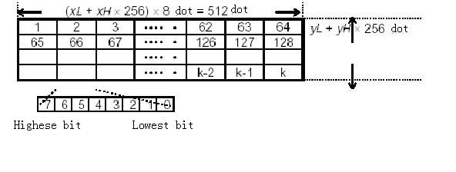

Appendix A: 128 code
A.1 128 code summary
128code can code128ASCII characters and 100 numbers from00~99and some special character by crossing using of character set A, BandC.Character of every character set code is as below：
Character set A： ASCII characterfrom 00H to 5FH
Character set B： ASCII characterfrom 20H to 7FH
Character set C： 100 numbers from 00~99
128 code can also code to the special character below：
SHIFTcharacter
“SHIFT” can make barcode character the first character after SHIFTcharacter transfor from character set AtoB,orBtoA,back to the character set used before SHIFT.“SHIFT”
Character can only be used to transform between character set AandB,it can not make the current code character enter or quit state of character set C.
Selecting character of character set（CODEA、CODEB、 CODEC）
These characters can transform the coding character followed to character set A,B or C.
Function character（FNC1、 FNC2、FNC3、FNC4）
Usage of these function character is determined by application software.OnlyFNC1 can be used in character set C.
A.2 Character sets
Character in set A
Charact-er | Sending data |  | Charact-er | Sending data |  | Charact-er | Sending data
Charact-er | Hex | Decimal | Charact-er | Hex | Decimal | Charact-er | Hex | Decimal
NULL  SOH  STX  ETX  EOT  ENQ  ACK  BEL  BS  HT  LF  VT  FF  CR  SO  SI  DLE  DC1  DC2  DC3  DC4  NAK  SYN  ETB  CAN  EM  SUB  ESC  FS  GS  RS  US  SP  !  "  #  $  % | 00  01  02  03  04  05  06  07  08  09  0A  0B  0C  0D  0E  0F  10  11  12  13  14  15  16  17  18  19  1A  1B  1C  1D  1E  1F  20  21  22  23  24  25 | 0  1  2  3  4  5  6  7  8  9  10  11  12  13  14  15  16  17  18  19  20  21  22  23  24  25  26  27  28  29  30  31  32  33  34  35  36  37 | &  '  (  )  *  +  ,  -  .  /  0  1  2  3  4  5  6  7  8  9  :  ;  <  =  >  ?  @  A  B  C  D  E  F  G  H  I  J  K | 26  27  28  29  2A  2B  2C  2D  2E  2F  30  31  32  33  34  35  36  37  38  39  3A  3B  3C  3D  3E  3F  40  41  42  43  44  45  46  47  48  49  4A  4B | 38  39  40  41  42  43  44  45  46  47  48  49  50  51  52  53  54  55  56  57  58  59  60  61  62  63  64  65  66  67  68  69  70  71  72  73  74  75 | L  M  N  O  P  Q  R  S  T  U  V  W  X  Y  Z  [  \  ]  ^  _  FNC1  FNC2  FNC3  FNC4  SHIFT  CODEB  CODEC | 4C  4D  4E  4F  50  51  52  53  54  55  56  57  58  59  5A  5B  5C  5D  5E  5F  7B,31  7B,32  7B,33  7B,34  7B,53  7B,42  7B,43 | 76  77  78  49  80  81  82  83  84  85  86  87  88  89  90  91  92  93  94  95  123,49  123,50  123,51  123,52  123,83  123,66  123,67
Character in set B
Charac-ter | Sending data |  | Charact-er | Sending data |  | Charact-er | Sending data
Charac-ter | Hex | Decimal | Charact-er | Hex | Decimal | Charact-er | Hex | Decimal
SP  !  "  #  $  %  &  '  (  )  *  +  ,  -  .  /  0  1  2  3  4  5  6  7  8  9  :  ;  <  =  >  ?  @  A  B  C  D  E | 20  21  22  23  24  25  26  27  28  29  2A  2B  2C  2D  2E  2F  30  31  32  33  34  35  36  37  38  39  3A  3B  3C  3D  3E  3F  40  41  42  43  44  45 | 32  33  34  35  36  37  38  39  40  41  42  43  44  45  46  47  48  49  50  51  52  53  54  55  56  57  58  59  60  61  62  63  64  65  66  67  68  69 | F  G  H  I  J  K  L  M  N  O  P  Q  R  S  T  U  V  W  X  Y  Z  [  \  ]  ^  _  `  a  b  c  d  e  f  g  h  i  j  k | 46  47  48  49  4A  4B  4C  4D  4E  4F  50  51  52  53  54  55  56  57  58  59  5A  5B  5C  5D  5E  5F  60  61  62  63  64  65  66  67  68  69  6A  6B | 70  71  72  73  74  75  76  77  78  79  80  81  82  83  84  85  86  87  88  89  90  91  92  93  94  95  96  97  98  99  100  101  102  103  104  105  106  107 | l  m  n  o  p  q  r  s  t  u  v  w  x  y  z  {  |  }  —  DEL  FNC1  FNC2  FNC3  FNC4  SHIFT  CODEA  CODEC | 6C  6D  6E  6F  70  71  72  73  74  75  76  77  78  79  7A  7B,7B  7C  7D  7E  7F  7B,31  7B,32  7B,33  7B,34  7B,53  7B,41  7B,43 | 108  109  110  111  112  113  114  115  116  117  118  119  120  121  122  123,123  124  125  126  127  123,49  123,50  123,51  123,52  123,83  123,65  123,67

Character in set C
Charac-ter | Sending data |  | Charact-er | Sending data |  | Charac-ter | Sending data
Charac-ter | Hex | Decimal | Charact-er | Hex | Decimal | Charac-ter | Hex | Decimal
0  1  2  3  4  5  6  7  8  9  10  11  12  13  14  15  16  17  18  19  20  21  22  23  24  25  26  27  28  29  30  31  32  33  34  35  36  37 | 00  01  02  03  04  05  06  07  08  09  0A  0B  0C  0D  0E  0F  10  11  12  13  14  15  16  17  18  19  1A  1B  1C  1D  1E  1F  20  21  22  23  24  25 | 0  1  2  3  4  5  6  7  8  9  10  11  12  13  14  15  16  17  18  19  20  21  22  23  24  25  26  27  28  29  30  31  32  33  34  35  36  37 | 38  39  40  41  42  43  44  45  46  47  48  49  50  51  52  53  54  55  56  57  58  59  60  61  62  63  64  65  66  67  68  69  70  71  72  73  74  75 | 26  27  28  29  2A  2B  2C  2D  2E  2F  30  31  32  33  34  35  36  37  38  39  3A  3B  3C  3D  3E  3F  40  41  42  43  44  45  46  47  48  49  4A  4B | 38  39  40  41  42  43  44  45  46  47  48  49  50  51  52  53  54  55  56  57  58  59  60  61  62  63  64  65  66  67  68  69  70  71  72  73  74  75 | 76  77  78  79  80  81  82  83  84  85  86  87  88  89  90  91  92  93  94  95  96  97  98  99  FNC1  CODEA  CODEB | 4C  4D  4E  4F  50  51  52  53  54  55  56  57  58  59  5A  5B  5C  5D  5E  5F  60  61  62  63  7B,31  7B,41  7B,42 | 76  77  78  79  80  81  82  83  84  85  86  87  88  89  90  91  92  93  94  95  96  97  98  99  123,49  123,65  123,66

Appendix B: the pre-print black mark description
User must obey the specification as follows when printing the black mark if wants to use pre-print black mark to progress note clamping,
Otherwise may cause printer cannot identify a black mark. The black mark pre-print specification:
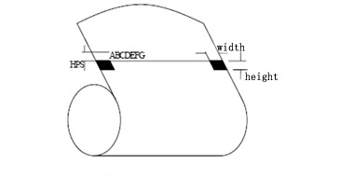
Printed lacation:is shown as chart above,the black mark should be printed to character surface of right or left side rim.
Width range:width≥7mm
Height range：4mm≤Height≤6mm
Vs the reflectivity of infrared：
<10%（the paper black mark width other fractions for the reflectivity of infrared>65%）
HPS：HPS marks the last rim to be apart from the distance of printing the origin top rim for printer black. 10mm≤HPS≤12mm

Appendix C：Thai Character Rules
According to the Thai Character Rules, we classify the Thai characters to the below kinds visually:
1. “Shoes” characters. They can be put under the body characters, like taking shoes for body.
2. “Body” characters. “Cap” characters can be put above “Body” characters, while “Shoes” characters can be put under “Body” characters, like taking caps and shoes for body.
3. “Caps” characters. They can be put above the body characters, like taking caps for body.
4. Tone characters. It marks the tone of one word and must be put above the body characters or cap characters.
5. Independent characters. For this kind of characters, no matter shoes, caps or tones characters can’t be put with them together.
6. Punctuation. They are used to make pauses during sentences, same with punctuations in other languages.

Below is the Contrast Table for Characters Type, Code and Characters. (Code is Unicode. The related Codepage code can be converted according to the current chose codepage.)

Characters Type | Code（Hex） | Character
Shoes | 0E38-0E39 | 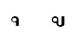
Body | 0E01-0E10,  0E11-0E1F,  0E20-0E2E,  0E32， | 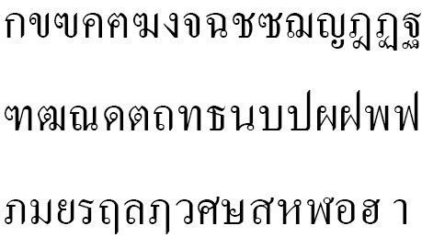
Cap | 0E31, 0E47,  0E33-0E37,  0E4C-0E4E | 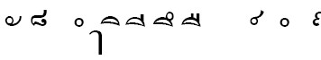
Tones | 0E48-0E4B | 
Independent | 0E2F,0E30,  0E3A  0E40-0E46  0E5A-0E5B | 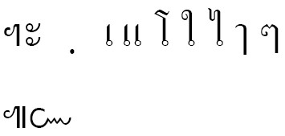
Punctuation | 0E00，0E3F,  0E4F-0E59, | 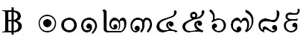
Others | 0E3B-0E3E  0E5B-0E7F
- “Shoes” characters will be under the other characters.
- “Caps” characters will be above the other characters.
- Tones will be above the whole complete Thai characters. If there is only body character, the tone will be above the body character; if there is caps characters, the tone will be above the cap characters. No matter cap characters, shoes characters or tones won’t be one characters independently. The example is as below,
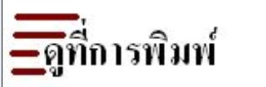
- Sending rules is: sending the body character firstly, then caps or shoes characters (generally cap and shoe will not in one character at the same time.); the last to send tones.

