TZ-TC602
---User Manual

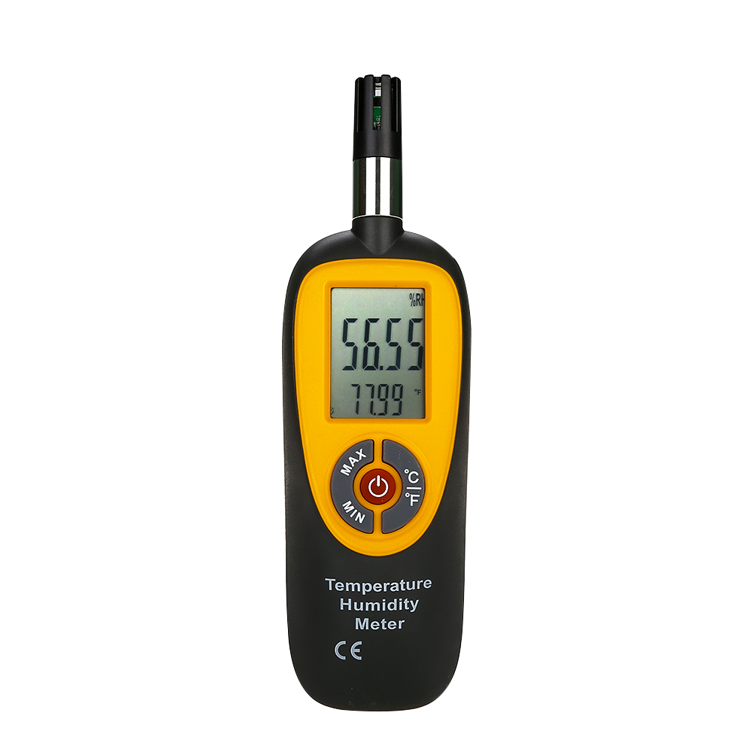

1.Product Introduction
TZ-TC602 is a professional instrument of our company for measuring ambient temperature, humidity, dew point temperature and wet bulb temperature. It is a high-precision, low-power digital temperature and humidity sensor, applicable to environments such as production workshops, factory warehouses, libraries, offices, laboratories, and family rooms.

2.Matters needing attention
☆ Do not disassemble or modify this product privately.
☆ Please remove the battery if it is not used for a long time to avoid battery leakage and corrosion of the meter.
☆ Do not put the sensor in liquid or expose the sensor to sunlight.
☆ Do not use or store this instrument in a high temperature, high humidity, flammable, explosive, or strong electromagnetic field environment.
☆ When cleaning, wipe gently with a soft cloth or sponge dipped in a little alcohol or weak soap. Do not use abrasives or corrosive solvents for cleaning.

3.Product Feature
◇ Low power consumption
◇ Low battery reminder
◇ Temperature and humidity measurement
◇ Automatic shutdown function
◇ Maximum and minimum measurement
◇ ℃/℉ temperature unit switching function
◇ Measurement of dew point temperature and wet bulb temperature

4.Product Specifications
Sensor measures temperature range | Temperature：-20~60℃  Humidity：0-100%RH
Precision | Temperature: ±1℃ (0～60℃); ±1.5℃ (other ranges)  Humidity: ±3.5%RH (25℃, 40～80%RH); ±5%RH (other ranges)
Resolution | Temperature：0.01℃/0.01℉  Humidity：0.01%RH
Sampling time | 2.5 times/sec
Automatic shutdown | About 16 minutes (no key operation)
Energy supply | A 9V battery
Energy life | About 50 hours (alkaline battery)
Operating temperature | 0～50℃
Operating humidity | 10%～80%RH
Storage temperature | -10～60℃
Storage humidity | 10%～75%
Size | 185mm×56mm×41mm
Weight | 100g

5.Structure introduction
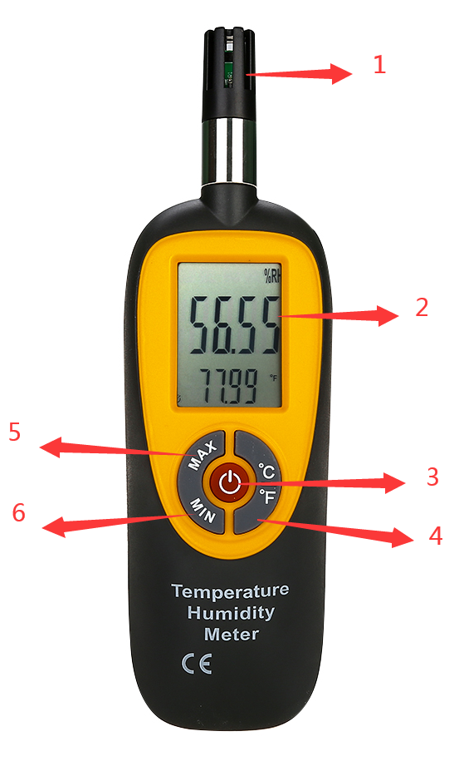
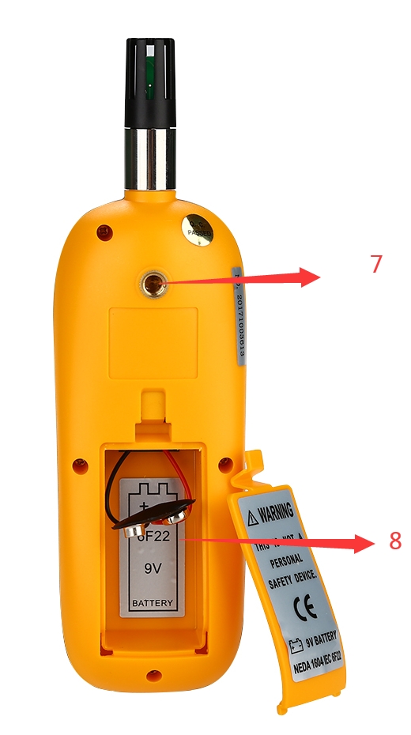
1. Temperature and humidity sensor.
2. Liquid Crystal Display
3. Power on/off button.
4. Mode/unit switch key.
5. Mode/unit switch key.
6. Min button: turn on/off the minimum value.
7. Tripod hole.
8. Battery.

6.Display information introduction
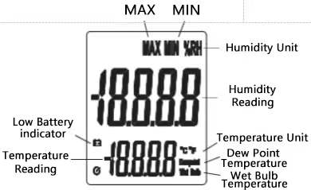

operating instructions
1) Open the battery cover, install a 9V battery, and turn on the power.
2) Check whether the battery is sufficient. If the symbol is displayed on the screen, it indicates that the battery is insufficient and the battery should be replaced.
3) Place the meter where you need to measure, or fix it on a tripod.
4) Press the "MAX/MIN" key to cycle through the three modes of maximum measurement, minimum measurement and normal measurement. When the maximum value measurement mode is selected, the screen always displays the maximum reading measured. When the minimum value measurement mode is selected, the screen always displays the measured readings
5) Press the "℃/℉" key to cycle through the following modes：

Temperature (℃ unit) → temperature (℉ unit) → dew point temperature (℃ unit) → dew point temperature (℉ unit) → wet bulb temperature (℃ unit) → wet bulb temperature (℉ unit)→Temperature (℃ unit)

Appendix
Dew point temperature:
The dew point temperature refers to the temperature at which the air is cooled to saturation when the water vapor content and pressure do not change. To put it vividly, the temperature at which the water vapor in the air turns into dew is called the dew point temperature. This is because when the water vapor in the air has reached saturation, the air temperature is the same as the dew point temperature; when the water vapor is not saturated, the air temperature must be higher than the dew point temperature. Therefore, the difference between the dew point and the temperature can indicate the degree to which the water vapor in the air is saturated.
Wet bulb temperature:
The wet bulb temperature refers to the air temperature when the water vapor in the air reaches saturation under the same enthalpy value. On the air enthalpy chart, the air state point drops along the isenthalpy line to the 100% relative humidity line, corresponding to the point Dry bulb temperature.
Wet bulb temperature is a means to calibrate the relative humidity of the air, and its meaning is that the air in a certain state, in contact with the humidity bulb of the wet bulb thermometer, undergoes adiabatic heat and moisture exchange, so that it reaches the temperature when it reaches the saturation state. The temperature is a thermometer wrapped with wet gauze on a thermos bulb. The surface temperature of the gauze measured in air with a flow velocity greater than 2.5m/s and not subject to direct radiation is used as a measure of the degree of air close to saturation. . The greater the saturation difference of the surrounding air, the stronger the evaporation that occurs on the wet bulb thermometer, and the lower its humidity. According to the difference between the dry and wet bulb temperature, the relative humidity of the air can be determined.

