**Duct Temperature and Humidity Transmitter**

**THT04C /THT04V**

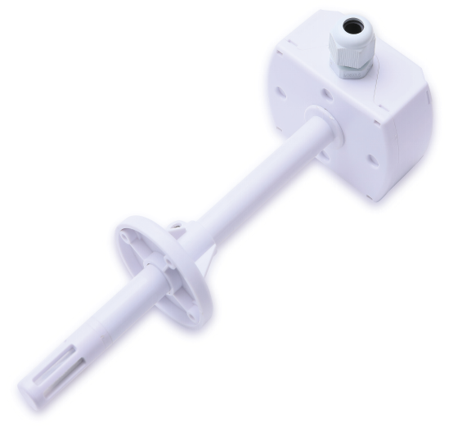

1 Product Overview

THT04C / THT04V duct temperature and humidity transmitter adopts professional imported humicap. It has the characteristics of high measurement accuracy, strong anti-interference ability and strong stability, which effectively ensures the excellent measurement performance.

It has a wide measurement range and can be applied to most industrial use environments. And it is widely used in HVAC automatic control, machine room monitoring, medical and other fields. THT04C output signal adopts industrial standard 4 ~ 20mA current signal output, and THT04V output signal adopts industrial standard 0 ~ 10V voltage signal output. They are excellent industrial temperature and humidity transmitters.

# 2 Overall Dimension

Unit: mm (± 0.5)

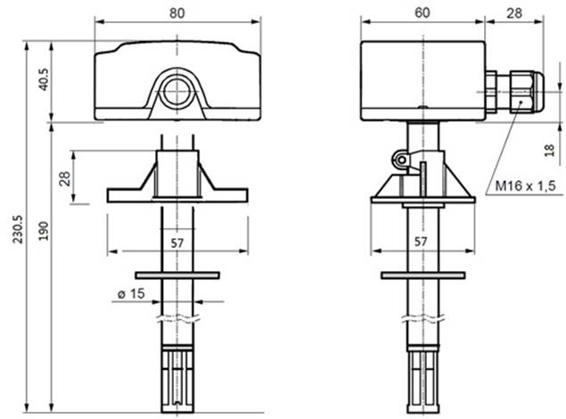

# 3 Application Field

    It is widely used in HVAC automatic control, computer room environment monitoring, medical ward and other fields, and it is an ideal solution for temperature and humidity measurement and monitoring in various application environments.

# 4 Electrical Characteristics

|  |  |  |
| --- | --- | --- |
|  | Temperature | Humidity |
| Measuring Range | -20~ 80 ℃ (Optional) | 0～100%RH |
| Accuracy | ±0.5℃（-10℃～60℃）  See Fig. 2 for full range accuracy. | Humidity: ± 3% RH (20% ~ 80% / 25 ℃)  See Fig. 2 for full range accuracy |
| Long Term Stability | < 0.2 ℃ / Year (Working under normal conditions) | < 2% RH / year (Working under normal conditions) |
| Signal Output | （THT04C）4～20mA/(THT04V)0～10V | |
| Power Supply | +13.5～24V DC | |
| Working Temperature | -20～80℃ | |
| Storage Environment | -40~ 80 ℃ (Non condensation, avoiding corrosion damage) | |
| Electrical Interface Spacing | 5.08mm | |

# **Electrical connections**

1. Current signal output

|  |  |
| --- | --- |
| Label | Function description |
| Hout | Humidity 4-20mA output |
| Tout | Temperature 4-20mA output |
| GND | Public ground (connect to the negative end of the power supply when DC power is supplied) |
| VCC | Power supply positive (when DC power supply is connected to the positive terminal of the power supply) |

II) Voltage signal output

|  |  |
| --- | --- |
| Label | Function description |
| Hout | Humidity 0-10V output |
| Tout | Temperature 0-10V output |
| GND | Public ground (connect to the negative end of the power supply when DC power is supplied) |
| VCC | Power supply positive (when DC power supply is connected to the positive terminal of the power supply) |

# 5 Performance Index

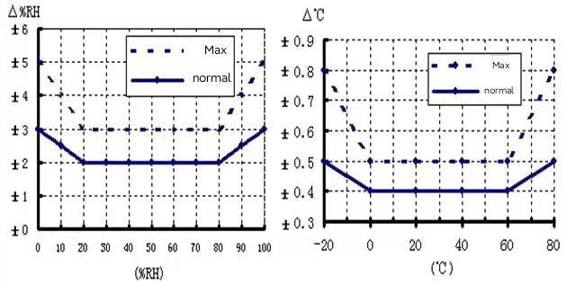

# 6 Output Current / Output voltage Calculation Methods

   Temperature output current: (Unit: mA)

 

T: Temperature; :Minimum temperature range; :Maximum temperature range.

    Humidity output current: (Unit: mA)

=;

H: Humidity; 100: Humidity range (Fixed value).

***T-Tmix***

***Tmax-Tmix***

Temperature output voltage: (Unit: V)

***T-Tmix***

***Tmax-Tmix***

*VTemp* = * 10.00

T: Temperature; :Temperature range min. - 20;  :Temperature range max 80

Humidity output voltage: (unit: V)

***H***

***100***

V*Humi* = * 10.00

H: Humidity; 100: Humidity range (Fixed value)

# 7 Temperature Setting

       The temperature range is selected by the 3-bit set range encoding switch in the upper left corner of the circuit board.When the dial switch is turned to on, it is 1, otherwise it is 0.

    The range parameters corresponding to the code are shown in the figure below：

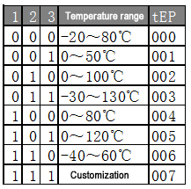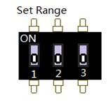

Temperature range setting method and corresponding startup TEP code

# 8 Power On Process

   Please note if there is no display module , the transmitter will not display information.

   After the transmitter is powered on 1st 0.5 seconds, the display screen will not display. After 2nd 0.5 seconds, the display screen will be fully lit to check the status of the display screen. After 3rd 0.5 seconds , the display screen will be shown the temperature range code tEP and the eEP number is in the above table, and the customer customized code FAd will be shown after 4th 0.5 seconds. If the transmitter has a fault, the fault code Err will be displayed. If the transmitter is in normal status, there will be no error code err, and the transmitter will directly enter the temperature and humidity display mode.

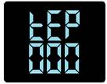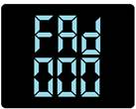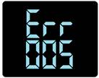

   （tEP） (FAd) (Err)

TEP: The humidity range of the current encoder of the transmitter.

The value ranges from "000" to "007". See the above table.

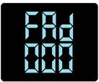FAd: The custom code of the transmitter.

The value is from "000" to "999" and it can be customized by customer , and the standard version code is "000".

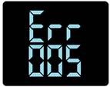Err: Fault code.

When "005" is displayed, it means that the sensor connection wire is disconnected or the sensor is faulty

# 

# 9 Application Circuit

I)   Current signal output

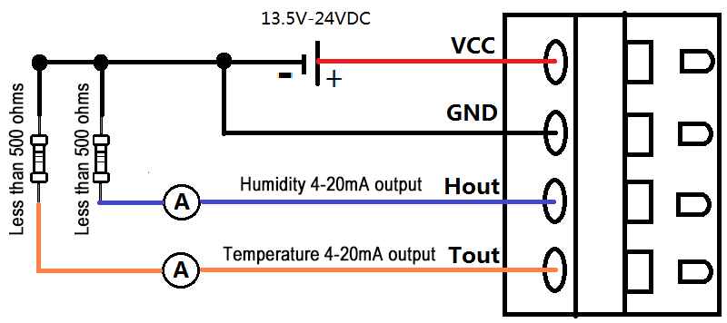

   II) Voltage signal output

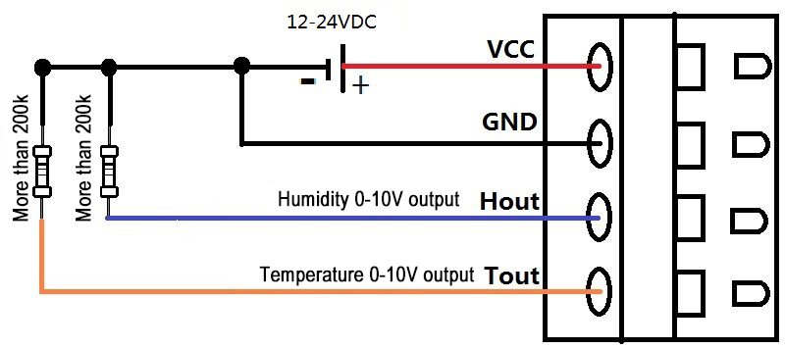

Note:

The load impedance must be less than 500 Ω, otherwise unexpected error will occur to the output current signal.

# 10 Error and Source

   Product temperature and humidity measurements may be affected by the following factors.

1. Temperature tolerance
2. The stability time is too short when placed in the test environment.
3. Close to heat source, cold source, or directly in the sun.

       II) Pollution: The machine must be cleaned regularly in dust or other polluted environment.

11 Attentions

1. Please read this manual carefully before use to ensure correct connections. This machine has anti reverse connection protection measures, but the wrong connections exceeding the rated parameters for a long time will still lead to product failure.
2. Please install it in an airy place, far from the local heating area.
3. Prevent chemical reagent, oil and dust from directly invading the sensor.
4. It will be tolerance after using for a long time, so in order to ensure the measurement accuracy, please calibrate it once a year.
5. Keep away from high-power interference equipment as far as possible to avoid measurement errors, such as frequency converter, motor, etc.