TZONE LBS Offline Map Package
- User Guide

Status | □ Draft □ Assess √ Release □ Edit
Version | V1.0
Author | Forrest Wu | Date | 2015.11.30

Preface
Distinguished software developer,

Thank you very much for using Tzone LBS. This user guide is to introduce how to use offline map package.

Tzone Team

Overview

Overview
The offline map package is to be used with location engine to show location info more directly on the map.

Function overview
  - 2D indoor map display, click, zoom and rotate
  - Map overlay

Offline map package structure
The package is to be put in root directory of the SD card of the phone.
Note: Do not rename the folder.
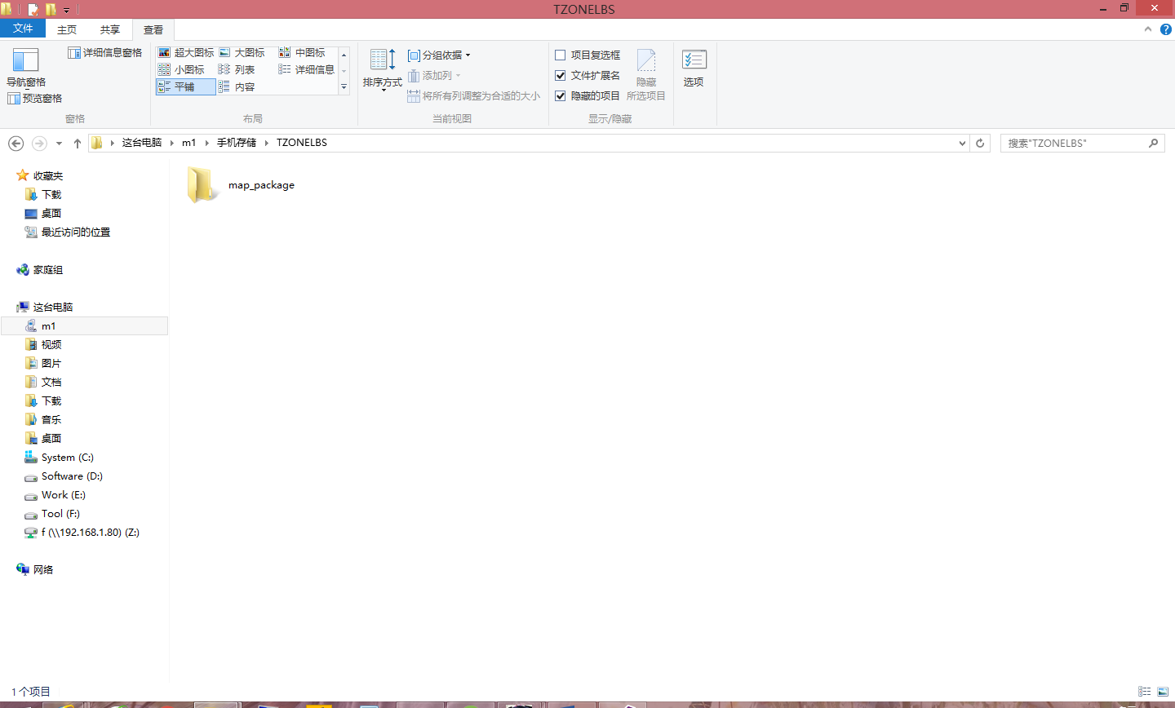

Put picture file in the folders in the folder of map_package.
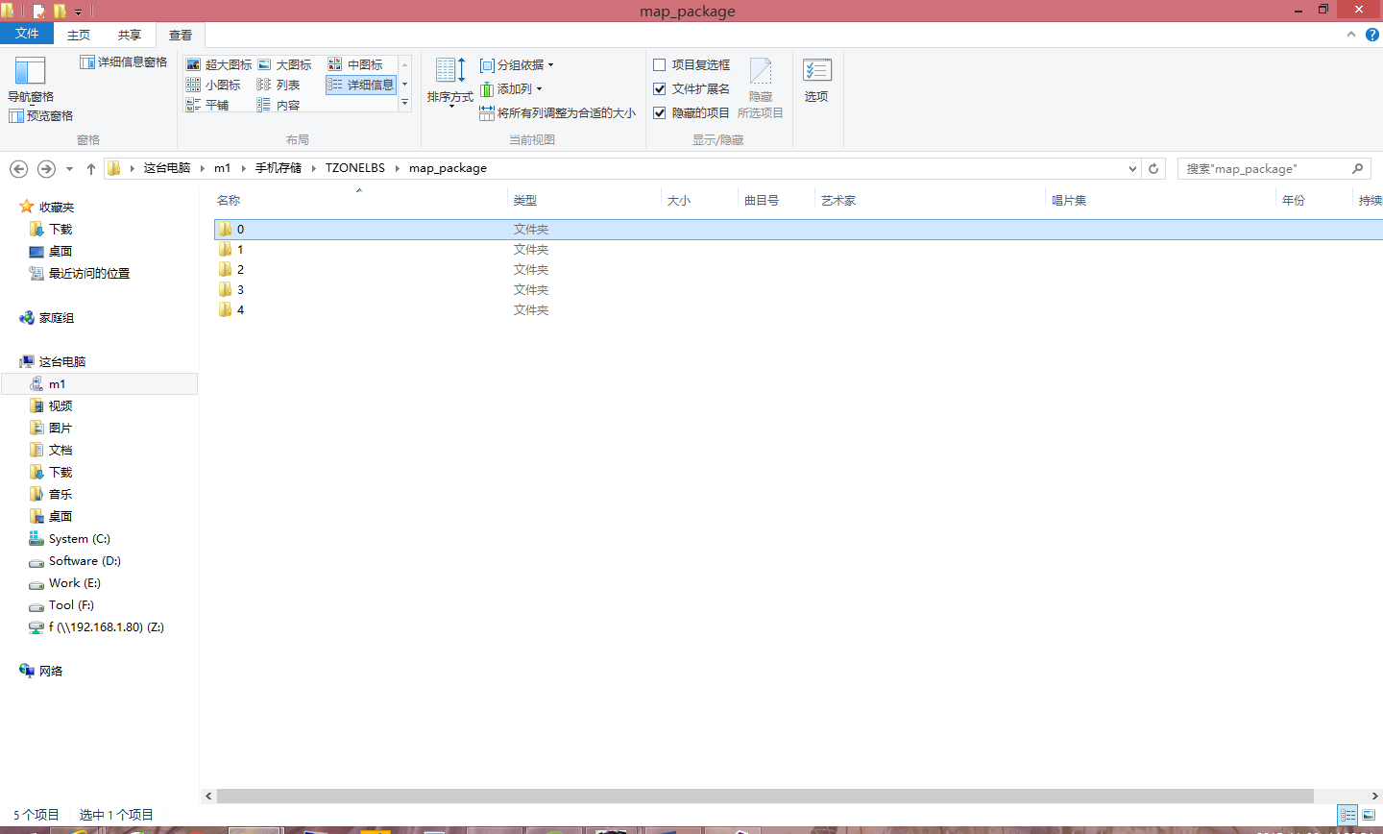
For example, Folder 2 is “海鹰大厦16D” (Tzone office). The first line of info.txt is the name of the map.

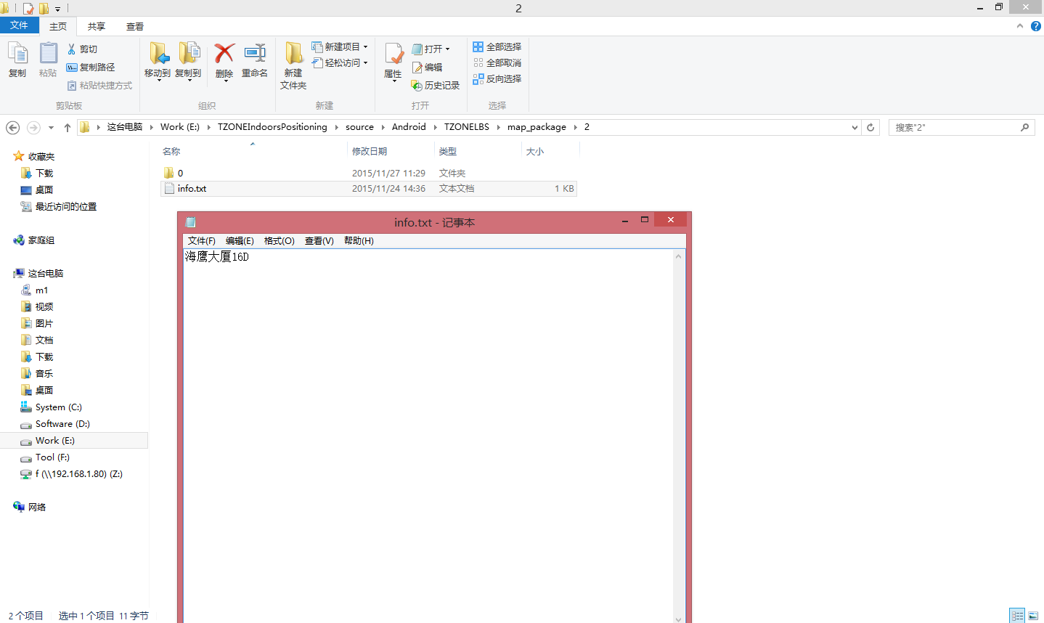

~/TZONELBS/map_package/2/0 is storey or area data of the map.
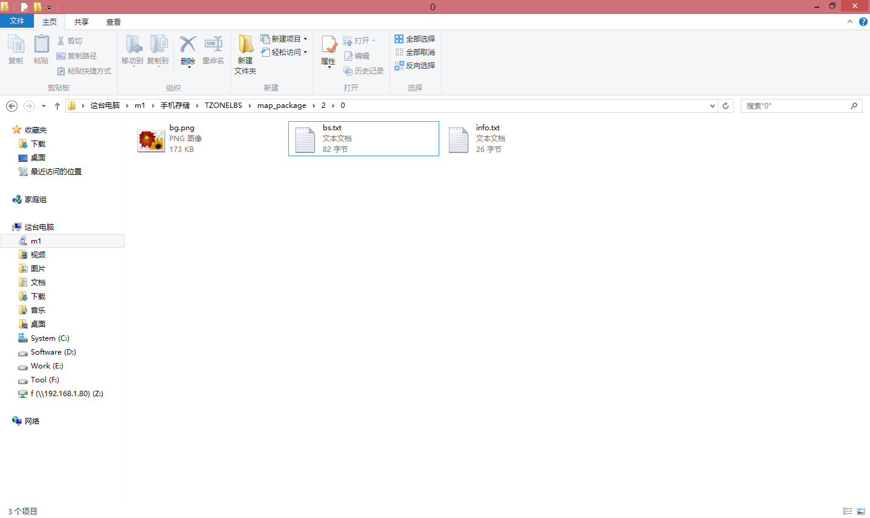

info.txt is storey or area info
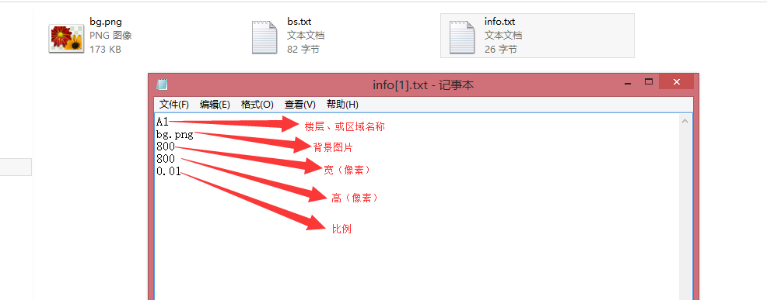
Scale
Height (pixels)
Width (pixels)
Background picture
Storey or area name

bg.png is map background.
bs.txt is beacon info.
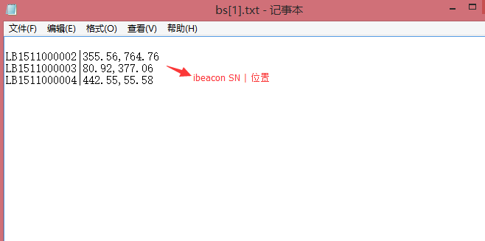
Location

area.txt is area info.
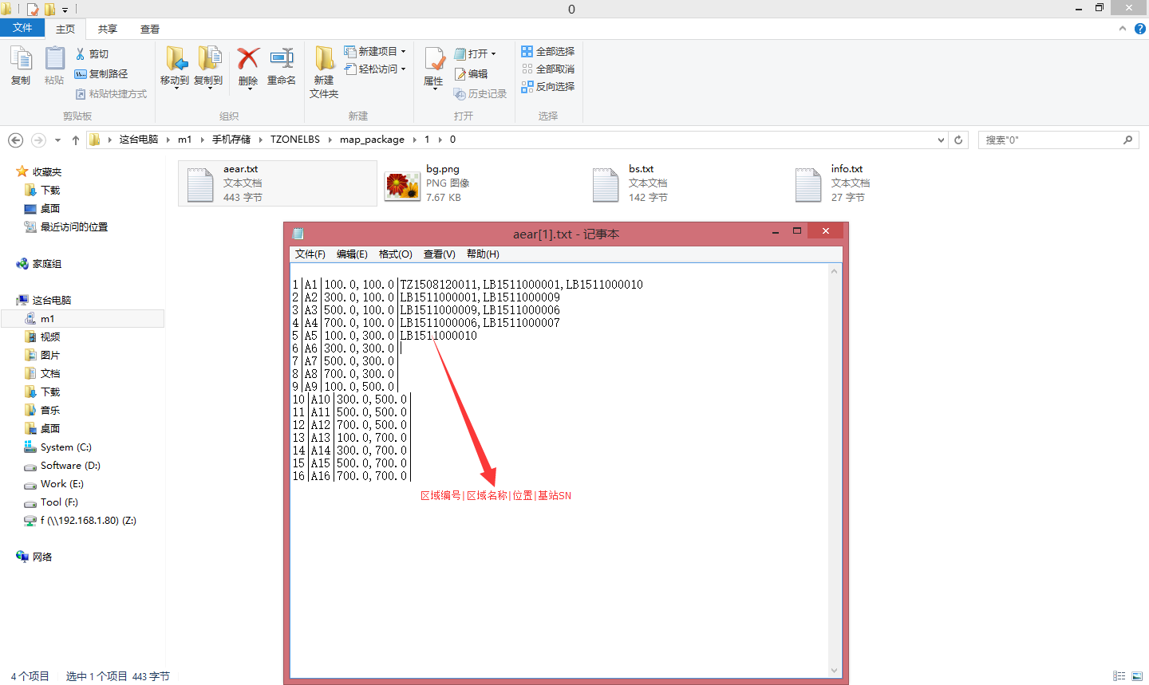
Area code︱area name︱location︱ beacon SN

Final display result:
