TZONE LBS
Beacon Deployment

Status | □ Draft □ Assess √ Release □ Edit
Version | V1.1
Author | Forrest Wu | Date | 2016.01.14

Preface
Distinguished software developer,

Thank you very much for using Tzone LBS. This user guide is to introduce how to deploy beacons.

Tzone Team

Overview
Location accuracy: 1~5 meter
Deployment density: eight meter interval, every 50 square meters

Beacon configuration requirement:
Broadcasting power: 4dBm
Broadcasting interval: 0.1s
Measurement power: RSSI value at 1m (normally 70dbm)

Deployment

Beacon height: 3m
The beacon is to be put 2.5~3m from the ground. If the installed location is high, need to consider attenuation. Or deploy on both ground and wall and keep the height within three meters.
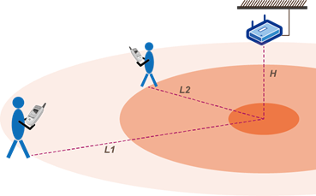

Beacon horizontal distance: 4-8 m
One dimension scene: Better for highly-isolated passage. Theoretically speaking, only one row of sequent beacon with 4-8 meter distance is enough.

Normal location scene (open area): beacons are to be deployed triangularly (three or more beacons), distance 4-8m.
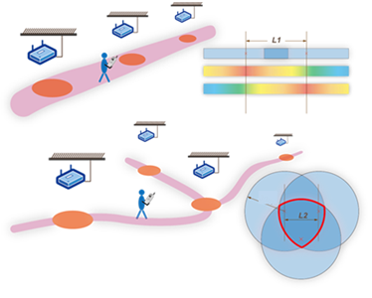

Notes
A. For normal indoor environment, keep the distance of beacons around 4-8m with an even deployment.
B. Keep away from cover, corner or obstacles.
C. Keep the distance between beacons about 5m in open area, with triangular lattice and with interlace.
D. Deploy at room door, entrance / exit of indoor route, corner, etc. to increase user satisfaction.
E. For small room or room that does not need accurate location, deploy one beacon inside it. For bigger rooms, do the triangular lattice and interlace deployment, similar to open area.
F. One-row or two-row deployment in the corridor according to its width. For narrow corridor (width about 3m), it is suggested deploy along the middle line of the corridor; for wider corridor, two-row interlace deployment is suggested.
G. For parking lot drives, deploy at places without cover with distance of 5m, one-row or two-row, according to the width; for every parking space (normally 2.5m*5.5m), deploy 1-2 beacons.
H. Do not deploy at the top of hall or area with height greater than 4m. Deploy along the wall or construction structure near the ground with distance of 5m.
I. Increase or decrease deployment density according to the need. Normally the distance of 4-6m distance is suggested for better accuracy. Accuracy would decrease if more than 6-8m.

