TZONE LBS Demo APP
- Manual

Status | □ Draft □ Review √ Publish □ Edit
Version | V1.0
Author | Forrest wu | Date | 2015.11.30

Preface
Distinguished Customer,

Thank you very much for using Tzone LBS Demo App, this document will guide you with its functions.

- Overview
  - General overview
This demo App is for the purpose of demonstrating iBeacon RTLS (Real Time Location Service) for customers and as example of LBS SDK for developers.
  - Function overview
- 2D indoor map display, click, zoom and rotate
- Indoor location
- Off-line map management
- Mobile device requirement
- Android 4.3
- Supports Bluetooth 4.0 Low Energy
- Function illustration
3.1 Main Page
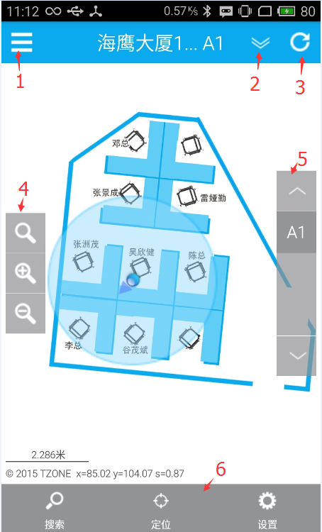
- System setting
- Map choosing
- Refresh
- Zoom
- Story / area switching
- Function menu

3.2 System setting
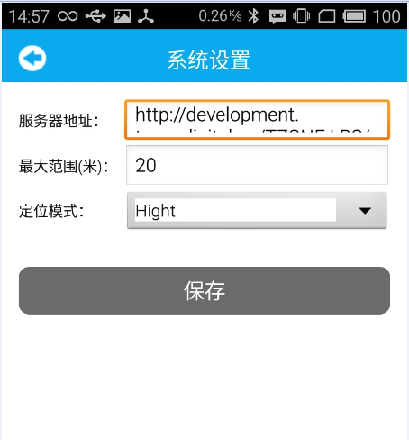
There are two kinds of positioning: a) Default; b) Precise positioning
- Position according to area: only need to judge which area;
- Precise positioning in an area.

3.3 Beacon setting
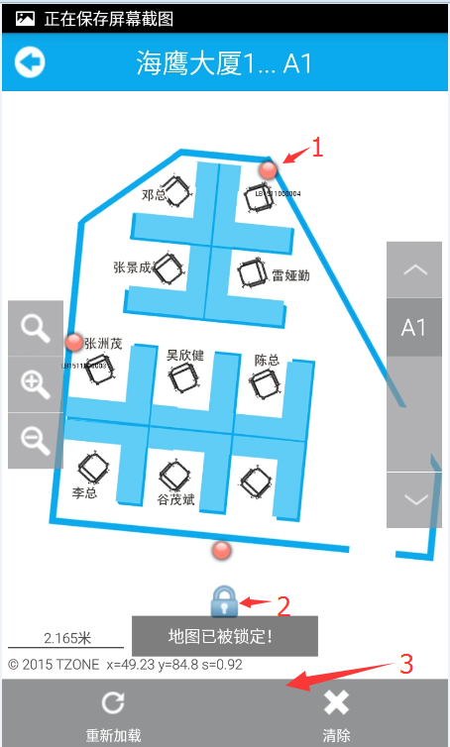
- Beacon location
- Map locking (Cannot zoom or drag the map when it is locked)
- Function menu

3.4 Area positioning deployment function
a) Put four beacons around the mobile device and let it read them.
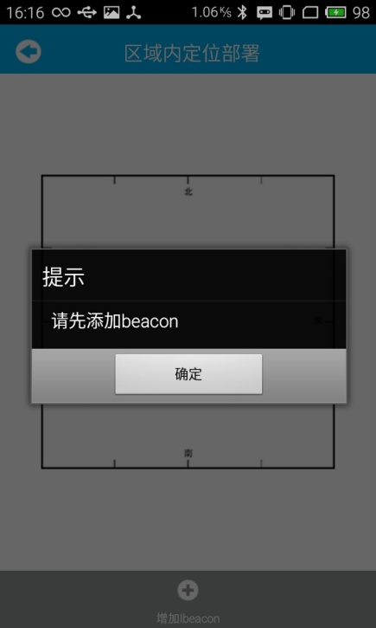
b) Put the mobile device to the center. Do not move it while installing the beacons. Put the beacons to designated location and click “Install beacons”.
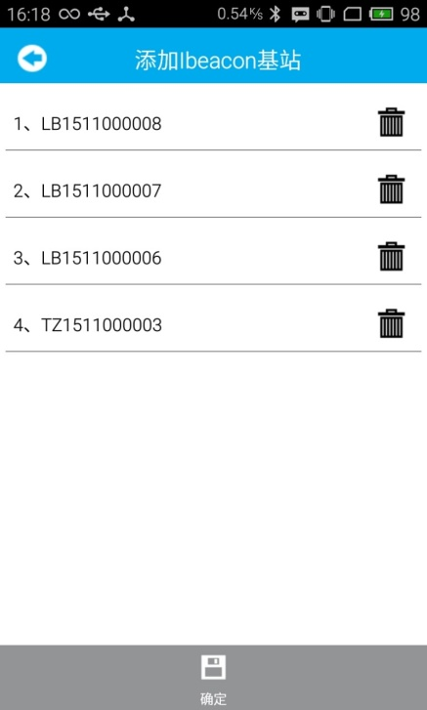

c) The App will analyze where the beacon is.
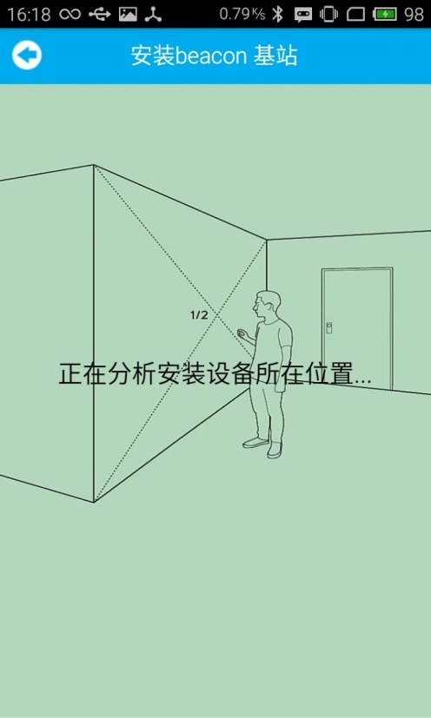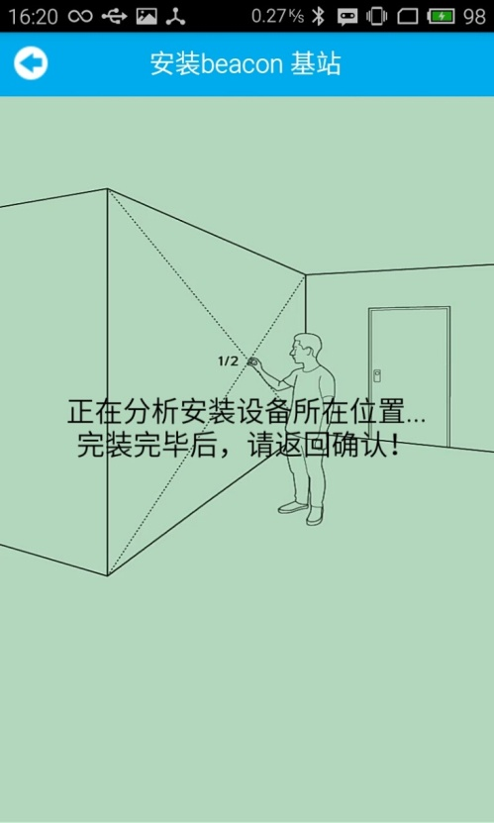
d) Check whether the actual location is the same with beacon location. If yes, click “Save the setting”.
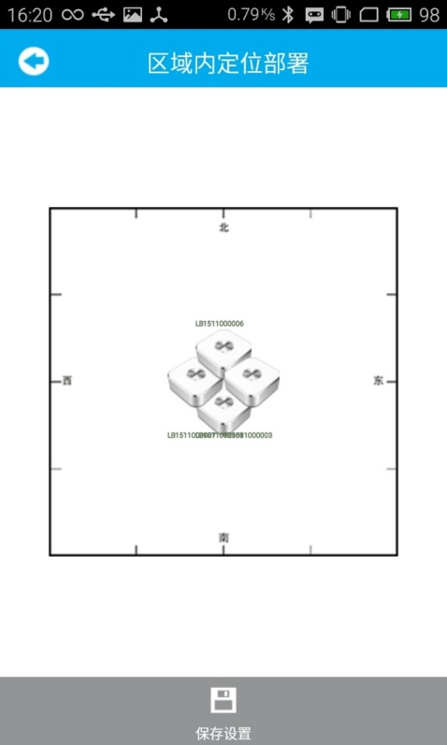

e) Positioning
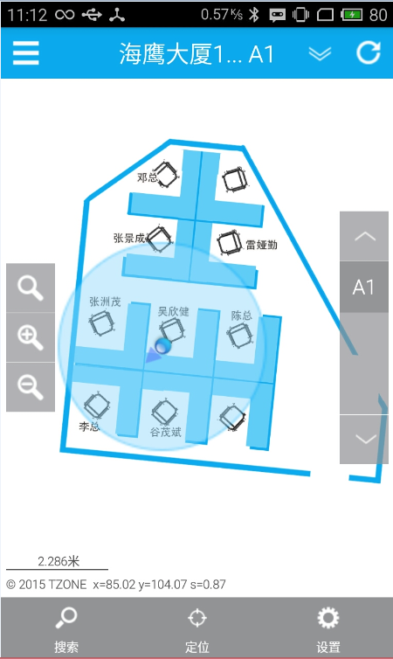
In the picture:
- The dot is your position
- The arrow shows the direction of the mobile device
- The round box is position precision

3.5 Indoor positioning deployment function
3.5.1 Place the mobile device near the beacon to read its info, then deploy it according to positions in the following picture.
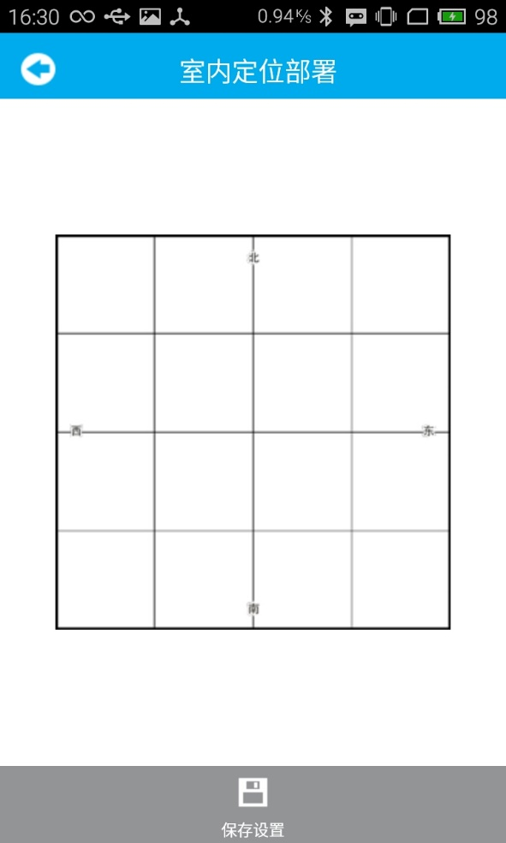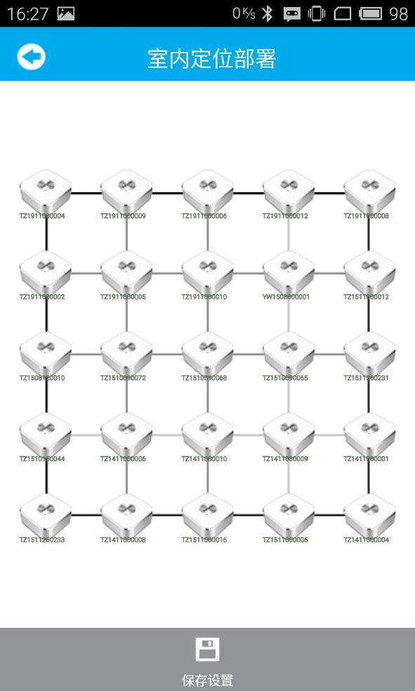
3.5.2 Positioning
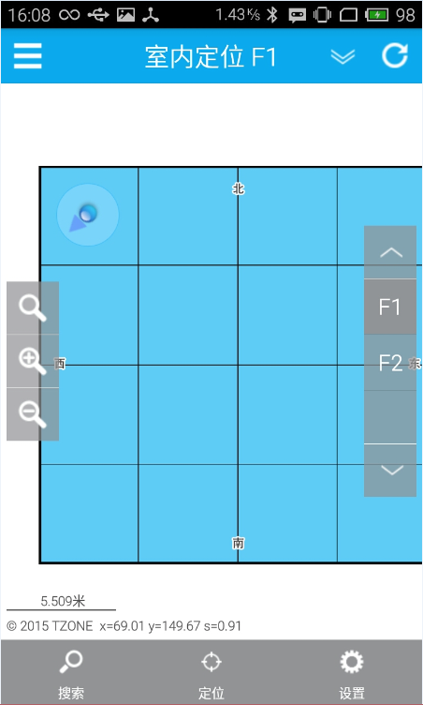
In the picture:
a) The dot is your position
b) The arrow shows the direction of the mobile device
c) The round box is position precision

3.6 Search for off-line map
